SKILLSYNERGY: A WEB-BASED SKILLS EXCHANGE PLATFORM

FOR CISTM STUDENTS OF PAMANTASAN NG LUNGSOD NG MAYNILA USING TAXONOMY-BASED MATCHING AND ASSESSMENT

A Research Project Presented to the

Faculty of Information Technology Department

College of Information System and Technology Management

Pamantasan ng Lungsod ng Maynila

In Partial Fulfillment of the Requirements for the Degree

**Bachelor of Science in Information Technology**  
­­­­

By

Amanda C. Duyan  
Ralph Aeron H. Estanislao  
Baby Joy M. Gomez  
Shahaina Jenevieve B. Ignacio  
Aldrin Manay

Maricar P. Reducto

Prof. Joseph Darwin C. Co

Prof. Mark Christopher R. Blanco  
SIA Adviser

April, 2025

**TABLE OF CONTENTS**

TABLE OF CONTENTS ii

LIST OF FIGURES iii

INTRODUCTION 1

1.1 Background of the Study 1

1.2 Statement of the Problem 4

1.3 Objectives of the Study 4

1.3.1 General Objectives 4

1.3.2 Specific Objectives 5

1.4 Significance of the Study 5

1.5 Scope and Limitations 6

1.5.1 Scope ………. 6

1.5.2 Limitations 7

1.6 Definition of Terms 8

REVIEW OF RELATED LITERATURE 10

2.1 Related Literatures 10

2.1.1 Local Literature …… 10

2.1.2 Foreign Literature … 22

2.2 Related Studies 37

2.2.1 Local Studies ……… 37

2.2.2 Foreign Studies ……… 44

2.3 Conceptual Framework 52

METHODOLOGY 54

3.1 Research Design 54

3.1.1 System Flowchart as a whole system process ……… 55

3.1.2 System Flowchart per process ……… 57

3.1.1.1 System in Pseudo code as a whole process ……… 71

3.1.1.2 System in Pseudo code per process ……… 71

3.2 System Architecture 78

3.2.1 User Interface ……… 80

3.3 System Requirements 108

3.4 Methods and Tools 109

3.4.1 Entity-Relationship Diagram(ERD) ……… 111

3.4.2 Data Flow Diagram (DFD) ……… 114

RESULTS AND DISCUSSION 119

4.1 Survey Results 119

4.2 Instrumentts Used 133

4.3 Population and Sample 133

4.4 System Evaluation 135

LIST OF REFERENCES 160

**LIST OF FIGURES**

|  |  |  |
| --- | --- | --- |
| **Figure No.** | **Figure Title** | **Page** |
| Figure 2.1 | Conceptual framework of the system…………………………........... | 52 |
| Figure 3.1.1 | System Flowchart for Main Functions……………………..…………. | 55 |
| Figure 3.1.2 | System Flowchart of Log-in, Sign-up and Forgot Password………….. | 57 |
| Figure 3.1.3 | System Flowchart of Profile Setup…………………………………….. | 59 |
| Figure 3.1.4 | System Flowchart of Homepage/Landing Page……............................ | 61 |
| Figure 3.1.5 | System Flowchart of Find Match………………………………………. | 63 |
| Figure 3.1.6 | System Flowchart of Notifications, Messages and Matched………….... | 65 |
| Figure 3.1.7 | System Flowchart of Skill Assessment…………………………………. | 67 |
| Figure 3.1.8 | System Flowchart of Edit Profile……………………………………….. | 69 |
| Figure 3.2 | System Architecture……………………………………………………. | 78 |
| Figure 3.2.1 | Sign-up Page for Validation…………………………………………… | 80 |
| Figure 3.2.2 | Sign-up Page for Creating Account…………………………………… | 81 |
| Figure 3.2.3 | Log-in Page……………………………………………………………... | 82 |
| Figure 3.2.4 | Profile Set-up Page……………………………………………………… | 83 |
| Figure 3.2.5 | Initial Assessment Direction………………………………………….... | 84 |
| Figure 3.2.6 | Initial Assessment ……………………………………………………… | 85 |
| Figure 3.2.7 | Submit in Profile Set-up Page…………………………………………. | 86 |
| Figure 3.2.8 | Profile Page for Display and Edit Information………………………….. | 87 |
| Figure 3.2.9 | Dashboard for General Skill Ranking…………………………………. | 88 |
| Figure 3.2.10 | Dashboard for Specific Skill Ranking………………………………. | 89 |

|  |  |  |
| --- | --- | --- |
| Figure 3.2.11 | Tutor and Liker Leaderboard Displaying General Rank 1…………... | 90 |
| Figure 3.2.12 | Specific Tutor and Liker Leaderboard Rank………………………. | 91 |
| Figure 3.2.13 | Liker Leaderboard and Assessment……………………………….. | 92 |
| Figure 3.2.14 | Find Match Tab……………………………………………………… | 93 |
| Figure 3.2.15 | Find Match Tab Filter Search……………………………………… | 94 |
| Figure 3.2.16 | Notification Tab……………………………………………………... | 95 |
| Figure 3.2.17 | Notification Tab for Find Match……………………………………. | 96 |
| Figure 3.2.18 | Matched Tab…………………………………………………………. | 97 |
| Figure 3.2.19 | Message Tab…………………………………………………………. | 98 |
| Figure 3.2.20 | Message Tab for Level of Difficulty……………………………….. | 99 |
| Figure 3.2.21 | Message Tab for Waiting Response…………………………………. | 100 |
| Figure 3.2.22 | Message Tab for Matched User’s POV……………………………… | 101 |
| Figure 3.2.23 | Message Tab for Menu Chat………………………………………… | 102 |
| Figure 3.2.24 | Assessment for Beginner…………………………………………… | 103 |
| Figure 3.2.25 | Assessment Result………………………………………………….. | 104 |
| Figure 3.2.26 | Message Tab with Assessment Result……………………………….. | 105 |
| Figure 3.2.27 | Rating in Message Tab………………………………………………. | 106 |
| Figure 3.4.1 | Entity-Relationship Diagram (ERD) for Skillsynergy System Main Functions…………………………………………………………….. | 116 |
| Figure 3.4.2 | Level 0 Data Flow Diagram (Context Diagram)…………………… | 122 |
| Figure 3.4.3 | Level 1 Data Flow Diagram (Decomposition Diagram)…………… | 123 |
| Figure 4.1.1 | Program……………………………………………………………….. | 119 |
| Figure 4.1.2 | Year Level……………………………………………………………. | 120 |
| Figure 4.1.3 | Block of Respondents (1st year - 4th Year)………………………… | 121 |
| Figure 4.1.4 | Age of the Respondents…………………………………………….. | 122 |
| Figure 4.1.5 | Confidence in Current Technical Skills…………………………….. | 123 |
| Figure 4.1.6 | Student Difficulties in Understanding Lessons during Lectures…….. | 124 |
| Figure 4.1.7 | Students’ Areas of Academic Struggle in Programming and Web Development Subjects………………………………………………... | 125 |
| Figure 4.1.8 | Students Coping with Difficult Lessons…………………………….. | 126 |

|  |  |  |
| --- | --- | --- |
| Figure 4.1.9 | Openness to Learning from Fellow Students………………………. | 127 |
| Figure 4.1.10 | Students Interest in Joining a Skill Exchange Platform…………….. | 128 |
| Figure 4.1.11 | Students Motivation to Join a Peer-to-Peer Learning Platform……. | 129 |
| Figure 4.1.12 | Students interest in tracking their progress………………………… | 130 |
| Figure 4.1.13 | Kind of Skills that Students Want to Learn from Fellow Students… | 131 |
| Figure 4.1.14 | Skills that Can Offer or Teach to Others………………………………. | 132 |
| Figure 4.2.1 | The System Has All Features……………………………………….. | 141 |
| Figure 4.2.2 | Students can Complete their Skills Assessments……………………. | 142 |
| Figure 4.2.3 | Skill Matching Works Accurately…………………………………… | 143 |
| Figure 4.2.4 | The Platforms Helps Students to Improve…………………………... | 144 |
| Figure 4.2.5 | All Major Functions are Working Properly……………………..…….. | 145 |
| Figure 4.2.6 | The System Works Consistently…………………………………….. | 146 |
| Figure 4.2.7 | Progress and Data are Saved Accurately …………………………........ | 147 |
| Figure 4.2.8 | Haven’t Lost Any Information During Use………………………… | 148 |
| Figure 4.2.9 | The Platform is Dependable………………………………………… | 149 |
| Figure 4.2.10 | Trusting the System to Function Proper……………...……………….. | 150 |
| Figure 4.2.11 | Interface is Simple and Easy to Navigate…………………………… | 151 |
| Figure 4.2.12 | Understood How to Use the System ………...……………………… | 152 |
| Figure 4.2.13 | The Platform Layout is Organized and Clear………………………...... | 153 |
| Figure 4.2.14 | The System Feels Intuitive and Smooth………………………………. | 154 |
| Figure 4.2.15 | Students Enjoy Using the SkillSynergy Platform……….……………. | 155 |
| Figure 4.2.16 | The Platform is Responsive……………………………….………… | 155 |
| Figure 4.2.17 | There is No Noticeable Lag…………………………….……………. | 156 |
| Figure 4.2.18 | The System Performs Well Even With Many Users Online……….. | 157 |
| Figure 4.2.19 | The System Loads Quickly ………..........................................…….. | 158 |
| Figure 4.2.20 | SkillSynergy Runs Smoothly on the Devices ………............................ | 159 |

**LIST OF tables**

|  |  |  |
| --- | --- | --- |
| **Table No.** | **Table Title** | **Page** |
| Table 4.3.1 | Population and Sample…………………………...................................... | 133 |
| Figure 4.4.1 | ISO 25010-2011 Characteristics used for System Quality Evaluation…. | 136 |
| Figure 4.4.2 | The five-point Likert Scale…………………………………… ……….. | 138 |
| Figure 4.4.3.1 | Overall Mean for Characteristics in ISO 25010 Evaluation…………….. | 139 |
| Figure 4.4.2 | The five-point Likert Scale……………………………………………... | 140 |

**Chapter One**

**INTRODUCTION**

**1.1 Background of the Study**

A skill is a unique ability or method that is obtained through specific training in either a physical or intellectual domain. Skills can include listening, communicating, organizing, designing, and programming. Skills enable the person to choose the best behavior or action to meet the demands of the task. Pamantasan ng Lungsod ng Maynila (PLM) is a known public university for its commitment to providing quality education to students from diverse backgrounds in business, education, law, and medical fields. The department of College of Information Systems and Technology Management (CISTM) offers soft skills, hard skills, transferable skills, personal skills, and knowledge-based skills guided by the values of academic excellence and integrity in the community embracing diversities that contribute to the growth of the college. However, despite having a competent teaching style to give CISTM students an excellent education, the department faced challenges due to the way students study. Learning styles among students enrolled in various courses in this department at Pamantasan ng Lungsod ng Maynila (PLM) may have an impact on their academic skills and abilities.

Student’s personal narratives and years of educational experience have a direct influence on how they react to instruction and learning. Students learn by connecting new knowledge with knowledge and concepts that they already know, most effectively in an active social community where they negotiate understanding through interaction and varied approaches. Recent developments in open, informal, and collective education have been progressively influencing an innovative approach of education known as "mass collaborative learning," in which an infinite number of formed but motivated individuals

(with different backgrounds and levels of knowledge) join a networked community with the goal of learning new things through interaction (Majid Zamiri & Camarinha-Matos, L. M., 2021). With a stronger focus on reciprocal learning and reflection, the interaction between people in the community teaching and learning approach combines instruction and reflection with meaningful community engagement to enhance the learning process (Marshall University, 2019). Through formal education, focused training, and hands-on experience in real-world scenarios, an individual can develop their skills, which are the ability to do a task or solve an issue at a high level. Skills-based mentor matching refers to connecting individuals based on the skills they seek and offer (Pursell, 2024). You can achieve synergy through factors like combined talent, combined technology, streamlined processes that allow for cost reduction and increased revenue.

With SkillSynergy, utilizing Skills Taxonomy-Based Matching and Assessment along with a score-based algorithm for the gamification leaderboard, students can exchange skills and knowledge, schedule academic sessions seamlessly, and foster collaborative and innovative learning within Pamantasan ng Lungsod ng Maynila.

A [Skills Taxonomy](https://initiatives.weforum.org/reskilling-revolution/future-skills-alliance)-Based Matching Algorithm is a comprehensive, structured framework that classifies and organizes the specific skills within an organization. Much like a dictionary for competencies, it breaks down the skill sets into categories and subcategories, mapping out the relationships between different skills. It includes definitions, proficiency levels, and sometimes associations to roles or functions, which creates a unified language for assessing and developing talent.

A skills assessment is an evaluation of an individual’s ability to perform a specific skill or set of skills. Usually, it’s an evaluation of skills specific to a job or role. Ideally,

the assessment captures the level of proficiency for each skill. This way, you know which participants are new to a skill and which have mastered it.

In addition, a score-based algorithm is used for the assessment to determine the leaderboard ranking based on the score in taking an assessment. Score-based algorithm is used to identify the best structure in probabilistic models like Bayesian networks by assigning scores to various possible configurations based on how well they fit the data. This scoring balances two key factors: the accuracy of the model in explaining the data and the simplicity of its structure, helping to avoid over fitting. A search process is then used to explore and select the highest-scoring model. This flexible approach can be applied to a wide range of data-driven systems.

In the study “*What is a skills taxonomy? A brief guide*” by Bohnert (2023) implementing skills taxonomy-based matching algorithms in SkillSynergy enhances the platform's effectiveness by systematically categorizing and defining the range of skills among PLM students. This structured approach enables precise identification of competencies, facilitating accurate matches between students seeking to learn and those offering expertise. According to Team (2024), the best way to understand one’s abilities and level of proficiency is to do an evaluation of skills. This can be done by conducting a skills assessment. But then, even though there is a benefit from implementing the assessments and s[kills taxonomy](https://initiatives.weforum.org/reskilling-revolution/future-skills-alliance)-based matching algorithms in the context of SkillSynergy, there is also a limitation for this. Students with interdisciplinary or emerging skills might not find appropriate matches if the taxonomy does not encompass these areas, hindering the platform's goal of facilitating effective skill exchange. The effectiveness of implementing an assessment and skills taxonomy-based matching algorithm in SkillSynergy depends on various factors that can impact its overall success.

This study aims to develop SkillSynergy, a web-based platform that is designed and made exclusively for the Pamantasan ng Lungsod ng Maynila students particularly in College of Information Systems and Technology Management (CISTM). This Platform aims to help the students to connect, socialize, and exchange skills. In order to promote a collaborative learning environment, the SkillSynergy system matches student to student using a skill taxonomy-based matching algorithm. A framework for assessing skill proficiency is also included, with the goal of enhancing educational opportunities and encouraging information exchange among PLM users.

**1.2 Statement of the Problem**

This study aims to address the following key problems:

1. How can a web-based platform effectively connect PLM CISTM students to exchange skills and share expertise based on their interests and capabilities?
2. How can the platform facilitate efficient academic sessions and encourage CISTM students to actively participate in skill-sharing activities through a competitive leaderboard system?
3. How can the platform implement an effective assessment method to evaluate skill improvement and knowledge transfer among students?

**1.3 Objective of the Study**

**1.3.1 General Objectives**

The main objective is to develop a web-based platform that enables PLM CISTM students to share skills. The platform will include a session management system for scheduling and communication, a taxonomy-based matching system that connects students according to their interests and skills, and an assessment-based evaluation system that will assess skill proficiency and monitor learning progress over time.

**1.3.2 Specific Objectives**

**1.3.2.1** To develop a taxonomy matching based platform that facilitates skill exchange among PLM College of Information Systems and Technology Management (CISTM) students, enabling them to offer and acquire skills based on their expertise and learning needs.

**1.3.2.2** To integrate a leaderboard that ranks CISTM students based on their skills using a score-based algorithm, in order to promote engagement and facilitate more effective academic sessions.

**1.3.2.3** To integrate an evaluation system that assesses skill proficiency and tracks learning progress through peer feedback, quizzes, or automated assessment methods.

**1.4 Significance of the Study**

The development of SkillSynergy, a web-based platform, is highly significant for the College of Information Systems and Technology Management (CISTM) at Pamantasan ng Lungsod ng Maynila (PLM). By facilitating peer-to-peer skill exchange, the platform enhances student learning, collaboration, and engagement within the IT and CS programs.

**For CISTM Students:** SkillSynergy provides an innovative way for IT and CS students to connect with peers who possess the technical skills they need to improve, such as programming, database management, cyber security, and software development. This allows students to efficiently find suitable learning partners, ensuring a more effective and personalized learning experience.

**For CISTM Faculty:** While the platform primarily focuses on informal peer learning, it complements the structured curriculum of the CISTM department. By

promoting student collaboration and knowledge exchange, SkillSynergy reinforces essential technical and problem-solving skills outside the classroom. It also encourages self-directed learning, teamwork, and the practical application of IT and CS concepts, which are essential in the tech industry. Faculty members can also use the platform as a supplementary tool to monitor student engagement and peer-to-peer learning dynamics.

**For the PLM CISTM Community:** The platform fosters a strong and supportive academic community within CISTM by encouraging collaboration and shared learning experiences among students. It enables aspiring IT and CS professionals to build valuable connections, exchange expertise, and enhance their academic performance.

**For Future Researchers:** SkillSynergy serves as a foundation for future studies in technology-driven education, peer learning, and collaborative skill development. Future researchers can explore enhancements in the platform’s design, scalability, and effectiveness in different academic settings. Additionally, the study can serve as a reference for developing similar initiatives in other educational institutions, promoting innovation in student learning and engagement.

While SkillSynergy is currently limited to the CISTM department, its impact on student learning and engagement could serve as a foundation for expanding similar initiatives across other academic disciplines. By empowering IT and CS students with a collaborative and technology-driven learning environment, the platform contributes to the continuous improvement of education within PLM.

**1.5 Scope and Limitations**

**1.5.1 Scope**

SkillSynergy is a web-based skill exchange platform exclusively designed for students of the College of Information Systems and Technology Management

(CISTM) at Pamantasan ng Lungsod ng Maynila (PLM), specifically for those who enrolled in the Bachelor of Science in Information Technology (BSIT) and Bachelor of Science in Computer Science (BSCS) programs. It is peer-to-peer learning by allowing the students to teach and learn specific skills through structured matchmaking and exchange processes. The platform includes key features such as OTP-Pin verified sign-up, profile setup with skill preferences, taxonomy-based matchmaking, a skill exchange mechanism, in-platform chat, and a practice assessment based on their skill level such as beginner, intermediate, or advanced to match the user’s current skills. Users can filter their matches by skill level, gender, program, age, and location to find the best learning partners. SkillSynergy creates a collaborative space for learning that promotes both academic and personal growth through informal knowledge-sharing instead of formal education.

**1.5.2 Limitation**

This platform has certain limitations. It is strictly restricted to College of Information Systems and Technology Management (CISTM) students and will not be accessible to other departments or the general public. Additionally, users can only select from a predefined list of skills, as custom skill additions are not allowed. SkillSynergy is a prototype that is meant for alpha and beta testing within Pamantasan ng Lungsod ng Maynila and not intended for any public or commercial use. And, the assessment feature function is only a practice tool, it generates basic multiple-choice, short-answer, or rating-scale questions without any formal grades or certificates. Since the platform focuses on collaborative learning instead of certification, completing the skill exchange does not grant users any official recognition. Moreover, its effectiveness heavily relies on user participation, meaning that active engagement is necessary for successful matches

and learning sessions. Also, if the user is not active, the opportunities for the skill exchange and learning experiences may be limited. Lastly, the system uses only the taxonomy-based algorithm for matchmaking instead of using the AI-powered suggestions. Even with these limits, SkillSynergy serves as a valuable tool for fostering practical skill development and peer collaboration within the PLM community.

**1.6 Definition of Terms**

**Automated Assessment Methods –** It refers to digital tools that track participation, feedback, and skill progress.

**Alpha Testing –** It refers to internal testing to identify and fix issues before broader testing.

**Beta Testing –** It refers to pre-launch testing by selected students to improve features.

**Collaborative Learning Environment –** It refers to a space for discussions, skill exchanges, and feedback.

**Competency Assessment –** It refers to measuring skill levels before and after sessions.

**Digital Literacy –** It refers to navigating the platform and engaging effectively online.

**Evaluation System –** It refers to feedback and rating tools for tracking skill growth.

**Interdisciplinary Skills –** It refers to combining expertise from different fields.

**Knowledge-Sharing Platform –** It refers to a space for exchanging skills and learning.

**Peer-to-Peer Learning –** It refers to students switching between mentor and learner roles.

**Proficiency Levels –** It refers to categorizing students as Beginner, Intermediate, or Advanced.

**Session Management System –** It refers to tools for organizing and tracking skill sessions.

**Skill Taxonomy-Based Matching Algorithm –** It refers to categorizing skills for accurate peer matching.

**Skills Taxonomy –** It refers to structuring expertise for better learning connections.

**Structured Matchmaking –** It refers to pairing students based on skills and goals.

**Taxonomy-Based Algorithm –** It refers to AI-driven skill categorization and matching.

**Chapter Two**

**REVIEW OF RELATED LITERATURE**

**2.1 Related Literatures**

This area contains published journals, essays, and other relevant literature from both local and foreign literatures. Those in this section contribute in introducing the developers to connected and pertinent study subject matter.

**2.1.1 Local Literature**

**Study Buddy System**

The Study Buddy System, initiated by the Junior Philippine Institute of Accountants (JPIA) - SKSU Local Chapter, successfully concluded its first semester of implementation. This program serves as a collaborative platform that fosters academic support and social interaction among students within the Accounting Studies Department. Through structured tutorials and peer-assisted learning, the system aims to enhance the academic performance of participants, particularly first-year students preparing for their qualifying exams. By strengthening their foundational knowledge and study habits, the initiative contributes to improved learning outcomes and academic success. (Junior Philippine Institute of Accountants - SKSU Local Chapter, 2024)

**Study: Over 50% of Pinoy IT students lack programming skills**

Joey Gurango, through Gurango Software Corp. (GSC), discovered a concerning trend regarding the programming proficiency of Filipino students. Based on the results of the Proxor examinations, which were conducted between

October 2015 and September 2016, it was found that more than 50% of the participants lacked the fundamental entry-level programming skills required to meet global industry standards. This alarming finding highlights a significant gap in the quality of programming education in the country, emphasizing the need for improved curriculum, better training methodologies, and stronger industry-academe collaboration to enhance the technical competencies of aspiring software developers. (NewsBytes.ph, 2017)

**Programming Competencies of Filipino Information Technology Students: Inputs to Improving Instructional Processes**

Many startup founders struggle to find the right expertise, leading to delays and frustration. Traditional solutions, such as hiring consultants, can be costly and inaccessible for early-stage entrepreneurs. To address this, skill exchange platforms have emerged, allowing founders to trade expertise instead of paying for services. This approach fosters collaboration, reduces costs, and strengthens professional networks. Recognizing this need, a platform is being developed to facilitate skill-sharing among startups, enabling mutual growth and support. Programming competency assessment plays a crucial role in evaluating students' skills, identifying their strengths and weaknesses, and ensuring proper job assignment matching. It serves as a key determinant of students' academic standing and readiness for on-the-job training (OJT). Additionally, it helps gauge the preparedness of fourth-year students for industry deployment, equipping them with the necessary skills for their future careers (Babas, 2020).

**PIDS study emphasizes interagency collaboration to address skills mismatch**

In the study “PIDS Study Emphasizes Interagency Collaboration to Address Skills Mismatch” by the Philippine Institute for Development Studies

(PIDS, 2024), it advocates the establishment of standardized skills taxonomy to improve data accuracy and forecasting capabilities, facilitating better alignment between educational outcomes and industry requirements. This underscores the significance of taxonomy-based systems in skill assessment and matching within educational institutions. The study also emphasizes the integration of Labor Market Information Systems (LMIS) and the use of frameworks such as TESDA’s Skills Anticipation and Prioritization of Skills Requirements (SAPSR) to enhance the responsiveness of education and training programs. Furthermore, it highlights the need for coordinated efforts among government agencies, the private sector, and academic institutions to promote real-time labor market analysis and ensure that training programs are aligned with current and future workforce demands. The study also recommends collaboration with digital platforms and the utilization of technology-driven solutions for job matching, skills mapping, and workforce development. These strategies aim to create a more agile and data-informed system that supports continuous skills development, reduces unemployment, and addresses the persistent issue of skills mismatch in the country.

**Peer Tutorial Program**

While (UPV's Teaching and Learning Resource Center (TLRC), 2024) provides a peer tutoring program that emphasizes peer-to-peer learning and collaboration as effective means for academic support and skill development, it also fosters a cooperative learning environment. In this program, academically proficient students mentor their peers in subjects such as physics, chemistry, and communication, promoting mutual growth. This student-centered approach empowers learners to actively engage in their own educational journey. The program is inclusive, offering free tutoring services to all students, which helps

reduce academic disparities and ensure that every student has access to the support they need. To further motivate tutors, the program offers incentives like unrestricted access to computer facilities, free printing for certain documents, and modest honoraria funded by university alumni and partners. These resources, along with the opportunity for tutors to develop important soft skills such as leadership, communication, and empathy, enhance both academic and personal growth. Overall, TLRC’s peer tutoring program contributes significantly to improving the learning outcomes and overall academic experience of the university community.

**ADB Study Calls for Skills Training Reform in the Philippines**

Additionally, Technical and Vocational Education and Training in the Philippines in the Age of Industry 4.0 were a research conducted at the request of the Technical Education and Skills Development Authority (TESDA) of the Philippines. As the need for skills are fast changing due to new industrial technology, known as Industry 4.0, it examines the achievements and difficulties facing the Philippines' skills training system. However, Due to pandemic-related school closures and disruptions, TESDA is now able to implement unconventional, creative, and adaptable solutions like digital tools and online learning. Retooling and skill enhancement for displaced workers have been greatly aided by these. The report advises the government to look for innovative and efficient methods to ensure industry participation in skills training. These methods include predicting the demand for skills, making sure that training programs are better targeted and that the supply of skills is more efficient, reducing mismatches, and enhancing labor market results. (Bank, A. D., 2021).

**Exploring the importance of soft and hard skills as perceived by IT internship students and industry: A gap analysis**

Among the basic skills gap problems faced are seen throughout the economy: underdeveloped state of skills training system in the public schools, outdated curriculum, insufficient dialogue and coordination amongst the stakeholders regarding skills needs and training, inadequate accreditation of training programs, and scant avenues for re-skilling. The Commission on Higher Education (CHED) came out with an intervention. To address this gap problem, an On the Job Training (OJT) or internship program to fill in the gap between academic acquired skills and practical skills knowledge needed by the industry. Policies and standards are adopted by the commission to rationalize Information Technology Education (ITE) in the country and keep pace with the demands of global competitiveness. In the policies and standard, internship is included and expanded as a requirement for the BSIT and BSIS programs which aims to give students the chance and opportunity to immerse themselves in the IT industries. Through the internship program, students will have the chance to apply the skills, knowledge and attitude learned in the school and at the same time the opportunity to experience the corporate environment (Patacsil and Tablatin, 2017).

**Effectiveness of Peer-Assisted-Learning Model in Teaching Physical Examination in Otorhinolaryngology to Clerks and Postgraduate Interns**

Peer-assisted learning (PAL) is an established concept in which students obtain mutual benefits by teaching and learning from each other. In the clinical environment, this often occurs intentionally or unintentionally in various formats such as same level or cross level peer tutoring, peer mentoring, cooperative learning and the like. This study determined the effectiveness of Peer Assisted

Learning in achieving identified program outcomes in the curriculum for clerks and postgraduate interns rotating in Otorhinolaryngology specialty. Methodology Study has 2 parts. Part 1 was a one-group pre-test and post-test design that involved teaching training of 16 PGI to be peer tutors in Otorhinolaryngology Physical Examination (ORL PE) to clerks. Video recorded pre-training baseline and post-training actual skills demonstrations of the PGI were rated. Scores were compared using Wilcoxon Signed Ranks test with p value at 5% level of significance. Part 2 was a randomized controlled single-blind trial of Peer-Led vs. Expert Faculty-Led ORL PE training of 55 clerks. Tutees performed a post training video-recorded skills demonstration assessed by a faculty rater who was blinded as to who among the clerks underwent the PAL-Led or Expert Faculty-Led training. Scores of the tutees in the 2 models of instruction were compared using the Mann-Whitney U-test at 5% level of significance. Results part 1 results showed significant improvement in the post-training scores of the 16 PGI in the identified micro skills and ORL PE skills. For Part 2, 33 and 22 clerks underwent PAL-Led and Expert Faculty-Led instruction respectively. Comparison of performance scores of the clerks in the 2 models of instruction showed no significant difference. Teaching training for PGI improved their knowledge, skills and attitude in teaching ORL PE skills to clerks. There was no significant difference in the performance outcomes between clerks that underwent the PAL-Led and Expert Faculty-Led model of instruction (Capuz and Atienza, 2017).

**An E-learning outreach program for public schools: Findings and lessons learned based on a pilot program in Makati City and Cabuyao City, Laguna, Philippines**

E-Learning Outreach Program (ELOP) is a multisectoral, collaborative, and commitment-driven action research that focuses on providing relevant and

useful computer and Internet literacy short courses for public elementary students. This study presents the critical action plans of setting up a pilot e-Learning station in Hen. Pio del Pilar Elementary School in Makati City and in Pulo Elementary School in Cabuyao City, Laguna, Philippines. The school’s computer laboratory was converted to an E-Learning station with additional devices and technical support from De La Salle University (DLSU). The study aims to account for a process-based heuristic approach in laying down the different phases of the program, specifically to: (1) coordinate and orient parents, pupils, teachers and school administrators, (2) set-up an e-Learning environment (3) design and write course modules (4) assess learning skills and experience of pupils, and (5) evaluate the program based on research team’s observation and results of the focus group discussion (FGD) with teachers and student-participants. In Pulo Elementary School, a pretest and posttests were conducted with results showing that the program has improved participants’ e-Learning knowledge and skills except for advance skills in hardware utilization (Nuncio, Rhoderick V., Arcinas, Myla M., Lucas, Rochelle Irene G., Alontaga, Jasper Vincent Q., Neri, Susan Grace T., and Carpena, Jose Marie 2020).

**Exclusive: Promoting Digital Literacy in the Philippine education system**

The Department of Education (DepEd) has taken significant steps to promote digital literacy as part of the Philippine education system. Recognizing the increasing influence of Information and Communication Technologies (ICTs), DepEd has implemented ICT-assisted teaching and learning initiatives to equip both teachers and students with the necessary digital skills. These initiatives include the distribution of tablet PCs and laptops, pre-loaded with open educational resources (OERs) to support classroom instruction. Despite these advancements, challenges remain, particularly in the procurement of software,

internet connectivity and teacher training. To address these, DepEd has partnered with software vendors, TESDA, and the Department of Information and Communications Technology (DICT) to enhance digital learning resources and infrastructure. The success of these efforts is measured through standardized national assessments, which evaluate students’ competency in digital literacy (OpenGov Asia, 2019).

**DepEd Online Learning: The Growing Role of the Smartphone in Education**

As digital education continues to evolve, the Department of Education (DepEd) in the Philippines has embraced online learning through the launch of DepEd Commons, an Open Educational Resources (OER) platform designed to support distance learning. This initiative aims to bridge the gap between teachers and students by providing access to review materials and digital learning resources, especially in times of disruptions like the COVID-19 pandemic. While the platform ensures continuous learning, it also raises concerns about accessibility and affordability, as students and teachers need appropriate devices and stable internet connections to fully utilize its features.

A major challenge highlighted is the financial burden on students and their families. Many public school students struggle to afford the minimum required laptops or desktop computers that makes digital learning inaccessible to a large portion of the population (Llego, 2020).

**E-learning: What it is, how it works**

The integration of e-learning platforms in Philippine education has been steadily increasing especially among major institutions such as UP Open University (UPOU), De La Salle University (DLSU), Ateneo De Manila

University (ADMU), University of Santo Tomas (UST), and the Asian Institute of Management (AIM). These platforms have provided alternative learning environments through learning management systems (LMS) such as Edmodo, MOODLE, and Google Classroom, which allow teachers to upload materials, facilitate discussions, and track student progress. Additionally, widely accessible tools such as Facebook, Skype, Google Hangouts, and Zoom have become essential for real-time instruction. However, challenges remain in fully adopting e-learning in the Philippines. The digital divide continues to be a significant barrier, as many students lack access to stable internet connections and digital devices, limiting their ability to participate in online learning. Additionally, distractions from social media, student readiness, and the lack of technological infrastructure pose further obstacles according to Tabios (as cited in Manila Bulletin, 2020).

**The Philippines: Digital Platforms for Inclusive Education**

In an article published by Samaya Dharmaraj (2025), the Philippine government has intensified efforts to bridge digital and educational gaps through strategic collaborations with global digital learning platforms. President Ferdinand R. Marcos Jr., in his 2024 State of the Nation Address (SONA), states the necessity of digitalization and solar-powered classrooms to enhance the country’s educational system. In response, the Department of Education (DepEd) formalized a partnership aimed at improving students' numeracy and literacy skills, particularly in mathematics. This initiative aligns with DepEd’s broader commitment to digital transformation, leveraging AI-powered teaching assistants and interactive platforms to supplement traditional teaching methods. Moreover, the integration of AI-driven tools supports teachers in lesson planning and enables personalized learning experiences. As the program scales nationwide, investments

in internet connectivity and private sector collaborations will be crucial in ensuring equitable access to digital education. Through this initiative, the Philippines are advancing towards a more inclusive, technology-driven education system, preparing Filipino learners for the demands of a rapidly evolving digital world.

**The Impact of Peer Tutoring on Academic Achievement in Financial Accounting and Reporting of First-Year Accountancy Students in Pamantasan ng Lungsod ng Maynila**

According to Ruoyao (2023), Peer tutoring has been a huge impact on education and is also known as an effective educational strategy, stating that collaborative learning is where students teach and learn from each other. This educational approach has been effective to improve academic performance, and enhance social skills of the students. Peer tutoring can be done in various forms such as cross-age peer tutoring and more as long as the tutor and tutee benefit from each other (Alegre, 2021). Studies highlight that well-structured peer tutoring sessions can help the students to become more creative, and let them socialize so that they can enjoy studying especially in large class settings where individualized attention is limited (Gordon, 2019, as cited in Ullah, 2020). Research has demonstrated that peer does not only enhances the student’s social life but also helps their mental health as they feel that they are not alone while studying (Keller, 2023). Peer tutoring has been widely studied across various schools, its impact on first-year Accountancy students, particularly in Financial Accounting and Reporting in Pamantasan ng lungsod ng Manila has yet to be fully explored and studied. This study aims to further investigate the role of peer tutoring in improving academic performance in this specific context.

**Virtual Mobility: The Lived Experience of Exchange Students in a Higher Education Institution in Asia**

Virtual mobility offers a valuable avenue for exchange students to engage in meaningful activities that significantly enhance their English language skills. The study highlighted that student participating in virtual mobility programs reported tangible improvements across a spectrum of language acquisition aspects. These included enhanced reading comprehension, a noticeable expansion of their English vocabulary, increased writing proficiency, and a marked improvement in their overall communication skills in English. Furthermore, Francisco's research suggests that the immersive nature of these virtual exchanges provides a context for practical language use that mirrors real-world interactions, fostering confidence and fluency in a way that traditional classroom settings might not fully replicate (Francisco, 2022).

**Empowering Filipino Youth with Informed Educational and Career Paths through Edukasyon.ph’s Innovative Platform**

Microsoft Philippines Communications Team's (2021) announcement regarding Edukasyon.ph underscores the platform's significant role in shaping the educational and career trajectories of Filipino youth. According to the team, Edukasyon.ph's comprehensive online ecosystem is designed to empower young individuals by providing them with a robust array of information and pertinent resources. This includes details about various academic courses, educational institutions, available scholarship opportunities, and a wealth of other relevant materials. The core objective of this platform is to enable Filipino youth to make well-informed career decisions that resonate with their personal passions and interests. Simultaneously, Edukasyon.ph aims to bridge the gap between academic

pursuits and the demands of the job market by offering insights into industries with high employment potential. This holistic approach ensures that students are not only guided towards fulfilling their vocational aspirations but are also equipped to identify and secure jobs that are currently in demand.

**Collaborative Learning in an Online Setting of Philippine State University Students in the Philippines: A Phenomenological Study**

Lantaca, Ehing, Tupos, Jadap, Capilitan Jr., and Namoco's (2022) phenomenological study delved into the lived experiences of students in Philippine state universities engaging in collaborative learning within online environments. Their research illuminated the multifaceted nature of this pedagogical approach in the digital realm, revealing both its significant advantages and the inherent challenges encountered by students. A key finding of their work underscores the critical role of well-designed and structured digital platforms in facilitating effective collaborative learning. These platforms, when thoughtfully implemented, serve as crucial virtual spaces that enable students to seamlessly exchange knowledge, share diverse skills, and collectively develop competencies. The study emphasizes that the architecture and features of these online learning environments can significantly impact the quality and efficacy of collaborative interactions and, consequently, the learning outcomes for students.

**Issues and Challenges in Open and Distance e-Learning: Perspectives from the Philippines**

According to Alfonso's (2015) study (as cited in Arinto, 2016) insightful analysis of the "Issues and Challenges in Open and Distance e-Learning: Perspectives from the Philippines" specifically focused on the operational realities faced by the University of the Philippines Open University as a pioneering

institution in this mode of education. A key aspect of Alfonso's discussion centered on the critical imperative for effective assessment strategies within online learning environments. The study illuminated the difficulties inherent in adapting traditional assessment methods, often designed for face-to-face interactions, to the unique dynamics and limitations of ODeL. Alfonso argued that the absence of direct, physical oversight necessitates the development and implementation of innovative and rigorous assessment techniques capable of accurately evaluating student learning, ensuring academic integrity, and providing meaningful feedback in the distance learning context. This emphasis on effective assessment underscores its pivotal role in maintaining the quality and credibility of open and distance e-learning initiatives in the Philippines.

**2.1.2 Foreign Literature**

**A Skills-Matching Perspective on Talent Management: Developing Strategic Agility**

A person may be matched based on a variety of cognitive and non-cognitive factors, such as knowledge, skills, abilities, and other traits. Matching is defined as "the process by which individuals are dynamically aligned with organizations and the situations (roles, jobs, tasks, etc.) within them. The degree of compatibility between the individual and the environment and its requirements determines the quality of a match, which can occur in both internal and external labor markets. In the end, the literature on person-environment fit clarifies that high-quality matches are indicated by strong fit. Both individuals and businesses can benefit from high-quality matches made through the matching process. Individually, match quality has a positive correlation with performance, job satisfaction, and lower levels of stress and turnover. This perspective is

increasingly valuable as 89% of executives state that skill are becoming important in defining talent, deploying talent, managing careers, and valuing employees. Yet, only one in five of those firms report adopting specific approaches to a significant extent and in a clear and repeatable way. The shift to skills-based approaches is still in its infancy in most organizations, and firms typically struggle to capture the skills they will require in the future, with one report suggesting that only 26% of respondents were confident in their ability to do so. Specifically, we develop a model which depicts how skills-matching builds a set of dynamic capabilities, underlying two meta-capabilities, strategic sensitivity and resource fluidity, which, in turn, enable strategic agility. Thus, we emphasize the need to focus on skills-matching in addition to more traditional forms of managing talent. By doing so, talent functions can enhance their capacity to adapt quickly and change the firm's resource base in response to shifting external and internal demands. (Jooss, S., Collings, D. G., McMackin, J., and Dickmann, M., 2023).

**Taxonomy Matching Using Background Knowledge**

Based on (Angermann, H., and Ramzan, N., 2017) Taxonomies are classifying objects based on hierarchically ordered formal concepts. Because of this, taxonomies have its benefits for controlling how instances can be classified. However, when exchanging data across multiple information systems inside a single firm, or with external systems (e.g., digital marketplaces), the underlying taxonomies are very often not the same. This is because the domain is different or because the underlying methodologies are varying. Logically, the underlying taxonomies have to be mapped before exchanging data in a proper way, named taxonomy matching. Because the type(s) of heterogeneity existing between two taxonomies decisively affect finding correspondences, recent matching

approaches are differing from the approaches published in the century before, in two directions.

Firstly, recent attempts are focusing on the combination of multiple techniques, instead of using a single technique. This allows that different types of heterogeneity can be overcome using a single approach, and the matching quality result is usually increased. Secondly, recent attempts are using so-called background knowledge. Background knowledge in the form of lexicons, thesauri, or additional taxonomies being published as linked data or elsewhere is additional resources used to help inferring further relationships between concepts and thus helps assessing similarity between concepts/taxonomies. Through this, the matching quality result is highly increased, as the amount of information to be used for analyzing the concepts grows by every resource of background knowledge used. The latest evaluations performed in the field evidenced that the taxonomy matching systems perform better than more resources of background knowledge they are using.

**The Disconnect of Soft Skill Development and Job Skill Proficiency in Higher Education**

According to a study by Merchant (2024), the purpose of this action research study is to study and improve student employee transferable job skill proficiency within higher education institutions, specifically at Worcester Polytechnic Institute (WPI). Transferable job skill proficiency is defined through teamwork, communication skill sets, and efficacy within the classroom on. This study was designed to investigate how WPI is assisting the students in soft skills for their own development and success not just inside the classroom but also outside the classroom. The knowledge generated from this study is expected to

inform and build expectations and a framework for student development where WPI can help the student work on not only their professional skill development but also their personal skill development. The knowledge generated from this study is expected to inform and build expectations and framework for student development where WPI can help the student work on not only their professional skill development, but also their personal skill development. Participants and data collected in Cycle 1 consisted of two focus groups of WPI students, one group categorized as full-time students and the other Alumni of WPI (who have been out in the work field for more than six months), two faculty members, and seven staff members within the WPI institution. Themes that emerged from the data were collaboration, communication, experience, and education. The action step was then designed in Cycle 2, through a Communities of Practice approach with 8 full-time professionals within the higher education institution.

**PeerLoom: peer-to-peer skill exchange platform for university students / Farrah Othman … [et al.]**

At its core, the platform operates as a digital marketplace where students can offer their skills and knowledge in various disciplines, and in return, learn from their peers in areas they seek to improve or explore. From academic subjects like mathematics and science to non-academic skills like photography, personal grooming, makeup skills, coding, or language learning, the platform embraces a wide spectrum of knowledge areas. This inclusive approach ensures that all students, regardless of their field of study, can share and gain skills. Functionality is enhanced with a user-friendly interface, advanced search features, and a robust rating and review system. These features allow students to navigate and find the right skill exchange opportunities easily. The platform also supports different formats of learning, including one-on-one sessions, group learning, and online

tutorials, offering flexibility and convenience to its users. Beyond mere skill exchange, this platform fosters a collaborative learning environment, promoting interaction, networking, and community building among students. It enhances the students' skill sets and cultivates a culture of collective growth and mutual support, essential attributes for their future careers and personal development. In addressing the multifaceted needs of the student community, the PeerLoom stands out as a pioneering project, poised to revolutionize learning and skill development in universities worldwide. (Othman, F., Kasim, S., Mohd S., Sharfizie, Md., Nor’Azurah, Ab Wahab, and Shahrul Amri, 2023)

**TagRec: Automated Tagging of Questions with Heirarchical Learning Taxonomy**

The study titled "TagRec: Automated Tagging of Questions with Hierarchical Learning Taxonomy" by Viswanathan, Mohania, and Goyal (2021) presents a novel approach to the automated tagging of academic questions based on a structured, hierarchical taxonomy such as subject → chapter → topic. The authors identify significant limitations in traditional flat multi-class classification methods, including their inability to capture the hierarchical relationships between labels and their tendency to overfit to frequently occurring leaf nodes, thus struggling with class imbalance and generalization to new or rare topics. To address these challenges, the researchers developed TagRec, a transformer-based model that utilizes semantic similarity between question-answer pairs and taxonomy labels. Instead of directly classifying questions into discrete categories, the model learns to retrieve the most relevant label paths by optimizing a combined cosine similarity loss and hinge rank loss, which enhances its ability to distinguish correct labels from unrelated ones. Through extensive testing on real-world educational datasets, the proposed method demonstrated superior

performance over baseline classification models, especially in cases involving unseen or underrepresented labels. This makes TagRec highly effective for applications in educational technology, where scalable and accurate content tagging is essential for organizing instructional materials, improving search functionality, and enabling personalized learning experiences.

**Collaborative learning in computer programming courses using E-learning environments**

Collaborative learning has proven to be an effective approach in computer programming courses, allowing students to solve problems efficiently and improve their academic performance. Traditional face-to-face classrooms are now being supplemented or replaced by e-learning environments, which promote interactive and collaborative learning among students (Kavitha, JalajaJayalakshmi, and Rassika, 2018). E-learning platforms provide students with flexible and convenient opportunities for communication and knowledge sharing. Through digital platforms, learners can collaborate, exchange ideas, and develop problem-solving skills, resulting in an enriched learning experience. Research in higher education institutions, particularly among postgraduate Computer Applications students, highlights key factors influencing online learning collaboration, including ease of communication, accessibility of resources, and interactive engagement with peers (Kavitha et al., 2018). Additionally, studies indicate that e-learning enhances work quality, facilitates seamless communication, and improves the overall learning process. Digital platforms enable effective knowledge sharing, leading to a deeper understanding of complex programming concepts. However, challenges such as technical difficulties, lack of motivation, and reduced interaction compared to traditional

classrooms may hinder the effectiveness of collaborative learning in e-learning settings (Kavitha et al., 2018).

**Knowledge sharing in organization: A systematic review**

According to Deng, Lu, Kozhakhmet, and Nazri (as cited in Yeboah, 2021), knowledge management involves a series of structured and interconnected activities, including knowledge acquisition, encoding, storage, transfer, application, and sharing. One of its key objectives is to systematically enhance knowledge sharing and application to generate value, making knowledge sharing an essential component of knowledge management. These activities are not isolated tasks but rather an integrated set of functions designed to help organizations leverage both internal and external knowledge resources effectively. At the core of knowledge management lies a deliberate effort to foster value creation by strategically influencing the ways in which knowledge is shared and applied across different organizational levels. In this framework, knowledge sharing is more than just a supportive function; it becomes a central pillar that facilitates the smooth flow of information, insights, and expertise among individuals, teams, and departments. Knowledge management, especially the practice of knowledge sharing, is a fundamental driver of organizational growth, adaptability, and long-term success. By connecting individual expertise with collective learning, it enables organizations to transform scattered knowledge into a powerful strategic advantage.

**Skill swapping: Helping your business innovate in uncertain times**

To begin with, skill exchanging is not an unpaid internship or job experience or both. This is not about working for free; there must be fairness in the exchange, and something of comparable value should be gained by both sides.

The concept of skill swapping revolves around a mutually beneficial arrangement where individuals trade their expertise in a way that satisfies the needs of both parties. It encourages a clear understanding of what each party can offer, ensuring that the services or skills being exchanged are well-defined. The exchange should be managed carefully, with expectations set up front and agreements documented to avoid misunderstandings. This model presents a practical way for businesses to remain innovative and resourceful during times of economic uncertainty, without requiring large financial investments. Additionally, it stresses the importance of fostering strong professional relationships by maintaining professionalism and treating others with respect. This approach can lead to valuable networking opportunities and word-of-mouth referrals. Ultimately, skill swapping is about leveraging each other’s strengths in a balanced and fair manner, allowing for growth and problem-solving in a cost-effective way (Independent Publishers Guild, 2024).

**The Power of Peer-to-Peer Learning: Creating a Culture of Knowledge Sharing**

Amic, J. (2023) highlighted that individuals can support one another in gaining new skills and knowledge through collaborative learning, where peer-to-peer learning offers a highly personalized, informal educational approach tailored to each student's specific needs. This method serves as an effective alternative to formal training or traditional courses, creating a more adaptable and dynamic learning environment. In peer-to-peer learning, students engage in real-world settings where new information and skills are taught directly by their peers, enabling a hands-on, practical learning experience. By engaging with peers, students have the opportunity to not only deepen their understanding of the subject matter but also to receive valuable insights from diverse perspectives. This

approach is especially significant in the context of knowledge management, as peer-to-peer learning allows for the effective transmission of information, where students can actively communicate, share, and discuss concepts in a way that enhances comprehension and retention. Peer-to-peer learning also fosters a sense of ownership over one's learning journey, empowering students to take responsibility for their own development while simultaneously helping others expand their areas of expertise.

Moreover, to enhance and streamline the peer-to-peer learning process, digital technologies play a crucial role. Online platforms, such as learning management systems (LMS), collaboration tools, and discussion forums, provide an accessible and efficient means for students to connect and share resources, regardless of their geographical location. These technologies enable the creation of virtual spaces where students can engage in collaborative activities, exchange knowledge, track their progress, and receive feedback. By using these digital tools, students can access a wealth of shared resources, collaborate on projects, and participate in discussions that extend beyond the classroom, thereby enriching their learning experience. Furthermore, these platforms can help structure the peer-to-peer learning process, allowing for more organized and scalable knowledge exchange that would be difficult to achieve in traditional, face-to-face settings. The integration of such technologies enhances the accessibility, flexibility, and effectiveness of peer-to-peer learning, ensuring that students can continue to learn and collaborate in ways that are both innovative and supportive of their academic and personal growth. Through these combined efforts, the impact of peer-to-peer learning is amplified, fostering a more collaborative, engaging, and interactive educational experience.

**Learning skill equivalencies across platform taxonomies**

Furthermore, "Learning Skill Equivalencies across Platform Taxonomies" by (Li, Z., Ren, C., Li, X., and Pardos, Z. A., 2021) tackles the problem of balancing disparate skill taxonomies across learning platforms. The study addresses the challenge of aligning different skill frameworks used by various educational platforms, where students may interact with different systems, each with its own set of skills and terminologies. The research proposes the use of machine learning techniques, specifically models like Content2vec and Skill2vec, to map equivalent skills across these platforms by transforming skill descriptions into continuous real-valued vectors. This method allows for more accurate mapping and comparison of skills, despite the inherent differences in the taxonomies. The unified system of skill equivalencies makes it possible to perform cross-platform skill assessments, enabling a more cohesive and interconnected learning experience. This technique is particularly relevant to the development of systems aimed at enhancing skill matching and assessment, as it ensures that skills taught and acquired in one platform can be recognized and aligned with others, facilitating more efficient skill exchange and progression across various educational tools.

**Circle City Readers needs funding to sustain its successful tutoring program**

Moreover, CWPT (Classwide Peer Tutoring) encourages reciprocal learning and skill reinforcement by having students take turns playing the roles of tutor and learner. This collaborative approach has been effectively applied in various subjects, including reading, math, and spelling, among others. The technique has been shown to significantly enhance participants' social relationships and academic success by promoting active engagement and peer

support. By engaging in both teaching and learning roles, students deepen their understanding of the material while reinforcing their skills through the act of tutoring others. The reciprocal nature of CWPT fosters a positive learning environment where students actively participate in the learning process, improving not only their own knowledge but also that of their peers. This process also helps to build stronger interpersonal relationships, as students work together to achieve shared learning goals. Furthermore, CWPT has been proven to increase student motivation, as they gain confidence in their abilities both as learners and as teachers.

To further enhance the CWPT approach, digital tools and online platforms can play a key role. By incorporating technology, such as learning management systems (LMS) or peer collaboration platforms, students can engage in virtual tutoring sessions, share learning materials, and track progress over time. The integration of digital assessment tools can also help monitor and measure the effectiveness of peer tutoring by providing data on students' improvement in various subjects. These technologies not only make peer tutoring more accessible, especially in remote learning settings, but also help streamline the process of pairing students based on skill levels, ensuring that the tutoring experience is productive and aligned with each student's individual learning needs. By leveraging technology, CWPT can be scaled and adapted to suit various educational contexts, enhancing its overall impact (Arika Herron, 2024).

**Empowering Lifelong Learning: The Role of Online Learning Platforms in Skill Development**

In today’s rapidly evolving world, continuous learning and skill development have become essential for career advancement and personal growth.

Boss Magazine (2024) highlights the significant role of online learning platforms in providing accessible, flexible, and diverse educational opportunities. These platforms allow individuals to acquire new skills, regardless of their geographical location or financial status, making education more inclusive and adaptable to different lifestyles. Beyond subject-specific learning, online education also fosters self-discipline and time management skills, as students must independently structure their study schedules and complete coursework on time.

Moreover, online courses aid in workforce re-profiling, bridging the gap between traditional education and industry requirements. They provide opportunities for professionals to reskill or upskill in response to changing job market demands, making them beneficial tools in today’s dynamic labor landscape. The article also underscores how online platforms support lifelong learning.

**Advantages and Disadvantages Of eLearning**

According to Clover (2023), eLearning has transformed education by providing flexibility, accessibility, and efficiency in delivering online courses. One of its primary advantages is that learners can access educational resources anytime and from anywhere. Additionally, eLearning promotes independent learning that allows individuals to study at their own pace without being constrained by traditional classroom schedules. Features such as discussion boards, video instructions, and interactive online materials enhance engagement and enable students to revisit lessons as needed.

However, Clover (2023) also highlights some limitations of eLearning, particularly the lack of hands-on and face-to-face interactions, which can be crucial for practical-based learning. Many online assessments rely heavily on

objective-type questions, making it difficult to measure a student's practical understanding. Issues related to academic integrity also arise, as verifying the authenticity of a student’s work can be challenging. Additionally, concerns about online security and data privacy remain prevalent in digital education platforms (Clover, 2023).

**Learning in the Digital Age**

In an article published in eSchool News (2024), it states that digital learning platforms have democratized knowledge, eliminating geographic and socioeconomic barriers. Technologies such as adaptive learning systems, artificial intelligence (AI), and data analytics now enable individualized learning paths that allow students to progress at their own pace. Moreover, emerging innovations such as augmented reality (AR) and virtual reality (VR) create immersive experiences, helping learners grasp complex concepts in engaging ways. These advancements have also facilitated global collaboration, where students from different parts of the world can exchange insights, participate in discussions, and work together on projects in real-time.

Despite these benefits, challenges remain, particularly regarding equity in access, digital literacy, and cyber security concerns. The digital divide remains a pressing issue, as students in underserved areas often lack access to reliable internet and technological devices, widening the educational gap. Additionally, overreliance on digital tools may lead to decreased attention spans and reduced hands-on learning experiences.

**Benefits of Web-Based Learning**

According to Padmesh (2019), this form of learning particularly benefits students who struggle with traditional book-based education, as well as those with disabilities who can utilize assistive devices and software to enhance their learning experience. The study highlights that technology-driven education enables students to cover their syllabus from the comfort of their homes, facilitating self-paced learning and reducing dependence on physical classrooms. Additionally, web-based education allows students to interact with subject matter experts, promoting better engagement and deeper understanding of topics.

Furthermore, Padmesh argues that while web-based education saves time, reduces paper consumption, and fosters skill development, the vulnerability of digital information remains a critical issue.

**The impact of peer learning within a group of international post-graduate students – a pilot study**

Peer learning is an important tool in education especially for the international students adjusting to new academic environment since the 1980s. It encourages student independence and encourages the sharing of knowledge among peers (Zacchagnini & Verenikina, 2018; Chilvers, 2019). Studies show that peer learning helps the student in communicating and aids them to understand each other very well.(Topping, 2019; Johnston, 2020). For international students, peer learning offers support in their transitioning phase and promotes them for active engagements (Chilvers, 2020). Additionally, it also helps students become more independent and interdependent, enhancing both academic and personal growth (Keenan, 2015). According to Stone, Cooper, & Cant (2017), Peer learning, including strategies like Problem-Based Learning, encourages deeper

understanding and critical thinking As institutions increasingly adopt learner-centered approaches, it allows students to take responsibility for their education and collaborate more effectively (Dearnley, McClelland, & Irving, 2015). In conclusion, peer learning has been shown to improve academic performance, develop essential skills, and prepare students for success in both academics and their future careers.

**Developing and Implementing a Web-Based Platform for Skills and Knowledge Exchange**

The Study meticulously outlines two critical challenges that impede widespread skill acquisition. Firstly, they point out the prevalent model of delivering skills training in group settings, a method that inherently struggles to accommodate the diverse learning styles and individual needs of all participants. This lack of personalization can result in a less effective learning experience for some individuals who may require more tailored instruction or a different learning pace. Secondly, the research underscores the significant obstacle presented by the cost of skill development services. The fact that most skill providers operate on a fee-for-service basis creates a substantial financial hurdle for many, particularly those from disadvantaged socioeconomic backgrounds. This financial barrier effectively limits access to essential education and skill development opportunities, thereby perpetuating a cycle of limited opportunities for individuals with fewer resources (Al-Ghamdi, A., Al Harbi, D., Alarfaj, N., Al Hajri, A., Almarashdeh, I., Alsmadi, M., Alshabanah, M., & Alrajhi, D., 2019).

**Unlocking the future: AI-enhanced skills matching and ontology**

According to the Cornerstone Editors (2024), innovative products like their Skills Graph leverage the power of sophisticated Artificial Intelligence

algorithms to meticulously analyze vast datasets encompassing both job descriptions and candidate profiles. This AI-driven analysis enables the extraction of highly relevant information pertaining to required skills, experience, and qualifications. By automating this traditionally manual and time-consuming

process, companies are empowered to transition towards AI-driven talent acquisition strategies. This technological shift allows intelligent systems to take on the crucial task of sourcing suitable applicants, thereby streamlining the recruitment process and potentially identifying candidates that might be overlooked through conventional methods. Furthermore, the AI-powered recommendation systems embedded within such platforms offer significant benefits to job seekers as well, facilitating a quicker and more efficient pathway for candidates to discover their ideal roles by intelligently matching their skills and experience with available opportunities.

**2.2 Related Studies**

The developers consulted a number of local and foreign studies to gain a deeper knowledge. The developers looked for resources in this section, including research and thesis papers, which are crucial for expanding their knowledge and skills.

**2.2.1 Local Studies**

**Factors Affecting Failing the Programming Skill Examination of Computing Students**

Bringula, Aviles, Batalla, Borebor, Uy and Diego (2017) highlighted that despite the increasing demand for programmers and their competitive salaries, many students struggle with programming. This challenge often leads some students to shift to other degree programs when they fail to overcome these

difficulties. The Programming Skill Examination (PSE) serves as an assessment tool to evaluate students' readiness for industry requirements. However, research indicates that a significant number of students face difficulties in passing the examination, even in the later stages of their coursework. To address these challenges, studies suggest implementing various learning interventions to enhance programming proficiency. Approaches such as collaborative learning, hands-on practice, and personalized support systems have been proposed to help students overcome programming difficulties and successfully complete their computing degree programs.

**The AI Hiring Platform Powering Talent Search in the Philippines**

In addition, Kalibrr is an employment platform located in the Philippines that matches companies and job seekers using sophisticated algorithms. Users of the platform can create profiles, complete skills assessments, and receive job recommendations based on their qualifications and behaviors. The platform uses artificial intelligence (AI) and machine learning to evaluate skills, experience, and preferences, ensuring accurate and efficient job matching. Kalibrr’s algorithm takes into account various factors such as skill levels, work environment preferences, job responsibilities, and educational background to determine the best-fit matches. This process reduces the time-to-hire for companies by streamlining the recruitment process and increasing the chances of finding the right candidate. By processing millions of applications annually, Kalibrr demonstrates how advanced AI technologies can be applied to improve the hiring process. The method used by Kalibrr to match job seekers with job openings offers valuable insights into how taxonomy-based matching systems can be implemented in academic settings to pair students with learning opportunities. Just as Kalibrr uses skills taxonomy to connect job seekers with employers, a

similar system could be used in educational platforms to match students based on their skill sets, academic backgrounds, and learning preferences, optimizing peer-to-peer learning experiences and fostering effective knowledge exchange (FedEx, 2022).

**Development and Evaluation of Study-Buddy Pairing Application for Android**

Collaborative studying among peers is an effective approach to enhancing learning, especially for students struggling to grasp certain lessons. Effective communication and cooperation between teachers and students play a crucial role in classroom learning, while small group activities contribute significantly to student empowerment (Bencito, Dabu, and Santiago, 2020). To address this need, developing a platform that encourages students to find study partners or share their skills and knowledge with others presents a practical solution. This led to the development of SkillSynergy, a platform designed to connect students seeking academic improvement with peers who possess the expertise to assist them. The main objective of this application is to eliminate social barriers that hinder students from learning from one another, thereby improving their skills, knowledge, and overall academic performance.

**Peer-to-Peer Skills and Knowledge Exchange Platform**

The Peer-to-Peer Skills and Knowledge Exchange Platform is designed to facilitate collaborative learning by enabling users to register, create profiles, assess their skills, and connect with others for skill-sharing. The platform integrates a skill assessment system to categorize users based on proficiency levels, allowing seamless interaction and knowledge transfer. Future developments aim to introduce real-time collaboration, including video calls and

interactive learning tools. This research paper presents the platform's implementation, methodologies, and potential impact on the e-learning landscape (Sri, M. Bhagya M., 2025).

**Paradigm Shift in Open Education and E-learning Resources as Teaching and Learning in Philippines**

Education has over the years moved from one stage of development to the other with its peculiarities and challenges. There have also been a series of innovations, strategies and policies based on the changes in the society. Some of these changes require technological approach which usually poses challenges because the country, like other developing countries, is ill-prepared and unable to immediately address each educational challenge as it appears. The paradigm shift, general acceptance of the new move or model in global technological education, government policies and massive enrollment for e-education and e-learning by the learners, the attitudes of all concerned in the design and full implementation of ICT and e-learning policies in education should be sustained. Some of the students and even the teachers or facilitators may still prefer the print materials which may limit their knowledge, effectiveness and resourcefulness with time. As a result, there is an increase in demand for a more flexible and cost effective means of education through e-education, e-learning or open and distance learning. This has brought a paradigm shift on how people generally view the significance of e-learning for higher education in Philippines (Acosta, M., 2016)

**Evidence-Based Peer-Tutoring Program to Improve Students’ Performance at the University**

Peer tutoring has been widely recognized as a helpful way for students to learn better and stay engaged in school. This is all about students helping each

other understand lessons, creating a more interactive and supportive learning environment. According to Topping (2015), peer tutoring works as a two-way street for both the tutor and the tutee because they both benefit from the process. Research has shown that this level of approach helps students improve their comprehension, memory, and even confidence in their studies (Colver & Fry, 2016). A study about peer tutoring conducted at a university in Spain explains just how effective structured peer tutoring can be, especially for first-year students (Arco-Tirado 2020). They then involved 102 students and divided them into two groups, the other group used peer tutoring while the other did not. By the end of the study, those who had access to tutoring showed clear Kuh (2015) also emphasizes how peer tutoring can aid students to remove their idea from dropping out. That said, while peer tutoring has proven its benefits, its effectiveness depends on other factors, such as how well tutors can explain to the tutees, how often sessions and meetings are held, and the level of support from the school itself (Holliday, 2017). Some studies show its effectiveness while some show the challenges in this kind of study (Colver & Fry, 2016). Despite these challenges, peer tutoring remains one of the most important and valuable learning tools in higher education. When properly planned and structured it can make a real difference in helping students succeed academically.

**Online Collaborative Learning and Its Impact on Student Achievement and Engagement**

According to Gaad (2022), Online Collaborative Learning (OCL) significantly enhances student achievement and engagement in Physical Science. The study, conducted among Grade 11 students in a public senior high school in Quezon City, Philippines, utilized a one-group pretest/posttest pre-experimental design to evaluate the effects of OCL. By implementing Google Docs Think-Pair-

Share activities, the research demonstrated a statistically significant improvement in students' cooperation, interest, and participation, all of which contributed to higher achievement scores. This aligns with prior research, reinforcing that collaborative learning strategies foster deeper topic comprehension and active engagement (Al-Ammary, 2013; Ajayi et al., 2020; Tsai & Guo, 2012). The results also validate Vygotsky’s (1978) social constructivist theory, which suggests that peer interaction leads to enhanced understanding beyond an individual’s initial capacity. Students in the study reported a positive perception of OCL, citing increased confidence in sharing ideas and greater motivation to participate in science-related discussions.

**A Web Application Job Placement Using Collaborative Filtering Recommender System**

Following the study of Mendez and Bulanadi (2020), job search practices have evolved significantly with the increasing reliance on digital platforms. Their research highlights that while traditional methods such as job fairs and employee referrals remain widely used, job search web applications have emerged as one of the most effective tools for both job seekers and employers. Recognizing this shift, the authors developed the Job Matcher Web Application, a recommender system that utilizes collaborative filtering to match applicants' skills with employer requirements, facilitating a more efficient job placement process.

Moreover, the system was developed using the V-Model Development Approach. Evaluations from students, HR professionals, and IT experts indicated that the platform performs well in functional suitability, performance efficiency, compatibility, and reliability. The results suggest that the system effectively meets

user expectations, streamlining the hiring process and reducing the time and effort required for job matching.

**Wadhwani Foundation launches AI skill-building platform in Philippines**

According to Candid (2025), the Wadhwani Foundation has launched a cutting-edge AI-powered skill-building platform in the Philippines, aimed at addressing the growing disconnect between education and employment. The platform integrates intelligent career counseling tools, personalized learning pathways, and real-time labor market insights to help students and young professionals develop job-ready skills. It leverages AI to assess individual aptitudes, recommend targeted training modules, and connect users with relevant employment opportunities. As noted by Candid, this initiative not only equips learners with in-demand technical and soft skills but also provides educators and institutions with analytics to fine-tune curriculum design. The platform serves as a compelling case study for the use of AI in large-scale skill development and may inform future efforts to create scalable, tech-driven talent pipelines across emerging economies.

**Assessment Using Solo Taxonomy in Strenghening the 21st Century Skills**

According to Cabrera (2024), the Department of Education in Bataan has actively explored the application of the Structure of Observed Learning Outcomes (SOLO) taxonomy as a framework for strengthening 21st-century skills among students. Cabrera’s study emphasizes that using the SOLO taxonomy provides a structured approach to assess the depth and complexity of student learning, moving from surface-level understanding to deeper, more abstract thinking. The paper outlines how educators in Bataan have integrated SOLO-based assessments into various subjects, promoting critical thinking, creativity, collaboration, and

communication—key competencies needed in the modern workforce. Cabrera highlights that incorporating such assessment models into digital platforms, like AI-driven skill-building tools, can significantly enhance the evaluation of learners' progress and readiness for real-world challenges. The findings suggest that blending SOLO taxonomy with technology-enabled assessments offers a comprehensive and scalable method to nurture and measure 21st-century skills effectively.

**2.2.2 Foreign Studies**

**Factors affecting students’ learning performance through collaborative learning and engagement**

Strebe’s study (as cited in Quereshi M., Quereshi J., Raza, Yousufi and Khaskheli, 2021) emphasize that in an interactive learning environment, students serve as learning resources for one another. This includes engaging in discussions, observing each other's work, sharing ideas, and making collective decisions. This collaborative approach not only enhances individual understanding but also fosters a sense of community and mutual responsibility among students. It encourages the development of critical thinking and communication skills as learners articulate their thoughts and respond to diverse perspectives. Moreover, such environments encourage active participation and critical thinking among learners. Collaborative learning fosters a sense of responsibility and accountability as students contribute to the success of the group. It also builds communication and interpersonal skills that are vital in academic and professional settings. Through peer-to-peer interaction, learners are exposed to diverse perspectives that deepen their understanding of the subject matter. Ultimately, this

dynamic exchange nurtures a community of learners where mutual respect and support enhance the overall learning experience.

**Skills Me - Knowledge Exchange Platform**

According to the IEEE Conference Publication (2022), the SkillsMe platform aims to facilitate a collaborative environment for information sharing among its users. It is intended for individuals who wish to elevate their intellectual capabilities, whether for personal development, career growth, or hobbies. This platform enables users to share and develop their skills by providing a space to exchange knowledge and experiences. Through this process, the platform motivates users to pursue new learning opportunities and encourages active participation in knowledge dissemination. The platform's main objective is to ignite users' desire to share their learning experiences and skills with others, fostering a sense of community and continuous personal development. Furthermore, the platform's usability is evaluated using the System Usability Scale (SUS), a widely recognized method for assessing user satisfaction and the ease of use of the platform. The evaluation aims to provide insights into the platform’s effectiveness in encouraging collaboration and knowledge exchange, ensuring that it meets the needs of its users and encourages an ongoing process of skill development and sharing.

In relation to the application in academic settings, this platform's taxonomy-based matching system could be beneficial for facilitating connections between students based on their learning goals, knowledge levels, and areas of interest. The integration of such a system would enhance the user experience by ensuring that individuals are paired with peers who complement their skill sets, thus fostering an effective and personalized learning environment. Additionally,

evaluating the usability of such a platform using approaches like SUS could be applied to refine the design of similar educational tools, ensuring they are user-friendly and impactful for students engaging in peer-to-peer knowledge exchange.

**Skills Taxonomy**

Abodoo’s Skills Bridge presents a global skills taxonomy translator that standardizes skills into a common language, bridging businesses, educators, and learners. By ensuring that skill sets align seamlessly with new roles, this tool keeps course material up-to-date with evolving industry requirements. Such taxonomy-based matching systems are essential for student skill exchange networks (Abodoo, 2024). Abodoo's Skills Bridge presents a global skills taxonomy translator that translates skills into a common language, bringing businesses, educators, and learners together. By ensuring that skill sets are smoothly linked to new roles, this tool keeps course material current with changing industry requirements. The Skills Bridge platform allows users to seamlessly navigate through different skill categories and terminologies, making it easier for businesses, educational institutions, and learners to identify relevant skills, match job roles, and educational content. It fosters efficient communication and collaboration across various sectors by reducing the complexity of skill classification and bridging gaps in understanding among diverse stakeholders. These taxonomy-based matching systems are essential for student skill exchange networks as they create a standardized approach to identifying and matching skill sets with learning opportunities or career paths. The platform's technology ensures that the most up-to-date skills are continuously aligned with industry demands, facilitating the development of relevant learning resources and improving the outcomes of skill-sharing networks. For academic institutions, this tool offers a framework that can be adopted to create better skill alignment for students,

ensuring that their capabilities are matched with appropriate peer learning experiences and career opportunities in a dynamic academic environment (Abodoo, 2024).

**Effects of Peer Tutoring on the Academic Achievement of Students in the Subject of Biology at Secondary Level**

Tutoring is a process in which expert and trained people help and support other people who are less skilled and have low level of knowledge (or expertise), in an interactive, meaningful and organized way. Peer tutoring helps to develop the skills of students to manage and plan learning experiences, work in association, give and receive responses about their activities and finally evaluate their own learning. At present, the significance of peer tutoring is increasing, and it has become an important part of many courses and disciplines in different countries. The objectives of the study were: (1) To find out the effects of peer tutoring on the academic achievement of students in the subject of biology; and (2) To examine the effects of peer tutoring with respect to knowledge, comprehension and application levels in cognitive domain of Bloom Taxonomy.

The Posttest-Only Equivalent Group Design was used. The data collected from pretest and posttest were analyzed through an independent sample t-test. It was found that the mean score of the experimental group was significantly better than that of the control group. It was concluded that peer tutoring enhanced the academic achievement of students in the experimental group significantly as compared to the control group; hence, it was an effective method of instruction for teaching biology at secondary level. It was suggested that peer tutoring may be incorporated along with other teaching methodologies for the subject of biology

and it may be given due consideration in all teacher education practices in the country (Ullah, I., Tabassum, R., & Kaleem, M., 2018).

**Digital peer assessment in school teacher education and development: a systematic review**

Reinholz presented a model in 2016 that explained how peer assessment worked in marking/grading, analysis, feedback, conferencing, and revision. He pointed out that it was more beneficial to look into learning possibilities than to look into the grade relationships between students and instructors. It encompasses: organization and engagement; cognitive conflict; scaffolding and error management; communication; affect; re-tuning and inter-subjectivity; practice and generalization; reinforcement; metacognition, self-regulation and self-efficacy; and levels of learning. This indicated many of the processes which may or may not occur during PA. Peer assessment (PA) is generally effective, and especially important for school teachers, as the experience might lead teachers to use PA more skillfully with school students. Digital PA (using computers) becomes more important as universities switch to online learning. This systematic review of research literature on digital PA for pre-service and in-service teachers encompasses: online/web-based, video, Massive Open Online Courses, digital frameworks to organize/structure PA, e-portfolios, Personal Digital Assistants (PDAs), Facebook, iPads and wikis. It contained 43 papers and all but one reported mainly positive effects. Potential moderator variables were considered, but studies rarely reported many of them. Few studies had control groups, only two reported Effect Sizes, and none reported implementation fidelity or follow-up. There was little evidence for carry-over of PA practices into later teaching of school children. However, the potential moderator variables provide a template for future reviews of PA and the design of PA by teachers (Topping, K. J., 2021).

**Developing and Implementing a Web-Based Platform for Skills and Knowledge Exchange**

According to Al-Ghamdi et al. (2019), the development of a web-based platform for skills and knowledge exchange has an important role in fostering collaborative learning and community engagement. The platform is designed to bridge the gap between individuals by facilitating the free exchange of knowledge and expertise across various disciplines including computer science, engineering, programming, artificial intelligence, and space sciences. Additionally, the study details the technical aspects of the platform, developed using Unified Modeling Language (UML) and Microsoft Visual Studio 2010. The evaluation phase involved usability testing with 20 students from Imam Abdulrahman Bin Faisal University (IAU), who provided feedback on the system’s practicality, usefulness, and alignment with its primary objectives. The results demonstrated a high level of user satisfaction, indicating that the platform successfully met its intended goals.

**Ontology-based skill matching algorithms**

Skill matching techniques are becoming increasingly vital in online recruitment, as they help reduce hiring costs, simplify the job search process, and improve overall hiring quality. In response to these challenges, Petrican et al. (2017) propose a semantic approach using ontology-based algorithms to enhance skill-based matching between candidates and job offers. Their study introduces a metric of similarity based on structured skills ontology and evaluates three different algorithms to determine their efficiency in ranking candidates according to job requirements. To assess the effectiveness of these algorithms, the

researchers created taxonomy with 485 skill-related concepts and implemented a data generator to simulate real-world hiring scenarios

Along with this, the evaluation results highlight that the Multi-Source Shortest Path (MSSP) algorithm demonstrated the best scalability and performance, making it the most efficient approach for real-time processing. However, the study acknowledges that the MSSP algorithm only functions in one direction, requiring a caching mechanism to enhance its bidirectional capabilities. In contrast, the Breadcrumbs algorithm offers greater flexibility by working in both directions but requires additional computational resources.

**Impacts of collaborative learning on student engagement**

According to (Griffin, 2017) as cited in Youngren, J. (2021), student engagement is a continuous topic. The significance of the student engagement is acknowledged by many people, educators, researchers, policy makers, but together with, they’ve also recognized the continuing problem of low engagement in schools. The academic success is higher when the students are more engaged, but discovering a method to boost involvement of a student is the main problem. Although, the student engagement is absolutely wide. The way how student engagement is measured is frequently discussed. But, most research consistently identifies three main types of engagement: behavioral, emotional, and cognitive (Louwrens & Hartnett, 2015). In these three types, there’s a blend of factors that can influence behavioral, emotional or cognitive engagement, yet only a few of them are within a teacher's control. And, a portion of these factors are personal matters or family background.

**Skilllab's Mobile Application for Skill Assessment**

According to MIT SOLVE (2025), SkillLab offers a mobile application that conducts detailed assessments to capture an individual's employable skills. Using the European Skills, Competences, Qualifications and Occupations (ESCO) framework, the app guides users through an AI-supported interview process that documents tasks, experiences, and knowledge from both formal and informal settings. It then generates a comprehensive skill profile, mapping the users capabilities to a wide range of relevant occupations. MIT SOLVE highlights that this approach enables individuals, especially those from underserved groups, to better understand their career options and empowers employers to adopt skills-based hiring practices by recognizing verified competencies beyond traditional credentials.

**Improve your skills-based matching with JANZZsme!**

According to JANZZ Ltd (2025), JANZZsme! is an AI-driven talent matching platform that transforms complex data from education, training, work experience, and specialization into structured, machine-readable formats. It combines JANZZ’s multilingual ontology of occupations, skills, and qualifications with deep learning models to deliver highly accurate and context-aware skill matching. The system goes beyond basic keyword searches by analyzing semantic relationships between competencies and job requirements. As highlighted by JANZZ Ltd, the tool is widely used by employers and public institutions to broaden talent pools, recognize transferable skills, and improve workforce planning. It also plays a key role in helping governments identify and respond to labor market trends and skill shortages through data-informed decision-making

**2.3 Conceptual Framework**

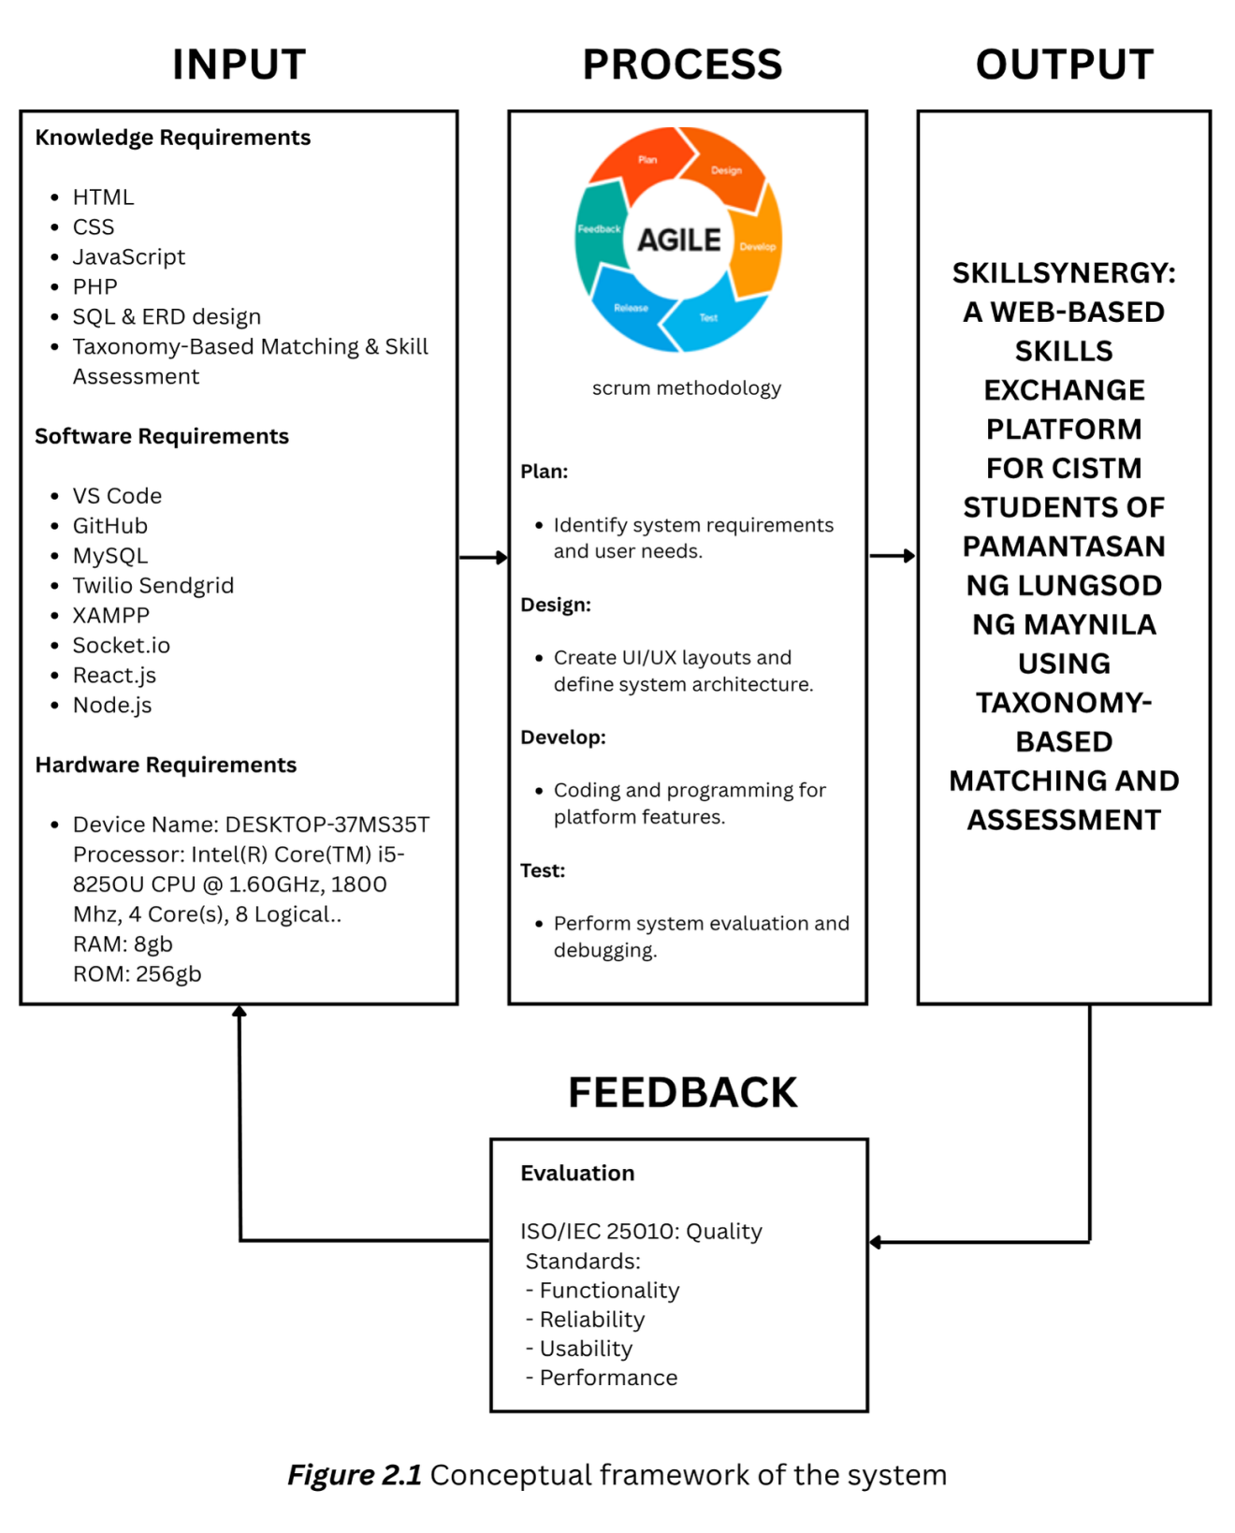

***Figure 2.1*** Conceptual framework of the system

This study applies the Input-Process-Output (IPO) model to structure the development of SkillSynergy, a web-based platform aimed at enhancing skill exchange among CISTM students at Pamantasan ng Lungsod ng Maynila.

The Input phase outlines the essential resources, including knowledge in HTML, CSS, JavaScript, PHP, MySQL, SQL, and taxonomy-based matching, along with software tools such as VS Code, GitHub, XAMPP, MySQL, SendGrid, React.js, Node.js, and Socket.IO. Hardware requirements include a development device with an Intel Core i5 processor, 8GB RAM, and 256GB of storage. The process follows the Agile Scrum methodology, which consists of iterative phases which are Plan, Design, Develop, and Test. During the planning phase, the team identifies system requirements and analyzes the user needs. The design phase involves creating UI/UX layouts and establishing the system architecture. Development focuses on programming and feature implementation based on the planned architecture. Finally, the testing phase evaluates the system’s performance through debugging and validation to ensure it meets its intended functions.

The output of this process is SkillSynergy: A Web-Based Skills Exchange Platform for CISTM Students of Pamantasan ng Lungsod ng Maynila Using Taxonomy-Based Matching and Assessment. This platform enables users to connect with peers, exchange skills, and find ideal skill-matching partners based on a taxonomy-driven assessment system that categorizes proficiency levels. The feedback system is based on the ISO/IEC 25010:2011 quality standards, focusing on functionality, reliability, usability, and performance. This evaluation process ensures that the system is continuously refined to meet user expectations and maintain high-quality software standards.

**Chapter Three**

**METHODOLOGY**

**3.1 Research Design**

This section describes the research design, which utilizes a **Descriptive Research Design** to examine how CISTM students engage in skill-sharing and to identify the essential features that promote effective collaboration. It aims to describe current behaviors, preferences, and challenges without manipulating any variables. To achieve this, the research integrates **quantitative methods** such as surveys and system analytics with **qualitative feedback** to obtain both measurable data and deeper user insights. Guided by an agile development approach, the study emphasizes iterative testing, continuous user involvement, and ongoing enhancements to ensure the platform remains effective, reliable, and aligned with user needs.

**3.1.1 System Flowchart**

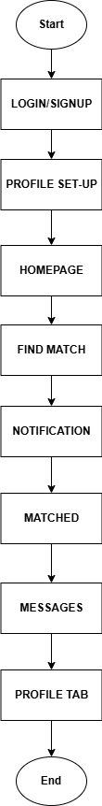 ***Figure 3.1.1*** System Flowchart for Main Functions

In Figure 3.1.1, the flowchart illustrates the whole process of using a system. The first step involves logging in or signing up to the platform. Once the user completes the login/signup, they proceed to set up their profile. After the profile is set up, the user is directed to the homepage. From the homepage, the user searches for a match. Once a match is found, a notification is received, and the user is shown their matched profile. Following that, the user can send and receive messages. Lastly, the user can view their profile tab to review or edit their information.

**3.1.2 System Flowchart per Process**

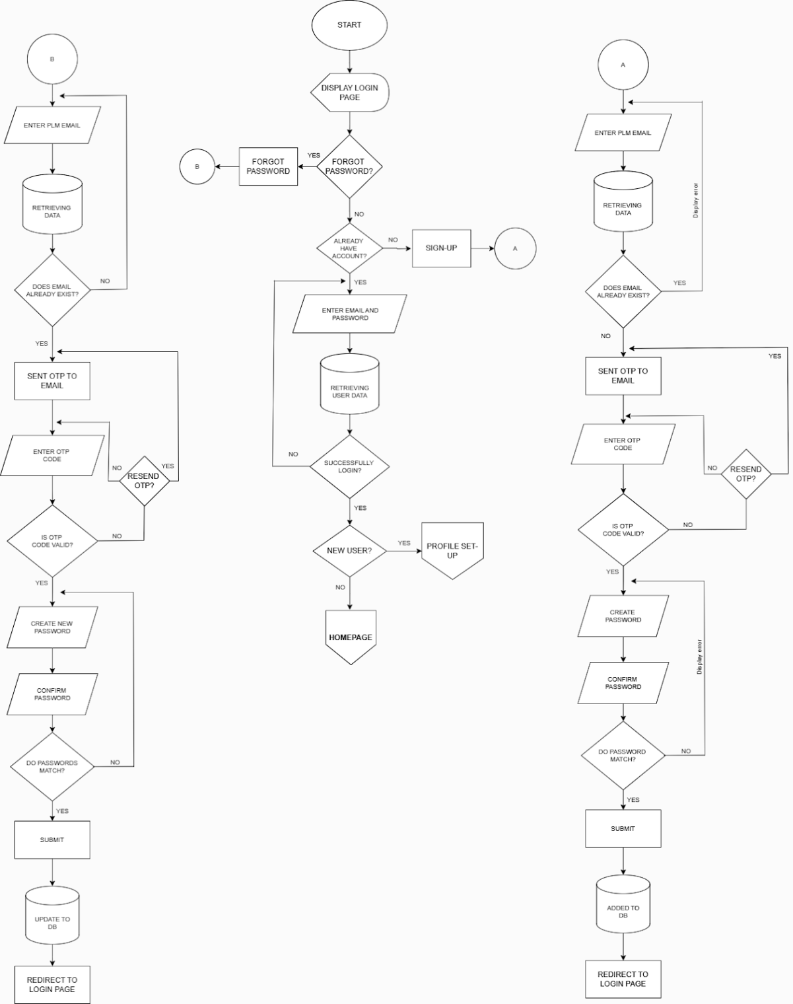

***Figure 3.1.2*** System Flowchart of Log-in, Sign-up and Forgot Password

In Figure 3.1.2, the flowchart illustrates the process for logging in or signing up on a platform. It begins by displaying the login page, where the user is presented with the option to either log in or recover a forgotten password. If the user selects the "Forgot Password" option, they are prompted to enter their email address. The system then checks whether the provided email already exists in the database. If the email is found, an OTP (One-Time Password) is sent to the user's email. The user must then enter the OTP code to proceed. If the entered OTP code is valid, the user is prompted to create and confirm a new password. If the passwords do not match, the system prompts the user to try again. Once the passwords match, the system updates the database and redirects the user back to the login page. If the OTP is invalid, the system asks the user if they would like to resend the OTP. In cases where the email does not exist in the database, the system displays an error message. For users who do not have an account, the flowchart directs them to the sign-up process, where they enter their email and create a password. If the email is already associated with an existing account, they are prompted to enter a new email. Once the sign-up process is completed, the new user is added to the database, and they are redirected to the login page.

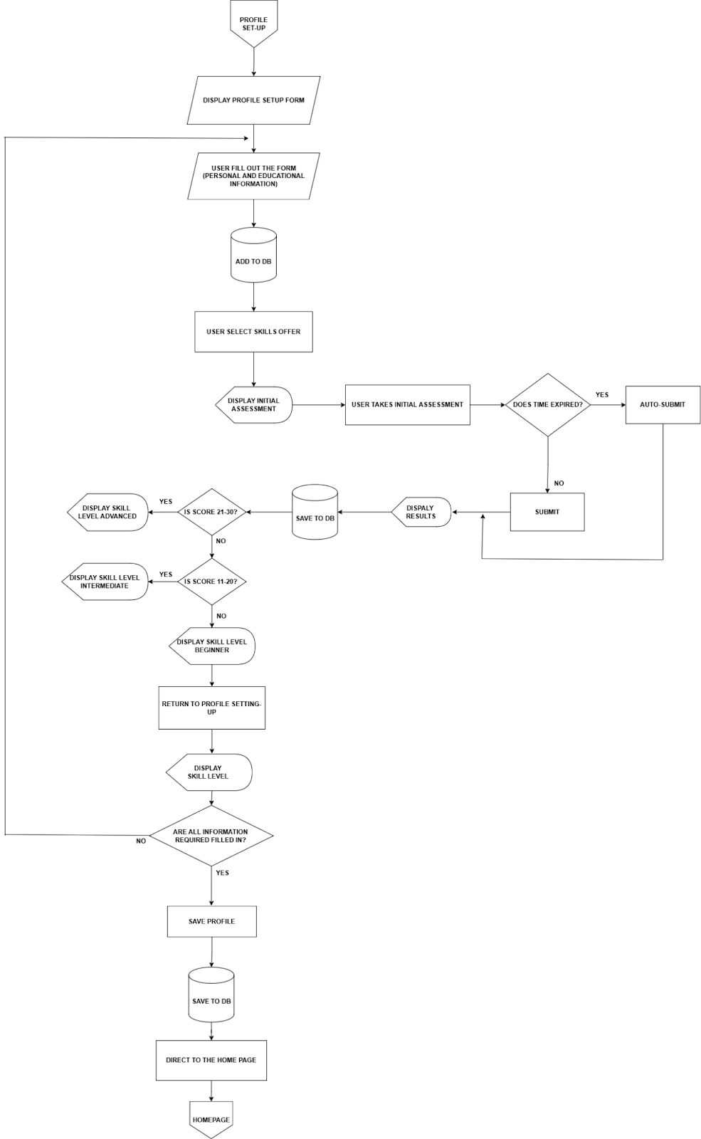

***Figure 3.1.3*** System Flowchart of Profile Setup

In Figure 3.1.3, the flowchart outlines the process for setting up a user profile; including data entry, initial assessment, and skill level determination. The process begins with the user filling out their profile setup form, including personal and educational information, which is saved to a database. Next, the user selects a skill offer, followed by an initial assessment. Based on the user's score, their skill level is displayed, categorized into beginner, intermediate, or advanced. After submitting their information, the user is directed to the homepage.

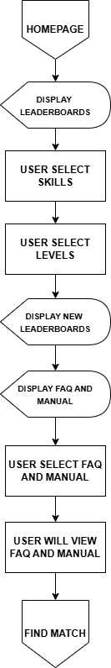

***Figure 3.1.4*** System Flowchart of Homepage/Landing Page

In Figure 3.1.4 flowchart outlines the steps taken by a user navigating through a platform. Starting at the homepage, the process moves to the display of leaderboards. From there, the user selects their skills and levels. Once those selections are made, new leaderboards are displayed, followed by the presentation of the FAQ and manual. The user then selects a FAQ or manual option and proceeds to view it. Then they can proceed to finding a match based on the selections made.

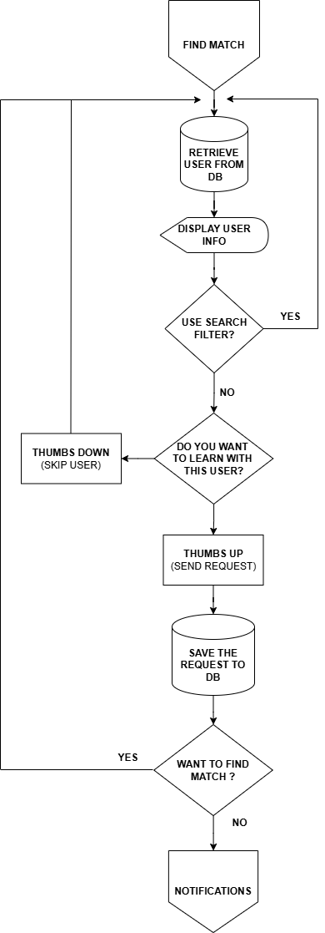

***Figure 3.1.5*** System Flowchart of Find Match

In Figure 3.1.5, the flowchart demonstrates the process of finding a match through a user database. It begins by retrieving a user from the database and displaying their information. Next, the user is prompted to use a search filter to narrow down potential matches. If the user chooses not to use a filter, they are asked whether they want to learn with the current user. If they express interest, the request is sent and saved in the database. The user is then asked if they want to continue searching for more matches. If they do, the process repeats; if not, notifications are sent, concluding the process.

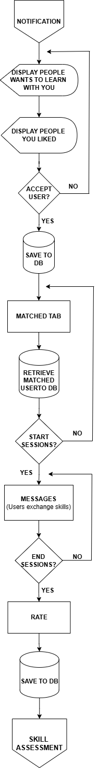

***Figure 3.1.6*** System Flowchart of Notification, Messages & Matched

In Figure 3.1.6, the flowchart outlines the process for completing a skill assessment. It starts by taking the assessment, where the user selects their skill level (Beginner, Intermediate, or Advanced). Depending on the choice, the appropriate difficulty level is set. After this, the assessment begins with multiple-choice questions, debugging tasks, and coding challenges. Time is monitored, and once the time expires, the assessment is automatically submitted. The results are displayed, and if the skill was passed, the results are stored in the database. If the user wants to retake the assessment, they must wait two days unless the limit has been reached. If the user attempts to retake the assessment after two days and still does not pass, they are prompted to wait another two days. If the user passes, they are asked if they would like to take a different skill or continue with their profile tab.

**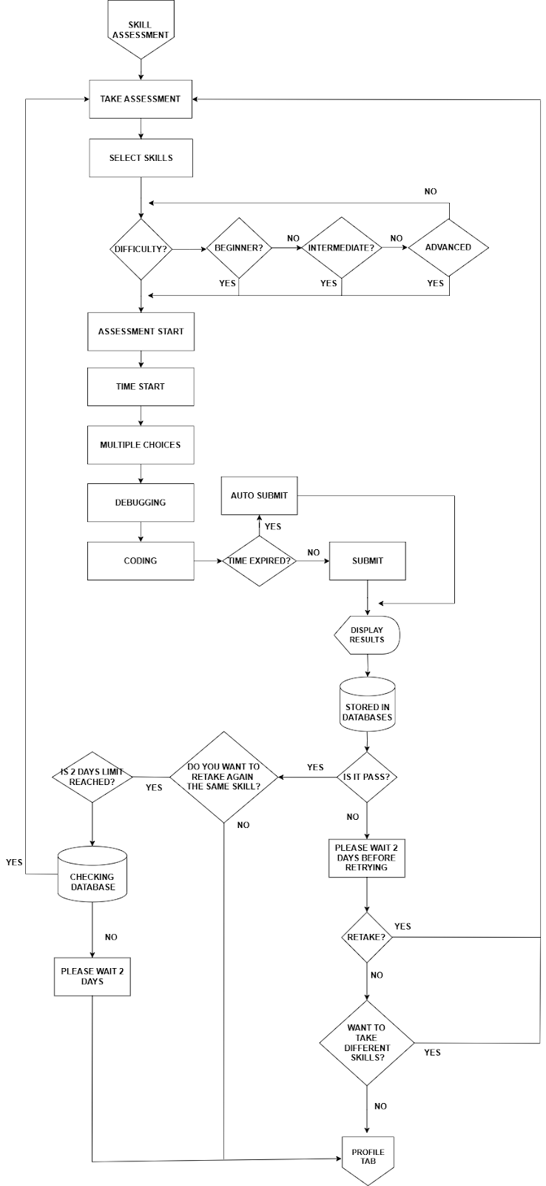 *Figure 3.1.7*** System Flowchart of Skill Assessment

In Figure 3.1.7, the process within the "Find Match" feature of an application. When a user opens the "Find Match" tab, people with active accounts along with their information and listed skills are displayed. The user has the option to use a search filter to narrow down the results based on their preferences. Once the list is refined or left as-is, the user can browse through the profiles. For each profile viewed, the user chooses to either give a thumbs up if they are interested in matching/learning or a thumbs down if not. If the user gives a thumbs up, a match request is sent; if thumbs down, the system simply proceeds to the next profile. This process continues until the user no longer wants to continue browsing profiles, at which point the session ends. The flow ensures a smooth and interactive user experience while allowing personalized searching and decision-making in finding potential matches.

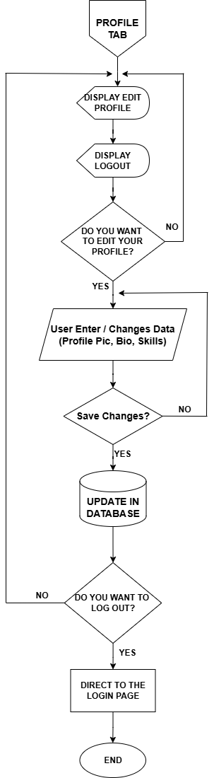

***Figure 3.1.8*** System Flowchart of Edit Profile

In Figure 3.1.8, the flowchart illustrates the process of editing a user profile in a system. It begins with the user accessing the profile tab, where they are presented with options to either edit their profile or log out. If the user chooses to edit their profile, they are prompted to input or modify their profile picture, bio, and skills. Once the user has entered the desired changes, the system asks whether they want to save the changes. If the user decides to save, the system updates the database with the new information. Afterward, the user is asked whether they want to log out. If the user confirms, they are directed to the login page. If they choose not to log out, the process ends without further action.

**3.1.1.1 System in Pseudocode as a whole process**

START

Display_Login_or_Signup()

Display_Profile_Setup()

Display_Homepage()

Display_Find_Match()

IF Match_Found THEN

Display_Notification()

Display_Matched()

Display_Messages()

END IF

Display_Profile_Tab()

END

This Pseudocode starts by displaying the Login/Signup process, where the user either logs into their account or signs up if they are a new user. After the login or signup is completed, the Profile Setup is displayed, prompting the user to provide and customize their profile information. Once the profile setup is finished, the Homepage is displayed, where the user can explore the platform. The user then proceeds to Find Match, where they search for a potential match based on their preferences. If a match is found, the system triggers a Notification to inform the user about the match, and the Matched Profile is displayed to the user. After this, the user can engage in communication by sending and receiving messages through the Messages feature. Finally, the Profile Tab is available, allowing the user to view and update their profile information whenever they choose.

**3.1.1.2 System in Pseudocode per Process**

**Log-in, Sign-up and Forgot Password:**

START

Display Login Page

IF User clicks Forgot Password

Prompt for Email

Retrieve User Data

IF Email exists in Database

Send OTP to Email

Prompt for OTP Code

IF OTP Code is Valid

Prompt for New Password

Confirm New Password

IF Passwords Match

Update Database

Redirect to Login Page

ELSE

Display Error: Passwords Do Not Match

ELSE

Ask to Resend OTP

ELSE

Display Error: Email Not Found

IF User clicks Sign-Up

Prompt for Email and Password

IF Email Already Exists

Prompt User to Enter New Email

ELSE

Add to Database

Redirect to Login Page

END

This pseudocode begins with displaying the login page. If "Forgot Password" is selected, the user enters their email, and if it exists, an OTP is sent. After entering the OTP, the user creates and confirms a new password. If the passwords match, the system updates the database and redirects the user to the login page. If the email doesn't exist or the OTP is invalid, an error or retry prompt appears. In the sign-up process, if the email already exists, the user is prompted to provide a new one. Once a valid email is entered, the user is added to the database and redirected to the login page.

**Profile Setup:**

START

Display Profile Setup Form

User fills out form with personal and educational info

Save info to database

User selects skill offer

Display Initial Assessment

User takes initial assessment

IF time expired THEN

Auto-submit the assessment

ELSE

Wait for user to submit

END IF

Save results to database

Display skill level based on score:

IF score > 20 THEN

Display Advanced Skill Level

ELSE IF score > 10 THEN

Display Intermediate Skill Level

ELSE

Display Beginner Skill Level

END IF

Save profile to database

Display skill level

IF all information is complete THEN

Save Profile

Save to database

Direct user to homepage

ELSE

Prompt user to fill in missing information

END IF

END

This pseudocode describes the flow of user profile creation, skill assessment, and redirection to the homepage after the successful submission of all required information. It automates the process of evaluating and categorizing the user's skill level based on the results of the initial assessment.

**Homepage/Landing Page:**

START

DISPLAY Homepage

DISPLAY Leaderboards

USER selects Skills

USER selects Levels

DISPLAY New Leaderboards

DISPLAY FAQ and Manual

USER selects FAQ and Manual

USER views FAQ and Manual

FIND Match

END

This pseudocode mirrors the flowchart by outlining the sequence of steps from start to finish. The process begins with displaying the homepage and progresses through the selections of skills and levels. After displaying the updated leaderboards and FAQs, the user can view the chosen manual and find a match accordingly.

**Find Match:**

Start

FIND MATCH

Retrieve user from DB

Display user info

Ask: Use search filter?

If YES, Apply search filter

If NO, Continue without filter

Ask: Do you want to learn with this user?

If YES,

Send request (Thumbs Up)

Save request to DB

Ask: Want to find match?

If YES, Repeat process

If NO, Send notifications

End

This pseudocode represents the steps in the flowchart. The process starts by retrieving a user from the database and displaying their information. The program then checks if the user wants to use a search filter. If they don't, it proceeds without filtering. Next, the user is asked if they are interested in learning with the current match. If yes, the request is sent and saved. Afterward, the user is asked whether they want to find another match. If they do, the process repeats; if not, notifications are triggered to end the process.

**Notification, Messages & Matched:**

START

NOTIFICATION -> Display people who want to learn with user

DISPLAY liked users

IF user accepts a person THEN

SAVE user to DB

END IF

DISPLAY matched tab

RETRIEVE matched user from DB

IF user starts session THEN

EXCHANGE skills via messages

IF session ends THEN

RATE session

SAVE rating to DB

END IF

END IF

SKILL ASSESSMENT

END

This pseudocode illustrates the flow of the process described in the flowchart. It begins with a notification that alerts the user about others who want to learn with them. After displaying the liked users, the user decides to accept someone, and their information is saved to the database. Then, the matched users' data is retrieved, and the user can choose whether to start a session. During the session, skills are exchanged, and when the session ends, the user rates the

session. Finally, the rating is saved to the database, and the process concludes with a skill assessment.

**Skill Assessment:**

START

DISPLAY skill assessment options

SELECT skill level (Beginner, Intermediate, Advanced)

START timer

TAKE assessment (Multiple-choice, Debugging, Coding)

IF time expires THEN

AUTO submit assessment

END IF

DISPLAY results

IF user passes THEN

ASK if they want to retake the assessment

IF YES THEN

RETAKE assessment

ELSE

GO to profile tab

END IF

ELSE

CHECK if 2-day limit is reached

IF 2-day limit reached THEN

DISPLAY "Please wait 2 days before retrying"

ELSE

ASK if they want to retry after 2 days

IF YES THEN

WAIT for 2 days and RETRY assessment

ELSE

GO to profile tab

END IF

END IF

END IF

END

This pseudocode flow starts by displaying the skill assessment options where the user selects their skill level (Beginner, Intermediate, or Advanced). The assessment begins with a timer and includes multiple-choice, debugging, and

coding tasks. If the time expires, the assessment is automatically submitted. The results are displayed, and if the user passes, they can either retake the assessment or go to their profile. If the user fails, the system checks if the 2-day limit for retrying is reached. If not, the user is asked to wait for 2 days before retrying. If the limit is reached, the user must wait and retry later or proceed to their profile.

**Edit Profile:**

START

Display Profile Tab

Display Edit Profile Option

Display Logout Option

If User Chooses to Edit Profile:

Prompt User to Enter or Change Profile Picture, Bio, and Skills

Ask User to Save Changes

If User Chooses to Save:

Update Database with New Information

End If

End If

Ask User if They Want to Log Out

If User Chooses to Log Out:

Redirect to Login Page

End If

END

This pseudocode outlines the process of editing a user profile. First, it presents the profile tab with options for editing the profile or logging out. If the user opts to edit their profile, they are asked to update their profile picture, bio, and skills. After making changes, the system prompts the user to save the updates. If the user agrees to save, the changes are stored in the database. The system then checks if the user wants to log out, and if so, redirects them to the login page. If the user does not want to log out, the process ends.

**3.2 System Architecture**

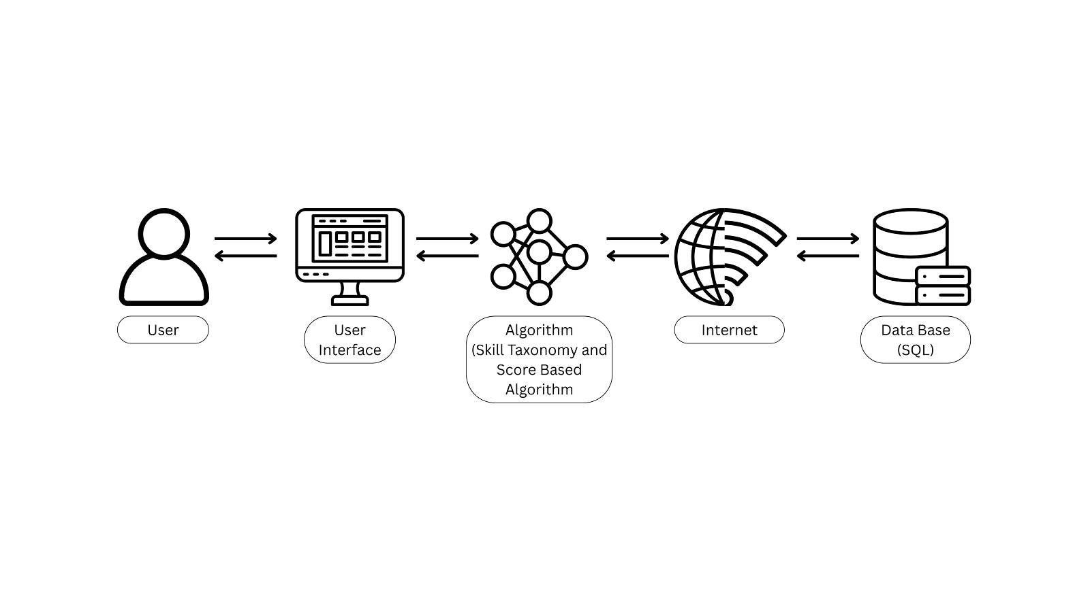The system architecture is designed for scalability, security, and efficiency, featuring a layered structure with separate modules for user management, data processing, and real-time communication. It ensures optimal performance while maintaining data integrity and security. The components are seamlessly integrated to facilitate smooth user interactions and real-time updates throughout the platform.

***Figure 3.2*** System Architecture

In Figure 3.2, is designed to provide a seamless user experience by efficiently integrating different components. The user is the primary actor, interacting with the system through a browser. Upon accessing the platform, users engage with the user interface (UI), the front-end component, where they can log in, take assessments, view their results, and check for potential skill matches with other users. The UI acts as the central hub for all user interactions, providing an intuitive platform for navigating through various features of the system.

Behind the scenes, the algorithm plays a crucial role in processing user input and ensuring users are connected with appropriate peers. The skill taxonomy matching

algorithm filters users based on their preference. Additionally, a score-based algorithm drives the leaderboard, calculating rankings based on the users’ assessment result. This adds a competitive element and encourages users to continuously improve their skills. These algorithms rely on data from the backend to generate meaningful and accurate matches, as well as to maintain a dynamic leaderboard.

The internet serves as the medium for communication between the user interface and the back-end system. It ensures that user actions, such as submitting assessments or requesting matches, are transmitted between the front-end and the back-end logic, which processes the data accordingly. All system data, including user profiles, assessments, matches, and leaderboards, are stored in a SQL database. This database is the backbone of the system, providing organized storage for all persistent information. It ensures that user data is easily retrievable and updated, making it an essential part of the system's functionality.

In summary, the SkillSynergy system is built on a robust architecture where the UI provides a user-friendly interface for interaction, the algorithm ensures efficient skill matching and leaderboard ranking, and the database serves as the storage for all critical data. The entire system relies on the internet to facilitate seamless communication between the front-end and back-end, ensuring that user requests and updates are processed efficiently.

**3.2.1 User Interface**



***Figure 3.2.1*** Sign-up Page for Validation

In Figure 3.2.1, illustrates the process where the user is required to enter their PLM email address to verify their identity as a student of Pamantasan ng Lungsod ng Maynila. After submitting a valid email, the system sends a One-Time Password (OTP) to the user’s inbox. The user must then enter the received OTP to proceed with account creation.



***Figure 3.2.2*** Sign-up Page for Creating Account

In Figure 3.2.2, illustrates the final steps in registering for the SkillSynergy system. After successful email and OTP verification, users are guided to create and confirm their password. Completing this step finalizes the account creation process and grants access to the platform.



***Figure 3.2.3*** Log-in Page

In Figure 3.2.3, illustrates the login process following successful account creation. To access the system, users must enter their PLM email address as the username and the password they set during registration.

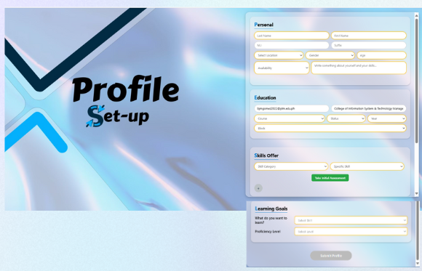

***Figure 3.2.4*** Profile Set-up Page

In Figure 3.2.4, illustrates the next step after logging in, where users are prompted to provide their personal information, educational background, the skills they are offering to share, and the learning goals they want to learn along with their proficiency level (Beginner, Intermediate, or Advanced). To complete the profile setup, users are also required to undergo an initial assessment to determine their actual skill proficiency level.

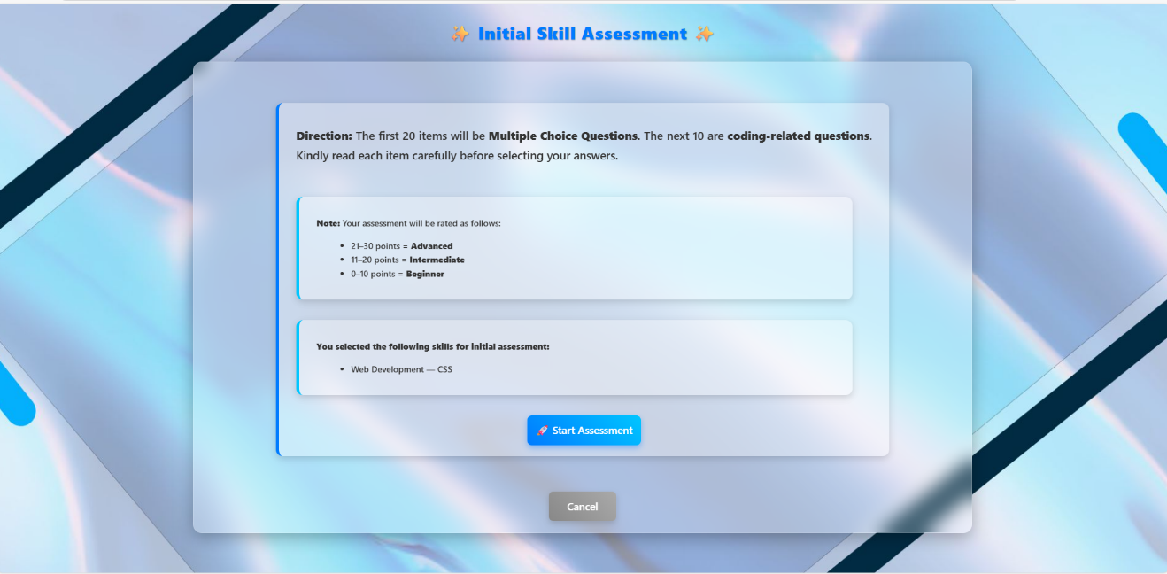

***Figure 3.2.5*** Initial Assessment Direction

In Figure 3.2.5, direction appears after the user clicks "Take the Assessment." It provides guidance and reminders to encourage users to answer the assessment questions carefully and thoughtfully.

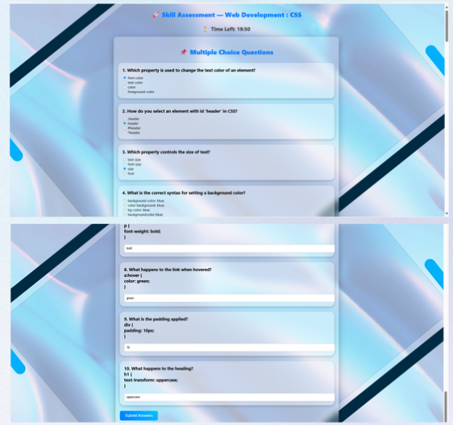

***Figure 3.2.6*** Initial Assessment

In Figure 3.2.6, displays the content of the assessment, which consists of multiple-choice questions with a total of up to 30 items. The assessment is timed, with a 45-minute limit. Users have the option to submit their answers early, on time, or after the time limit. Once submitted, the system evaluates the responses and determines the user's expertise level: beginner, intermediate, or advanced.

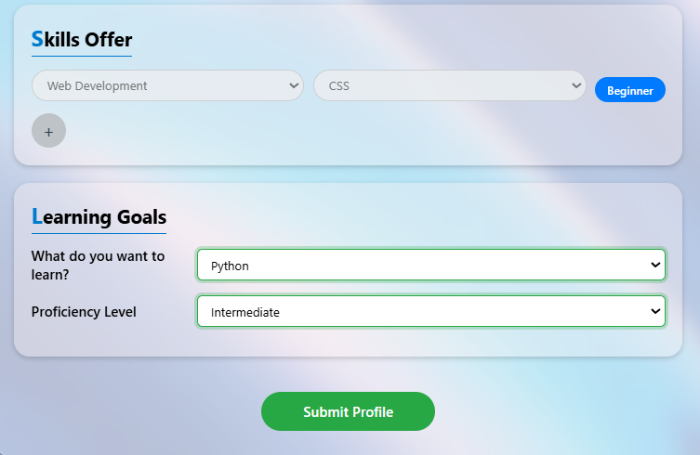

***Figure 3.2.7*** Submit in Profile Set-up Page

In Figure 3.2.7, shows the submit button that becomes available after completing the assessment. If any required fields are left unfilled, the form cannot be submitted, even after taking the assessment, and an error message will appear. However, if all fields are completed, the profile setup can be successfully submitted.

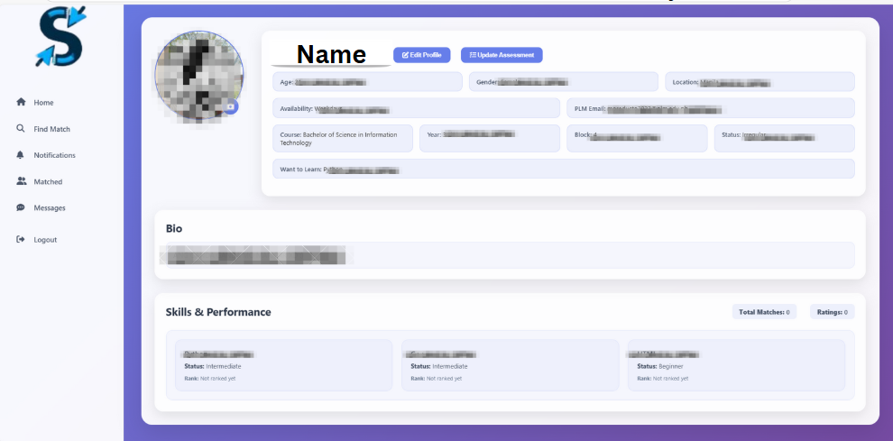

***Figure 3.2.8*** Profile Page for Display Edit Information

In Figure 3.2.8, displays the user's complete profile information including personal details, educational background, availability, and learning preferences. It also features a section for bio, skills and performance, as well as profile management options like editing the profile and updating the assessment.

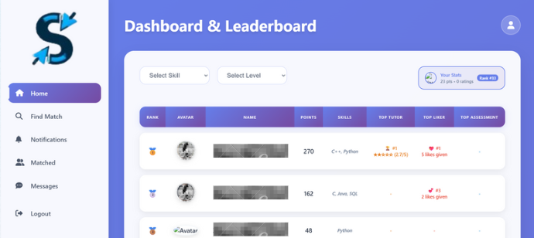

***Figure 3.2.9*** Dashboard for General Skill Ranking

In Figure 3.2.9, A Select Skill dropdown menu allows users to view rankings for specific skills. While a Select Level is to view what is their rank based on their level proficiency. On the left side, the Navigation Tab provides access to additional functionalities and features. Users can also use FAQs and the user MANUAL for guidance. This interface presents a structured overview of user rankings based on accumulated points, demonstrated skills, tutor performance, engagement through likes, and assessment outcomes. The leaderboard includes filtering options by skill and proficiency level, enabling comparative analysis of user performance within the system.

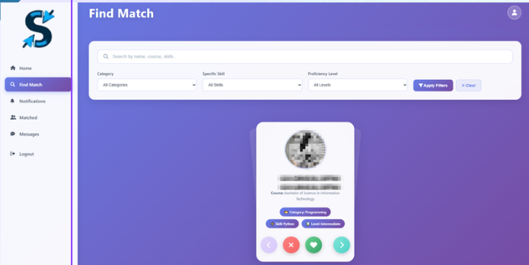

***Figure 3.2.10*** Find Match Tab with Filters

In Figure 3.2.15, illustrates the Find Match Tab, which serves as the main focus of this system. The tab enhances user interaction by allowing users to view profile pictures and information to help decide if the person is a suitable match. Below the user's information, x and heart buttons are incorporated for easy matches. This feature is designed to connect users based on their preferred skills to learn and the skills they offer. Additionally, a search bar and a filter are provided to allow users to easily find individuals who match their specific skill preferences.

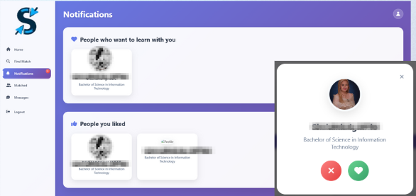

***Figure 3.2.11*** Notification Tab

In Figure 3.2.11, illustrates the Notification Tab. In this tab, users can view the section "People Who Want to Learn with You," which allows them to check the profile of individuals who wish to connect. When a user clicks on a specific person, their profile will pop up, displaying their information below. The user can then choose to connect and interact by clicking the "Like" (Heart) or "Dislike" (x) button. The "People You Liked" section shows the users whom the current user has liked or wants to match with. Both sections can be empty, depending on the user's actions. This feature provides users with an overview of their interaction status with other members, enabling them to manage and respond to learning requests or mutual interests efficiently.

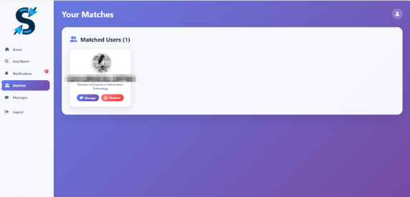

***Figure 3.2.12*** Matched Tab

In Figure 3.2.12, illustrates the Matched Tab, where all matched users are stored. Matched Users interface displaying the list of users with whom a successful match has been made. Each matched profile includes options to send a message or remove the match, allowing users to initiate communication or manage their connections within the platform. There is no limit to how long matched users are stored, whether it’s a week or several months. It is up to the user to decide if they want to delete a matched user, either after a session or at any time.

***Figure 3.2.20*** Message Tab

In Figure 3.2.20, illustrates the Message Tab. When a user starts a session, the system will display the message: “This person has [skill], he/she is (B, I, A). Choose what skill do you want to learn from this person.” The skills offered by the matched user will appear as clickable buttons, allowing the user to select which skill they wish to learn from the matched user.

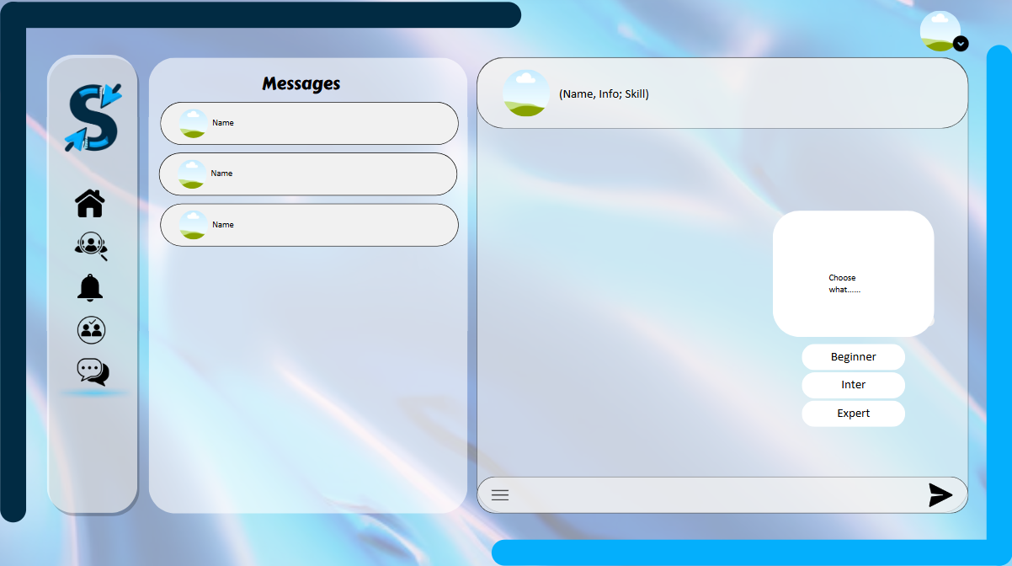

***Figure 3.2.21*** Message Tab for Level of Difficulty

In Figure 3.2.21, illustrates the Message Tab for Level of Difficulty. After the user selects the skill they wish to learn, the system will display a prompt message: "Choose what level of difficulty you want to learn from this person." The user can then select from Beginner, Intermediate, or Advanced/Expert, depending on their learning preference. This allows the session to be tailored based on the user’s current needs and the matched user’s capability.

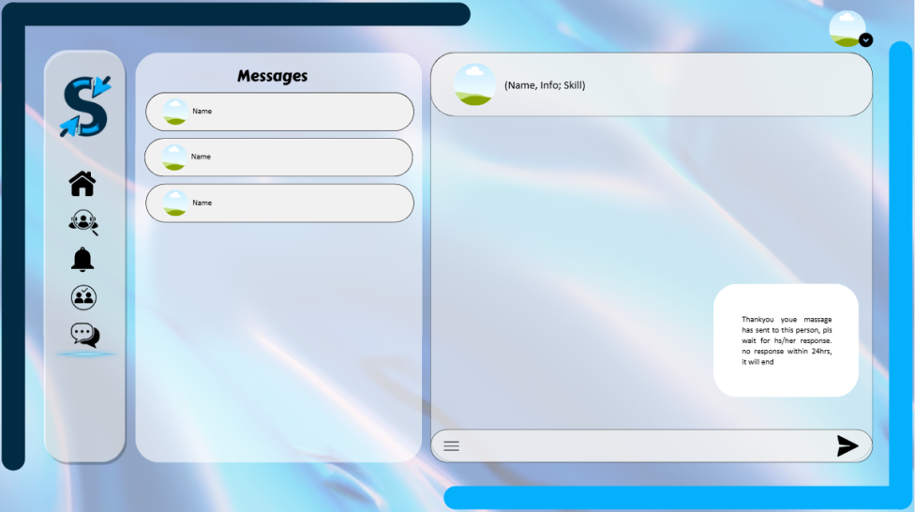

***Figure 3.2.22*** Message Tab for Waiting Response

In Figure 3.2.22, illustrates the Message Tab for Waiting Response. After the user has selected the desired skill and level of difficulty, the system will display a thank-you message and inform the user to wait for the matched user’s response. If the matched user does not respond within 24 hours, the session request will automatically expire and end.

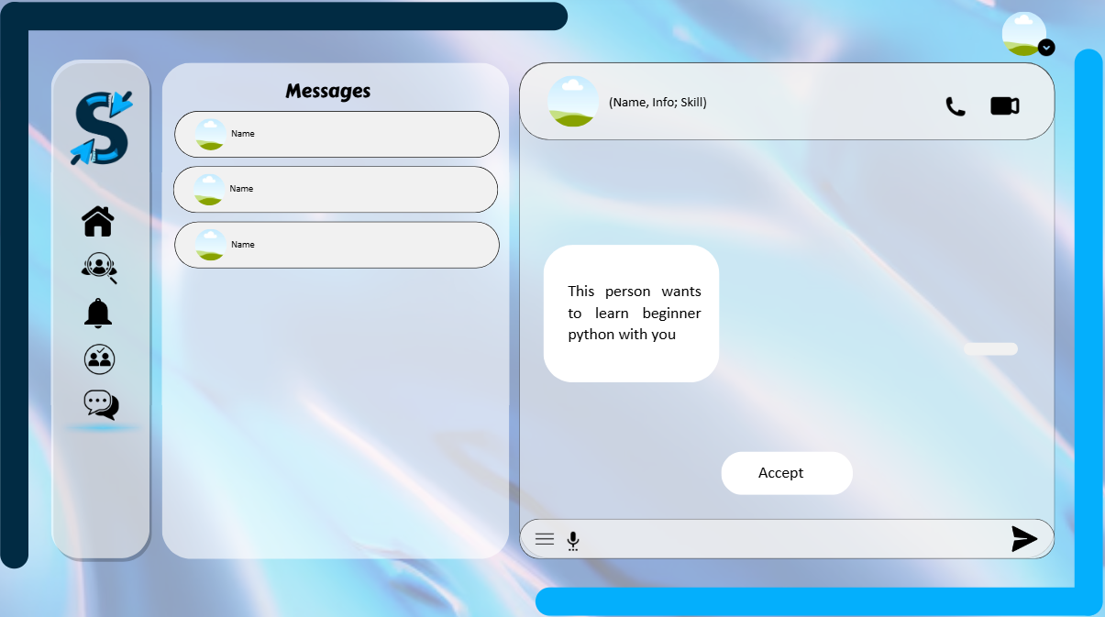

***Figure 3.2.23*** Message Tab for Matched User’s POV

In Figure 3.2.23, describes the Message Tab from the Matched User’s Point of View (POV). When the matched user receives a message from the user, the conversation interface will appear with a message such as, “This person wants to learn Beginner Python with you.” The matched user can choose to accept the session request by clicking a prompt button like “Accept” to initiate the interaction. Alternatively, if the matched user chooses not to respond, they may simply ignore the message, and the session request will automatically expire after the designated waiting period.

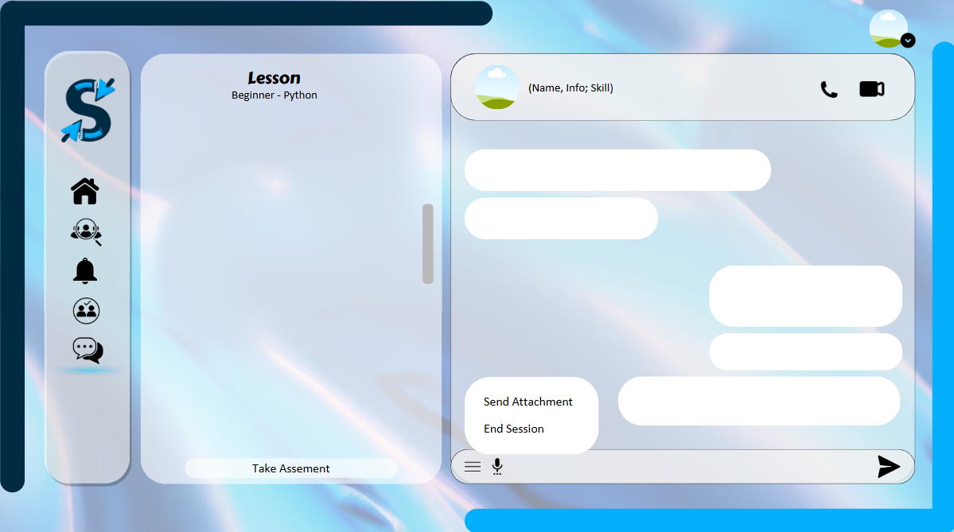

***Figure 3.2.24*** Message Tab for Menu Chat

In Figure 3.2.24, presents the Message Tab with Menu Options and Lesson holder on the left side, which both of them can see the provided lesson or topics and the system will also provide an activity for that, like assessment for monitoring on the lesson they want to learn or offer (tutor). Once both users have initiated a conversation, they can exchange messages and also send files or pictures by clicking the "Send Attachment" option in the menu. Additionally, users can set a schedule to start learning from each other, choosing their preferred mode of interaction whether through an online platform or face-to-face teaching.

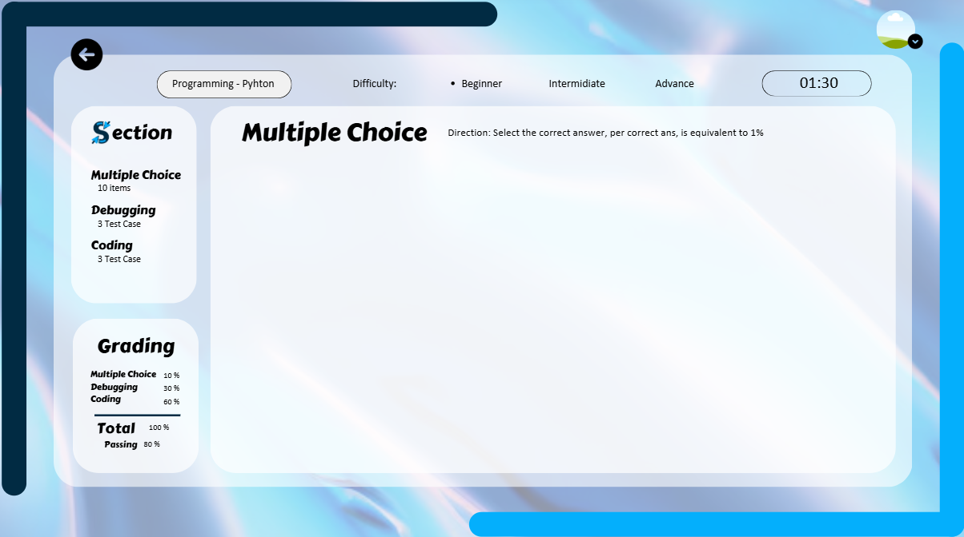

***Figure 3.2.25*** Assessment for Beginner

Figure 3.2.25, shows the assessment process for the Beginner level. The assessment for Beginners is limited to 1 minute and 30 seconds, and it consists of three types of question formats. It also displays the grading point system, indicating the passing score and failing grade. For the Intermediate and Advanced levels, users will have less time compared to the Beginner level, providing a more time-pressured experience. After selecting the level of difficulty, users who choose Beginner will first read the directions before starting the assessment.

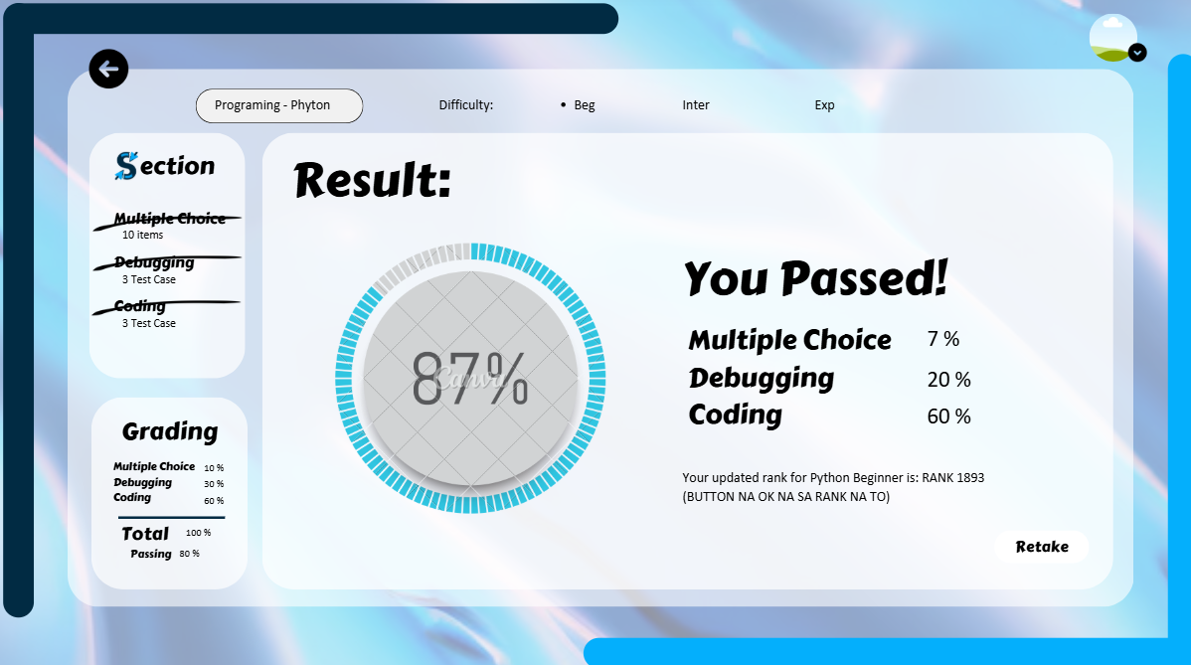

***Figure 3.2.26*** Assessment Result

In Figure 3.2.26, it shows the assessment result page, which appears after completing the assessment. If the user passes, they will have the option to retake the assessment and/or if they feel unsatisfied with their score, they can retake even though they have passed. If the user fails, they must retake the assessment to achieve a passing score. Regardless of whether the result is a pass or fail, the outcome will determine whether the user will be ranked and contribute to leveling up their proficiency.

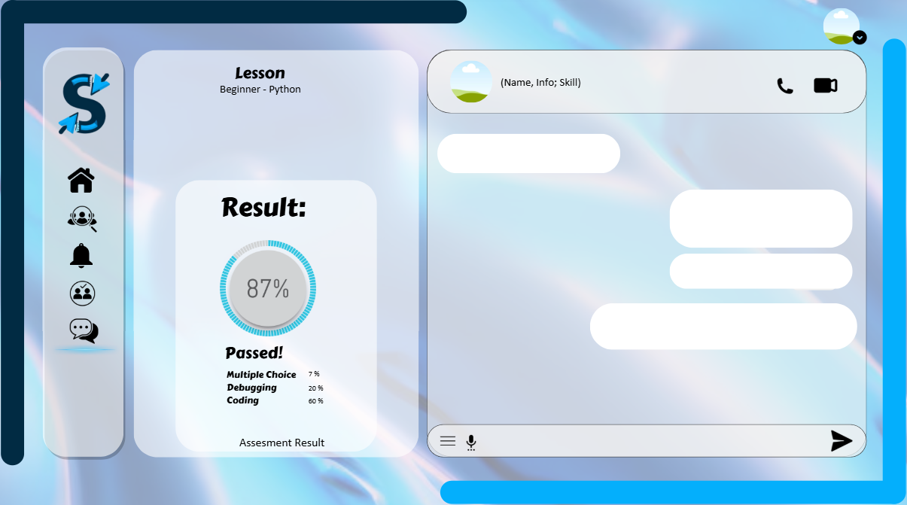

***Figure 3.2.27*** Message Tab with Assessment Result

In Figure 3.2.27, after taking the assessment, the lesson holder on the left stay still but the result will display there for monitoring of what is the result and need to improve or up to them if they will continue after the result is done. Again, if they wish to end the session, they can do so by clicking the "End Session" button.

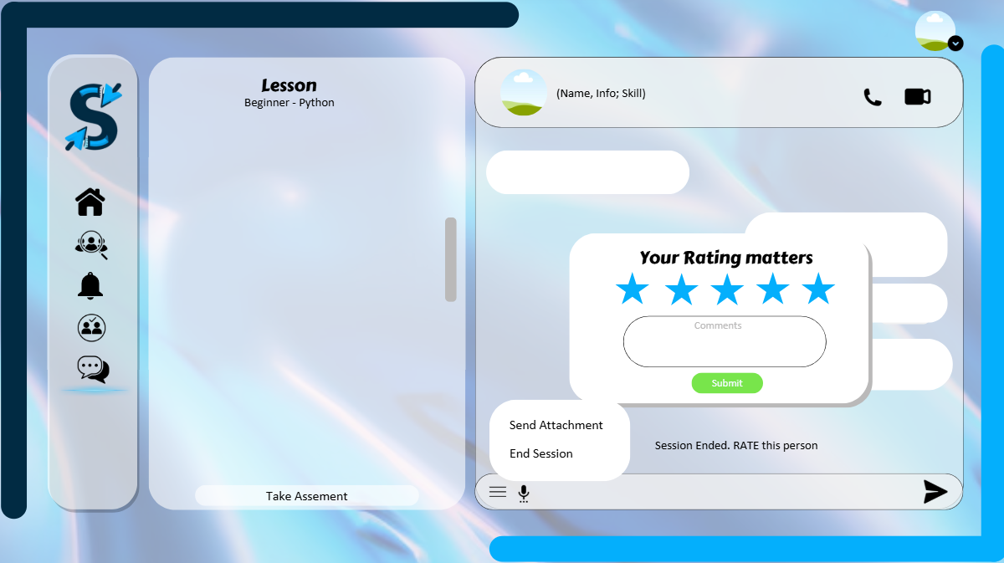

***Figure 3.2.28*** Rating inMessage Tab

In Figure 3.2.28, shows the Rating Feature in the Message Tab. After users have set a schedule, had a conversation, and shared files, they can choose to end the session. Once the session ends, the system will prompt both the user and the matched user to give a rating. Providing a rating is required, as it plays a key role in improving the matchmaking process and increasing user visibility. Comments are optional, as not all users may prefer to leave written feedback.

**3.3 System Requirements**

**a. Hardware**

**Laptop** – The development setup utilizes the device DESKTOP-37MS35T, powered by an Intel® Core™ i5-8250U processor with a base frequency of 1.60GHz and a turbo boost up to 1.80GHz. It is equipped with 4 cores and 8 threads, 8GB of RAM, and a 256GB SSD for efficient performance and storage. A stable internet connection ensures smooth and uninterrupted development and testing activities.

**b. Software**

**VS Code** – Used to write and debug HTML, CSS, JavaScript, React.js, PHP, and SQL for efficient development of the web application.

**GitHub** – Used to manage project code, enable collaboration among team members, track changes, and maintain a centralized code repository.

**MySQL** – Used to store and manage data such as user profiles, skill records, assessments, and leaderboard information.

**Node.js** - Used to run the backend server that handles real-time chat and notification features in SkillSynergy.

**Socket.IO** - Implements the live chat and real-time notifications by managing WebSocket connections within the platform.

**SendGrid** – Used for sending email verifications and OTPs to users during account registration.

**XAMPP** – Used to run and test the website locally on a computer.

**React.js** - Used to build a dynamic, responsive frontend for SkillSynergy, enabling real-time updates and interactive features like live chat, skill matchmaking, and notifications

**3.4 Methods and Tools**

To address the identified problems and fulfill the objectives of the study, the following methods and tools will be utilized in the development and implementation of SkillSynergy, a web-based skills exchange platform for Pamantasan ng Lungsod ng Maynila (PLM) College of Information Systems and Technology Management (CISTM) students:

To effectively connect PLM CISTM students for skill-sharing based on their interests and capabilities, the platform will use a **taxonomy-based matching system**. This system organizes and classifies students' skills such as programming, design, or coding along with their proficiency levels (beginner, intermediate, or advanced) and personal learning preferences. During registration or assessment, students input the skills they can offer and the ones they want to learn. These details are stored in a **MySQL database**, which is managed through **phpMyAdmin** for ease of handling data. The **backend is developed using plain PHP**, where the matching logic compares users based on shared interests and complementary skills. On the **frontend**, users can view suggested matches and connect with others through an intuitive interface. By using a structured taxonomy instead of random pairing, the system ensures meaningful and goal-oriented connections between students making the skill-sharing experience more efficient and engaging.

The platform will leverage a combination of effective tools and technologies to facilitate a competitive leaderboard system and encourage active participation in skill-sharing activities. A score-based algorithm will track and rank students based on their involvement in skill-sharing sessions, feedback, and assessment results. MySQL will

store the relevant data to ensure real-time leaderboard updates. The leaderboard interface will be created using React.js, providing an interactive and responsive view of student rankings. Node.js will power the backend, ensuring seamless session management, while Socket.IO will handle real-time notifications, alerting students of any changes to their ranking or new session opportunities. These technologies will foster a competitive, yet supportive environment for continuous student participation and improvement.

To implement an effective assessment method for evaluating skill improvement and knowledge exchange, the platform will utilize an assessment-based evaluation system that combines quizzes, peer feedback, and performance tracking. After each ended session, users have the choice to take skill-related quizzes or not, depending on their preference. These quizzes are designed to measure understanding and reinforce learning, with results stored in MySQL to monitor progress consistently. Peer feedback will also be collected through session ratings and optional comments, providing valuable insights into each participant's strengths and areas for improvement. The results from quizzes and feedback will be processed using a score-based algorithm and reflected on the leaderboard, encouraging continuous engagement. The assessment interface will be built using React.js for a dynamic user experience, while PHP will handle quiz submissions and feedback processing. These tools work together to support a reliable and motivating evaluation system that enhances the learning journey of every student.

**3.4.1 Entity-Relationship Diagram (ERD)**

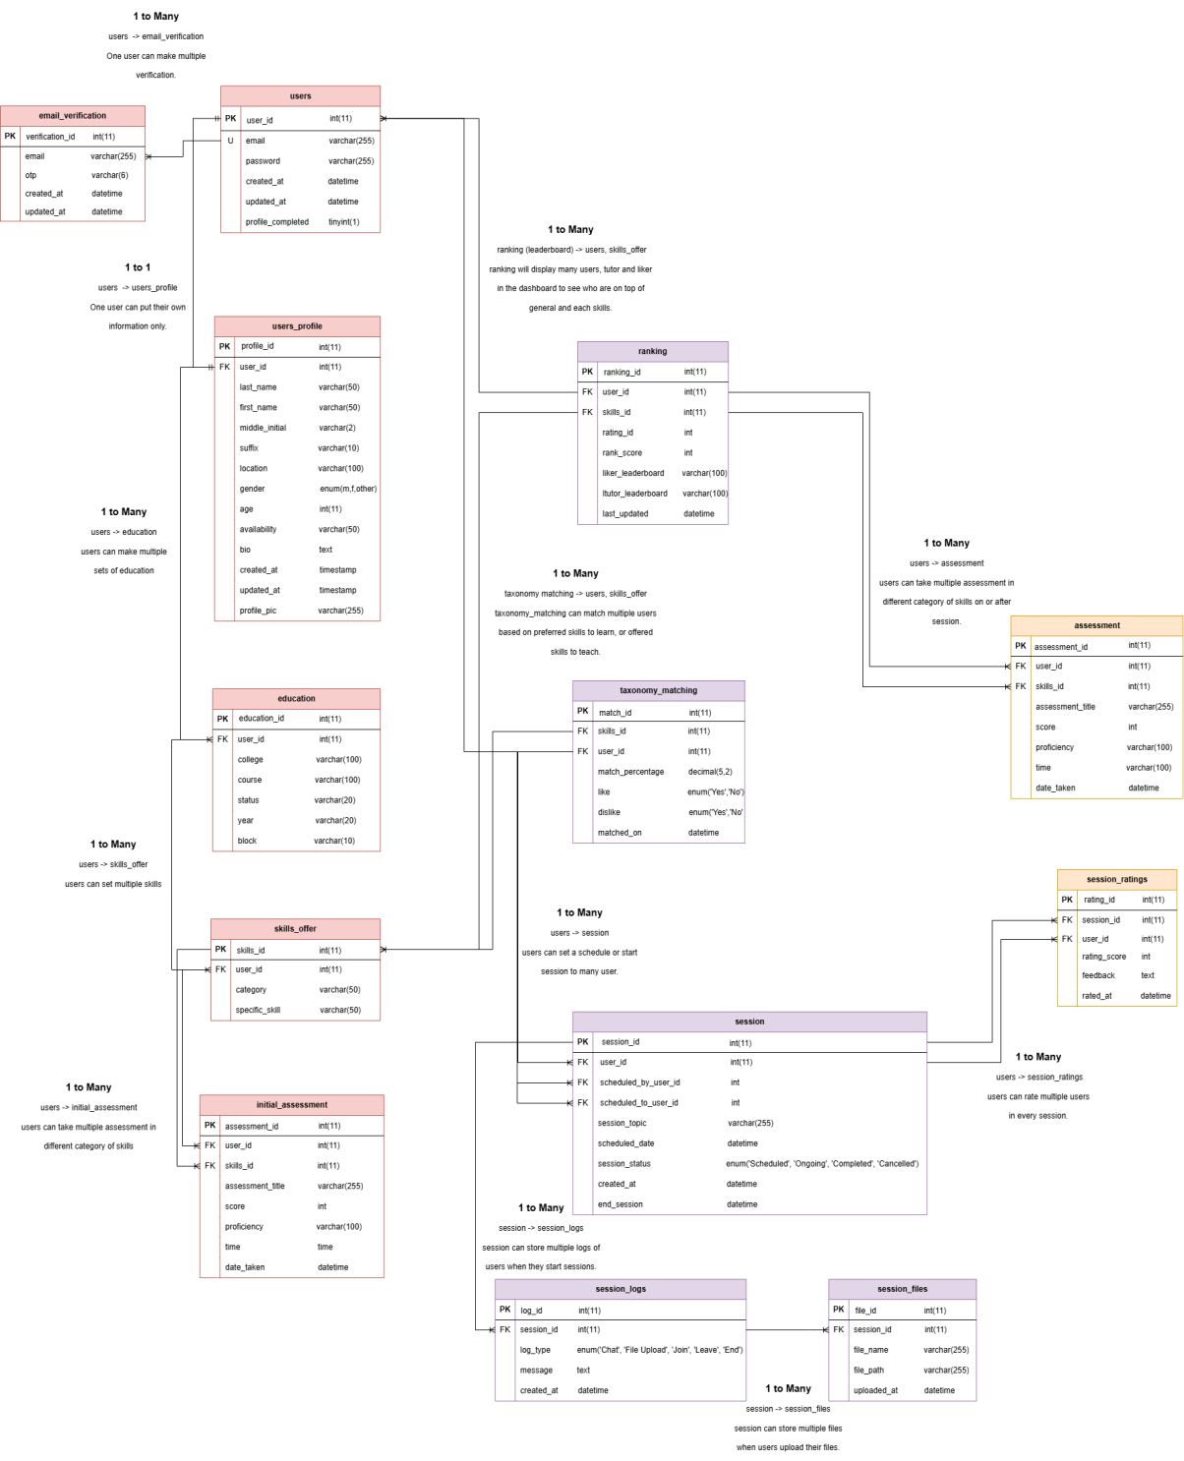

***Figure 3.4.1*** Entity-Relationship Diagram (ERD) for Skillsynergy System Main Functions

The Entity-Relationship Diagram (ERD) presented in Figure 3.4.1 illustrates the data structure and relational flow of the Skillsynergy system. This system is designed to handle various processes related to user management, skill offerings, assessments, taxonomy-based matching, session handling, and leaderboard tracking. At the core of the system is the users table, which manages user credentials, email, passwords, and profile status. It establishes one-to-many relationships with several key tables, ensuring that each user can maintain multiple records in modules such as email verification, skill offerings, assessments, and sessions.

The email_verification table is responsible for handling one-time password (OTP) transactions prior to registration or login attempts. This table is related to the users table through the email field but allows multiple verification attempts per email address before a final registration occurs. Once registered, users can input their personal details in the users_profile table, which holds personal information like name, age, location, gender, bio, and profile picture. This relationship is strictly one-to-one, ensuring each user has a unique profile. For educational details, the system uses the education table, allowing users to submit multiple educational records through a one-to-many relationship. Skills that users wish to offer are managed in the skills_offer table, which supports multiple records per user and categorizes skills for structured matchmaking. Users are evaluated through two tables: initial_assessment for preliminary skill assessments and assessment for subsequent evaluations. Both tables store assessment results, scores, and timestamps, linked to both users and their offered skills through one-to-many relationships. Notably, the system integrates a score-based ranking algorithm within the assessment module, wherein users' assessment scores and proficiencies are automatically computed and updated to reflect their

competencies. These scores are used to calculate overall and skill-specific rankings in the ranking table, ensuring that users with higher scores are prioritized in leaderboards and skill matching processes. This scoring algorithm ensures a dynamic and merit-based evaluation mechanism that continuously updates a user's standing within the system. The taxonomy_matching table facilitates the system’s core skill matching feature by linking users to skills based on preferences, recorded match percentages, and mutual interest indicators. Ranking information is managed by the ranking table, which compiles scores and leaderboard standings for general users, tutors, and likers, also maintaining a one-to-many connection with both users and skills. This ranking dynamically adjusts based on assessment outcomes and session feedback. Skill-sharing sessions are handled through the session table, which records scheduled sessions between two users, session topics, dates, and status. Each session can store multiple logs in the session_logs table, which records actions like messages and session status updates, as well as files in the session_files table and ratings in the session_ratings table. These maintain one-to-many relationships with the session table to ensure proper session tracking and feedback collection.

In conclusion, the Entity-Relationship Diagram (ERD) developed for the Skillsynergy system presents a well-structured, modular, and scalable data architecture that comprehensively supports the platform’s core functionalities. It effectively organizes interrelated modules while maintaining strict relational integrity across all entities, ensuring consistency in data handling and user interaction processes. The ERD facilitates a dynamic and flexible environment for skill exchange, taxonomy-based matchmaking, session management, and collaborative learning within the system. Furthermore, the design promotes modularity, allowing for seamless future system enhancements and feature

integrations without compromising existing database relationships. Notably, the incorporation of a score-based ranking algorithm within the assessment and ranking components provides a data-driven and transparent mechanism for evaluating and comparing user skill proficiencies. This algorithm ensures fair and merit-based ranking updates, directly influencing matchmaking outcomes and leaderboard positions. Overall, the proposed ERD establishes a solid, efficient, and adaptable data foundation essential for the successful operation and continuous development of the Skillsynergy system.

**3.4.2 Data Flow Diagram (DFD)**

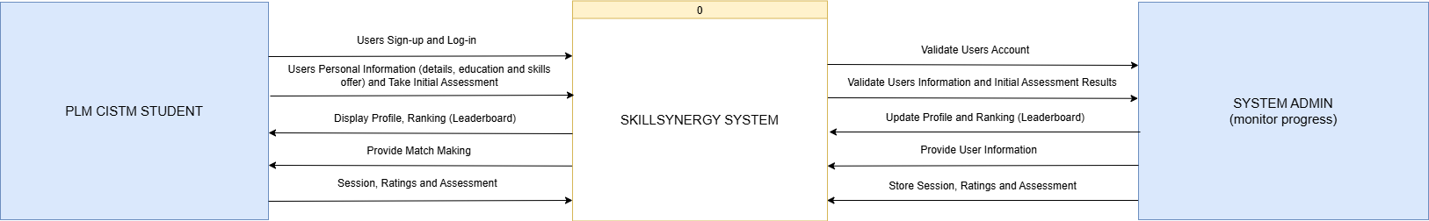By utilizing Data Flow Diagrams (DFD), the development of the SkillSynergy system ensures a clear and structured representation of how data moves within the platform. Using Sarson notation, the Level 0 DFD illustrates the overall flow of data between PLM CISTM Students, the System Administrator, and the SkillSynergy system, offering a high-level overview of the platform’s external interactions. Meanwhile, the Level 1 DFD provides a more detailed view by breaking down the system’s internal processes and showing how each function manages data. Ultimately, they serve as essential design tools in systematically organizing, clarifying, and refining the overall workflow and data interactions of the SkillSynergy system throughout its development lifecycle.

***Figure 3.4.2*** Level 0 Data Flow Diagram (Context Diagram)

The Data Flow Diagram (DFD) Level 0 presented in Figure 3.4.2 represents the entire SkillSynergy System as a single, unified process, denoted as Process 0. This high-level diagram illustrates the core interactions between the system and its two principal external entities: the PLM CISTM Students and the System Administrator. In accordance with standard DFD conventions, all internal operations are encapsulated within a single process to emphasize external data flows, while deferring the decomposition of internal components to more detailed diagram layers.

Within this model, PLM CISTM Students begin their interaction by signing up, logging in, and submitting their personal information, educational background, and skills, as well as taking an initial assessment to determine their proficiency level. These inputs are processed by the SkillSynergy System and transmitted to the System Administrator for verification to ensure completeness, accuracy, and eligibility before granting access to key system functionalities. Once verified, students may view and update their profiles, engage in skill-based matchmaking, and join or initiate collaborative sessions with their matched peers.

After each session, students provide peer evaluations through a rating system, which the platform stores and uses to update session records, peer feedback logs, and leaderboard standings. Students may also choose to retake the initial assessment to improve their rankings, thereby fostering continuous development and engagement. Simultaneously, the System Administrator oversees the verification of assessments, monitors session logs, and ensures that evaluation processes are conducted fairly and consistently across the platform.

By consolidating all functions into a single process representation, the Level 0 DFD provides a clear and structured overview of how information flows between

users, administrators, and the system. This abstraction serves as the foundation for exploring more specific system operations in subsequent layers of process modeling.

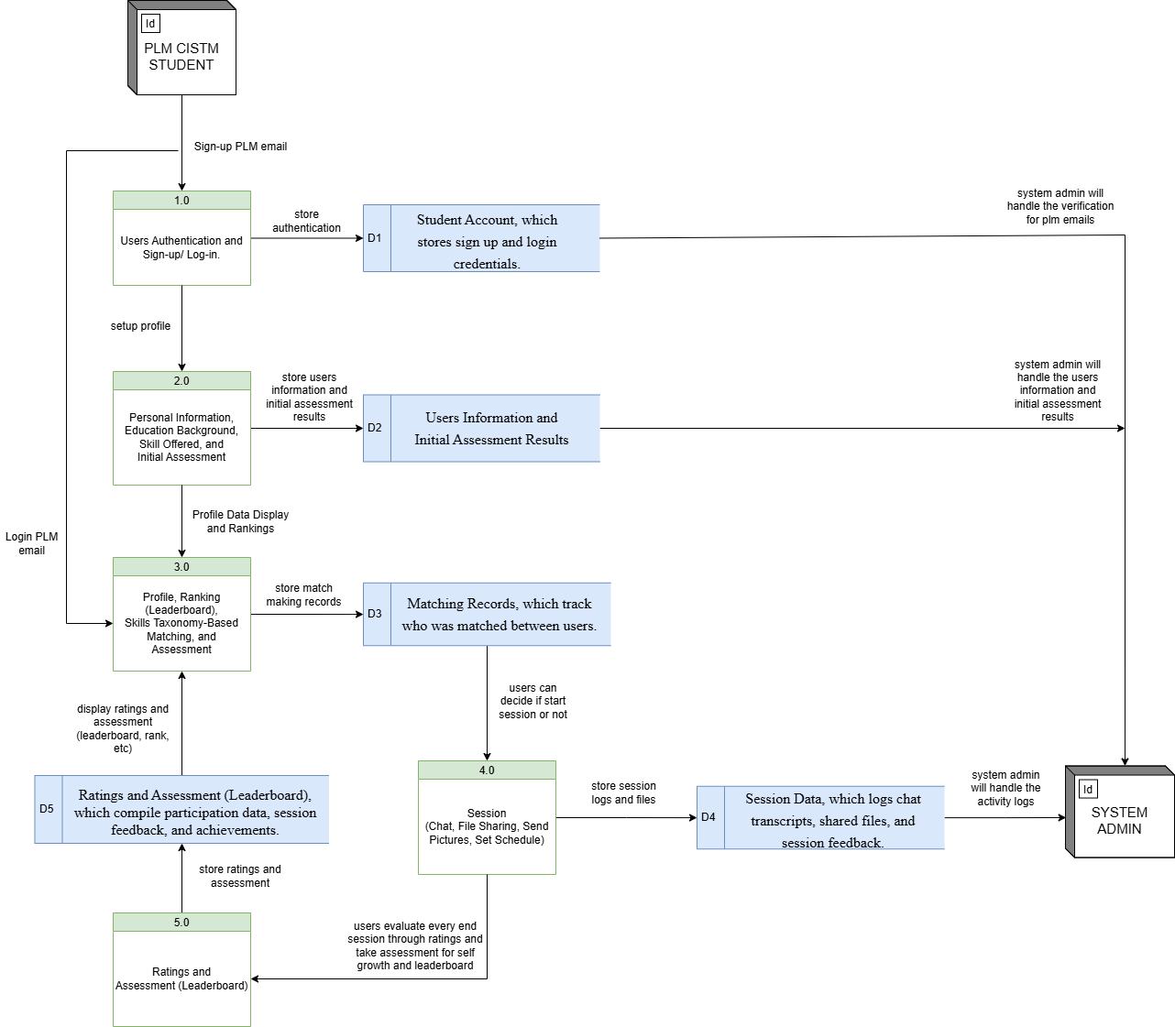

***Figure 3.4.3*** Level 1 Data Flow Diagram (Decomposition Diagram)

In Figure 3.4.3 presents the Level 1 Data Flow Diagram (DFD), which offers a detailed decomposition of the SkillSynergy System’s core functionalities, processes, data flows, data stores, and interactions with external entities. This diagram expands upon the high-level Process 0 from the Level 0 DFD by breaking it down into five distinct subprocesses that collectively represent the system’s operational logic.

The workflow begins with the PLM CISTM Student registering using their official PLM email address. This information is directed to Process 1.0: Account Registration and Verification, where the System Administrator validates the email credentials. Upon successful verification and authentication, students proceed to Process 2.0: Input Personal, Educational, and Skill Information, where they enter their personal data, educational background, offered skills, and take their initial assessment. These inputs are stored in the Users Information and Initial Assessment Results (D2) data store, while login credentials are maintained in the Student Account (D1) data store. The system continues with Process 3.0: Profile, Matching, and Ranking, which enables students to view their profiles, find compatible peers using a taxonomy-based skill matching algorithm, and check their leaderboard status. Matching data is stored in Matching Records (D3), which tracks connected users and pairing outcomes. Once matched, students may initiate or join collaborative learning sessions through Process 4.0: Session Management, which supports real-time chat, file sharing, and scheduling functionalities. All session-related activities and shared materials are logged in the Session Data (D4) data store. Following the completion of each session, users engage in Process 5.0: Ratings and Assessment, where they rate their peers and optionally retake assessments to improve their rankings. These inputs are stored in the Ratings and Assessment (D5) data store. This continuous feedback loop promotes self-

improvement, encourages student engagement, and drives leaderboard progression.

Throughout these operations, the System Administrator remains involved in overseeing account validation, managing session logs, handling assessment results, and ensuring the integrity of all feedback and matchmaking activities. Altogether, the Level 1 DFD provides a comprehensive view of how the SkillSynergy system’s subsystems interconnect and operate. It clarifies the detailed processes and their associated data flows, offering a strong foundation for system analysis, implementation, and refinement.

In conclusion, the methods and tools utilized in the SkillSynergy platform establish a robust, scalable, and user-centered system that effectively facilitates skill exchange among PLM CISTM students. By leveraging taxonomy-based matching, real-time session management, dynamic leaderboard tracking, and comprehensive assessment methods, SkillSynergy addresses key challenges in collaborative learning. The detailed ERD and DFDs provide a strong foundation for system development, ensuring clear data organization and process flow. Overall, this chapter demonstrates how the integration of thoughtful design, appropriate technologies, and structured methodologies culminates in a platform capable of enhancing skill development, peer collaboration, and academic growth within the PLM community.

**Chapter Four**

**RESULTS AND DISCUSSION**

**4.1. Survey Results**

The system was evaluated by the developers using the ISO/IEC 25010 standard to assess its usability, functionality, performance efficiency, and reliability. This section presents the initial data collected from 200 respondents who participated in the evaluation by completing the assessment questionnaire.

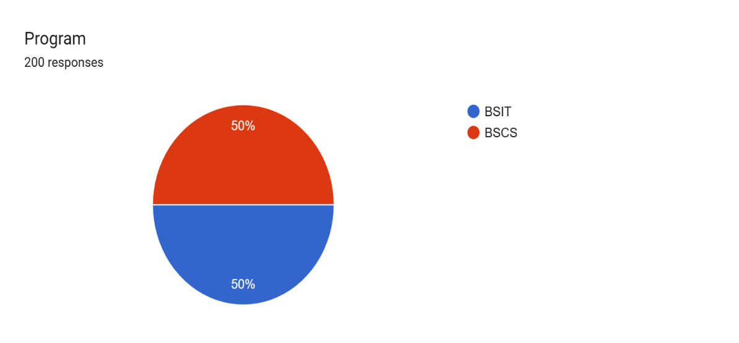**4.1.1 Program**

***Figure 4.1.1*** Program

In figure 4.1.1, the pie chart presents the distribution of student respondents by academic program prior to the evaluation. Out of 200 responses collected, the data reveals an equal representation between the two programs: Bachelor of Science in Information Technology (BSIT) and Bachelor of Science in Computer Science (BSCS).

Each program accounted for 50% of the total responses, indicating that the perspectives and insights gathered from the pre-evaluation are evenly balanced between the two cohorts. This equal distribution ensures that the results of the study are not biased toward one program and allows for a more objective comparative analysis of their responses and experiences.

**4.1.2 Year Level**

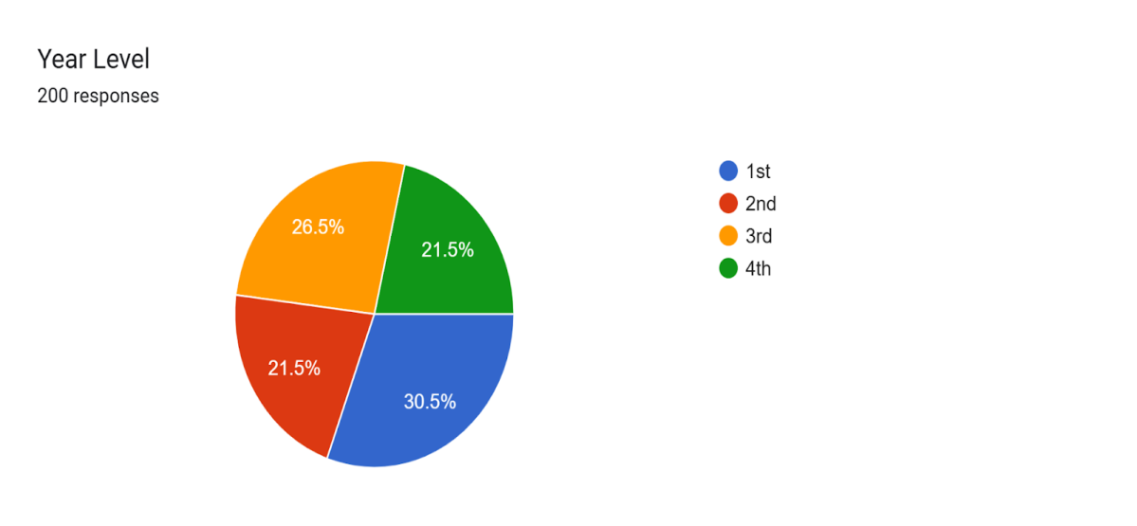

***Figure 4.1.2*** Year Level of the Respondents

In figure 4.1.2, illustrates the distribution of student respondents according to their year level. Out of the 200 total responses collected, 30.5% came from 1st Year students, making them the most represented group in the survey. This was followed by 21.5% both from 2nd Year and 4th Year while 3rd Year students each accounted for 26.5% of the total responses. The data suggests a healthy representation across all academic levels, with a notable concentration from 1st Year students.This diversity in respondents contributes to a more comprehensive and balanced evaluation of the system, as it incorporates insights and experiences from both newer and more advanced students.

**4.1.3 Block of Respondents (1st year - 4th Year)**

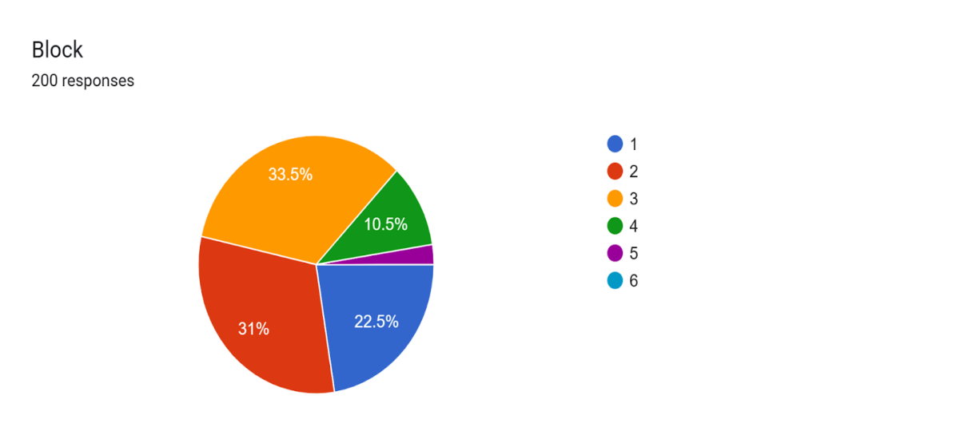

***Figure 4.1.3*** Block of Respondents (1st Year – 4th Year)

In figure 4.1.3 presents the distribution of student respondents across various academic blocks from 1st Year to 4th Year. Based on the data from 200 participants, Block 3 had the highest proportion of respondents at 33.5%, followed closely by Block 2 with 31%. Block 1 contributed 22.5% of the responses, while Block 4 had a smaller share at 10.5%. Blocks 5 and 6 had little to no representation in the responses, as indicated by their absence or minimal percentage in the chart.

**4.1.4 Age of the Respondents**

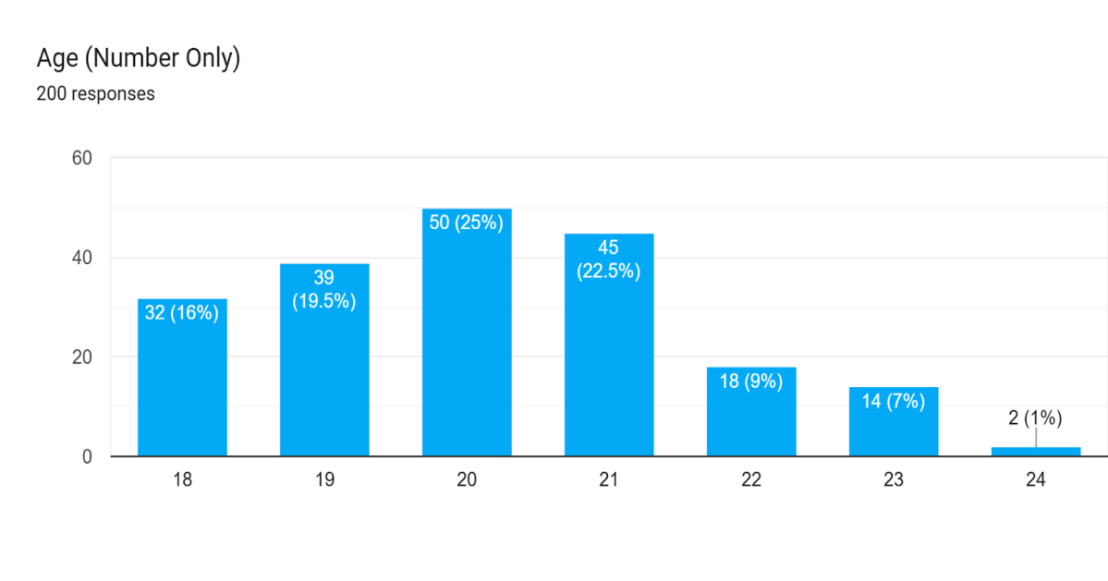

***Figure 4.1.4*** Age of the Respondents

In Figure 4.1.4, the chart illustrates the age distribution of the respondents. The data represents 200 responses, with the age group 20 having the largest number of respondents, accounting for 50 individuals or 25% of the total. Following this, the age group 21 comprises 45 respondents (22.5%), while age group 19 includes 39 respondents (19.5%). The age group 18 has 32 respondents, representing 16% of the total. Smaller groups are seen in the age categories 22 (18 respondents, 9%), 23 (14 respondents, 7%), and 24 (2 respondents, 1%).

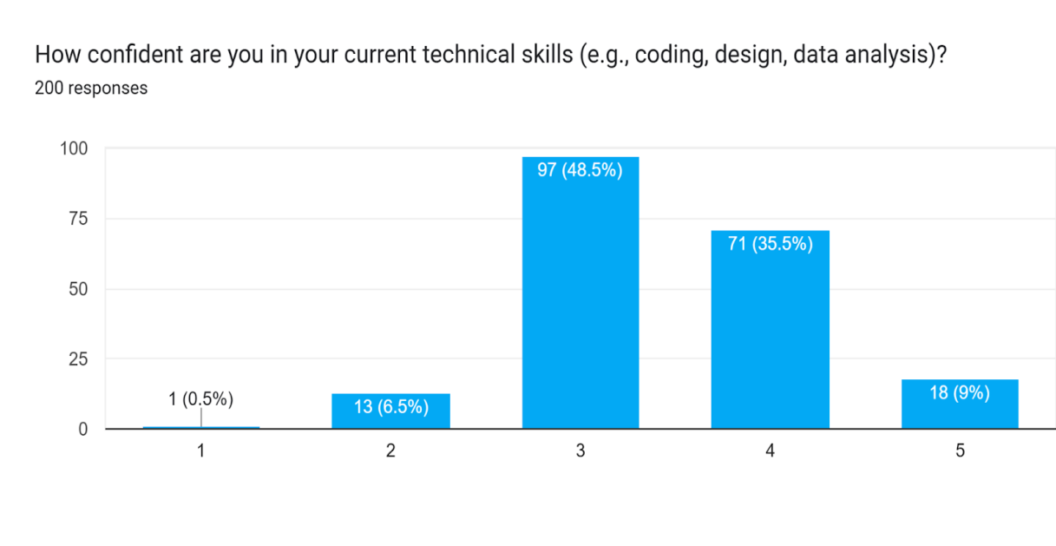 **4.1.5 Confidence in Current Technical Skills**

***Figure 4.1.5*** Confidence in a Current Technical Skills

In figure 4.1.5, The chart illustrates the individual’s confidence in their current technical skills, such as coding, design, and data analysis, based on 200 responses. The majority of respondents (48.5%) expressed a moderate level of confidence (rated 3), while 35.5% indicated a higher level of confidence (rated 4). A small portion of respondents reported a low confidence level (0.5% rated 1) or a very high confidence level (9% rated 5).

**4.1.6 Student Difficulties in Understanding Lessons during Lectures**

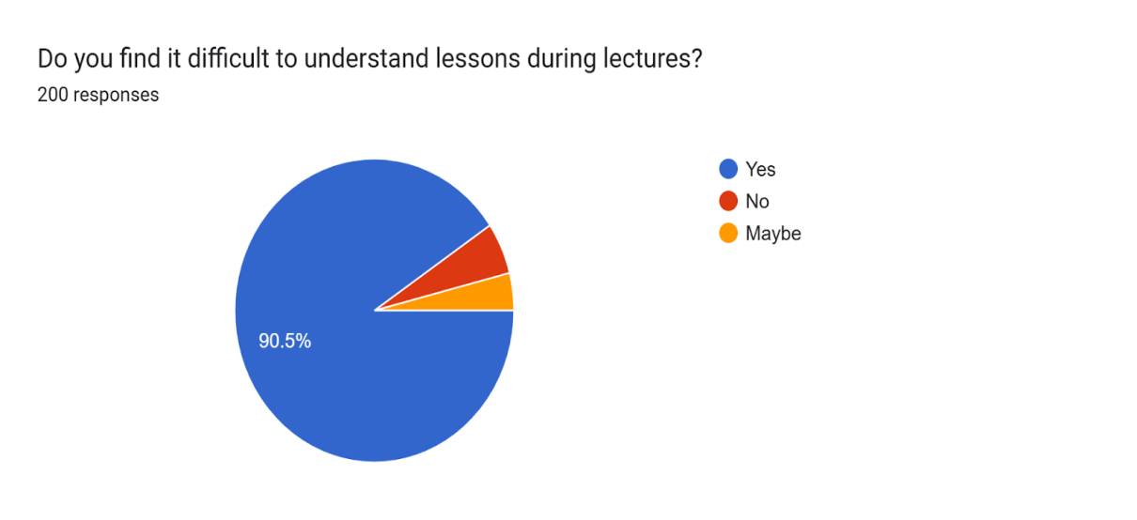

***Figure 4.1.6*** Student Difficulties in Understanding Lessons During Lectures

In figure 4.1.6, presents the results of whether they find it difficult to understand lessons during lectures. Out of 200 respondents, a significant majority (90.5%) answered "Yes", indicating that they do experience difficulties. Only a small percentage responded "No", while an even smaller group selected "Maybe". This overwhelming majority suggests a critical concern in the learning environment, highlighting the need for more effective teaching strategies, clearer communication, or supportive tools that enhance student comprehension during lectures. The results underscore the importance of addressing instructional barriers to improve overall educational outcomes.

**4.1.7 Students’ Areas of Academic Struggle in Programming and Web Development**

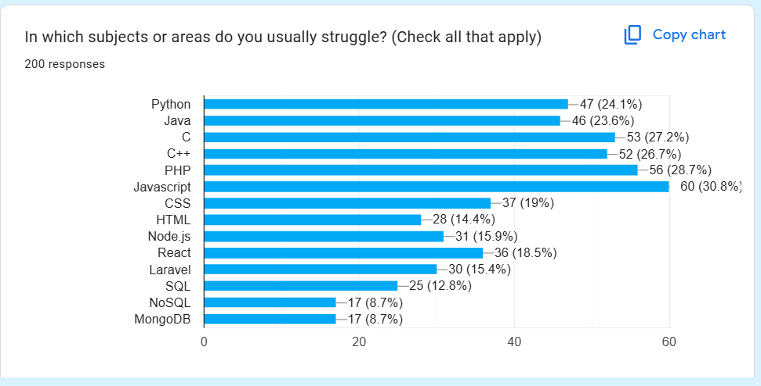**Subjects**

***Figure 4.1.7*** Students’ Areas of Academic Struggle in Programming and Web Development Subjects

In figure 4.1.7, presents the responses of 200 students regarding the subjects or areas in which they usually encounter difficulties. The data shows that the highest percentage of students reported struggling with JavaScript (30.8%), followed closely by PHP (28.7%), C (27.2%), and C++ (26.7%). Other notable areas of difficulty include Python (24.1%) and Java (23.6%). Meanwhile, a smaller but still significant number of respondents indicated challenges with CSS (19%), React (18.5%), Laravel (15.4%), and HTML (14.4%). Subjects such as Node.js (15.9%), SQL (12.8%), NoSQL, and MongoDB (both at 8.7%) had fewer students reporting difficulty.

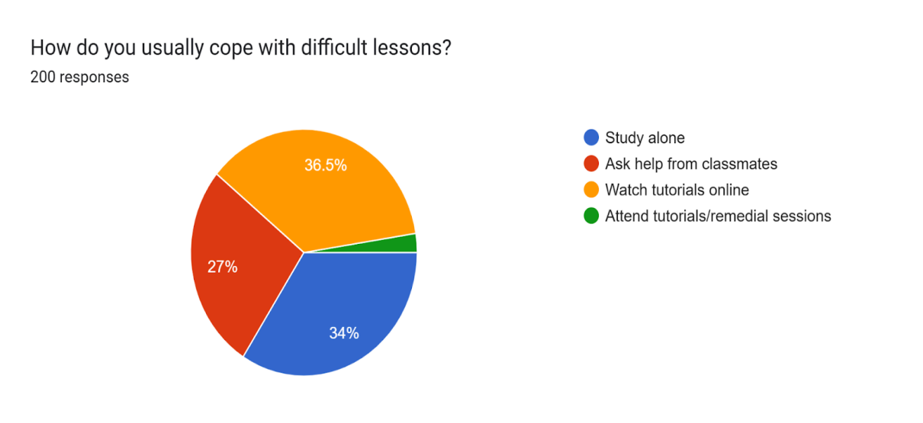**4.1.8 Students Coping with Difficult Lessons**

***Figure 4.1.8*** Students Coping with Difficult Lessons

In figure 4.1.8, illustrates the responses of 200 students to the question of how they usually cope with difficult lessons. The data reveals that the majority of students, 36.5%, prefer to watch tutorials online, while 34% turn to study alon to help them understand challenging content. A smaller group, 27%, seek assistance from their classmates, and only a minority, 2.5%, attend tutorials or remedial sessions. This chart provides insights into the varying strategies employed by students to overcome academic challenges.

**4.1.9 Openness to Learning from Fellow Students**

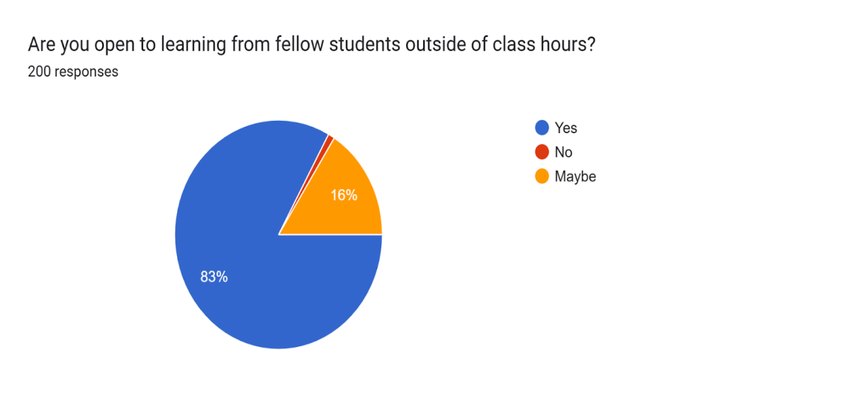

***Figure 4.1.9*** Openness to Learning from Fellow Students

In Figure 4.1.9, presents the responses of 200 students regarding their openness to learning from fellow students outside of class hours. The data indicates that a significant majority of students, 83%, are open to learning from their peers, while 16% answered “Maybe”, and a small portion, 1%, remain uncertain with a "No" response. This suggests that most students are willing to engage in peer learning outside of formal class settings.

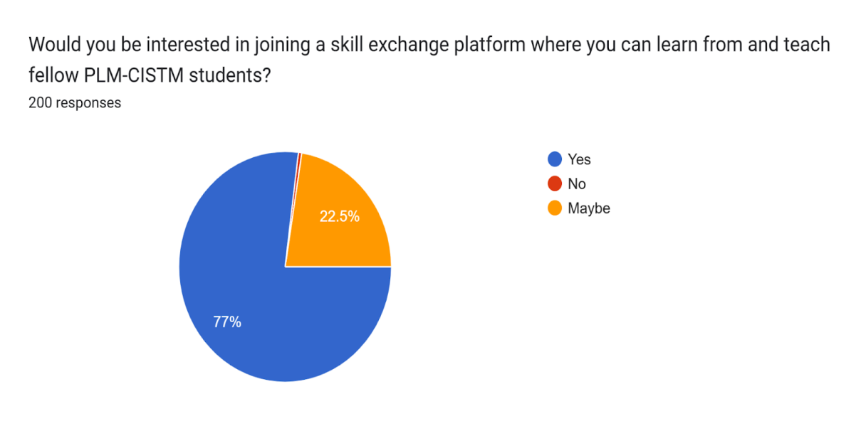**4.1.10 Students Interest in Joining a Skill Exchange Platform**

***Figure 4.1.10*** Students Interest in Joining a Skill Exchange Platform

In figure 4.1.10, presents the results of a survey conducted among 200 PLM-CISTM students regarding their interest in joining a skill exchange platform. The responses indicate that 77% of students are in favor of participating in such a platform, expressing their interest in both learning from and teaching fellow students. In contrast, 22.5% of students expressed uncertainty, selecting "Maybe," while none of the respondents chose "No." The data suggests a strong inclination among students toward engaging in a collaborative learning and teaching environment.

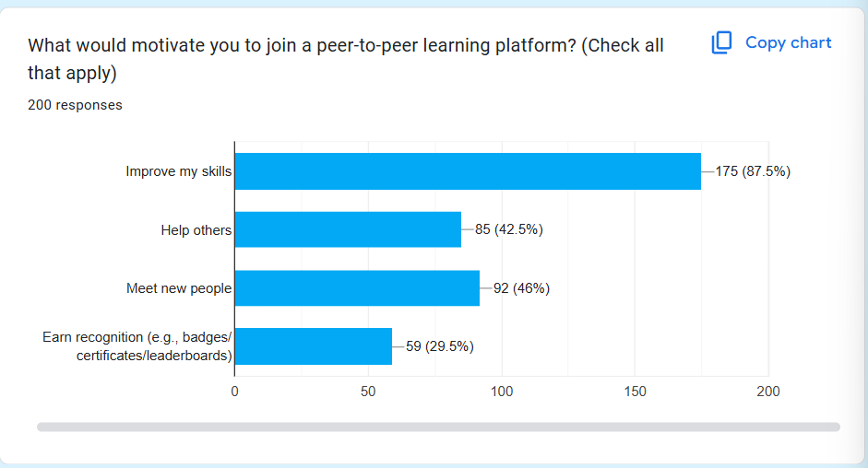**4.1.11 Students Motivation to Join a Peer-to-Peer Learning Platform**

***Figure 4.1.11*** Students motivation to join a peer-to-peer learning platform

In figure 4.1.11, presents the motivations of 200 PLM-CISTM students for joining a peer-to-peer learning platform. The majority (87.5%) are driven by the desire to improve their skills, followed by interests in meeting new people (46%) and helping others (42.5%). While only 29.5% are motivated by recognition through badges or certificates, the overall results reflect a strong inclination toward collaborative and self-driven learning.

**4.1.12 Students interest in tracking their progress**

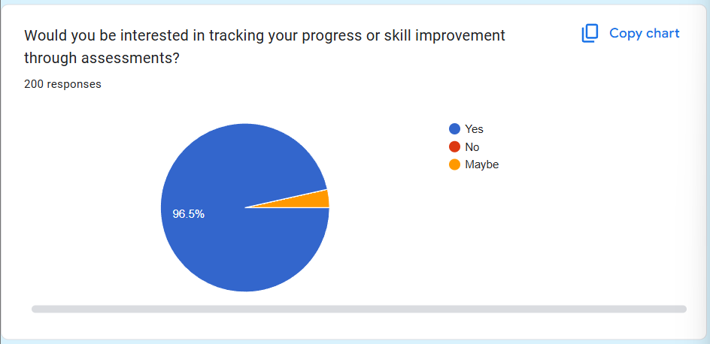

***Figure 4.1.12*** Students interest in tracking their progress

In figure 4.1.12, illustrates that a vast majority of respondents (96.5%) are interested in tracking their progress or skill improvement through assessments. This indicates a strong preference among PLM-CISTM students for measurable and structured learning. The minimal percentage of "Maybe" and absence of "No" responses highlight a clear demand for progress-tracking features in the platform.

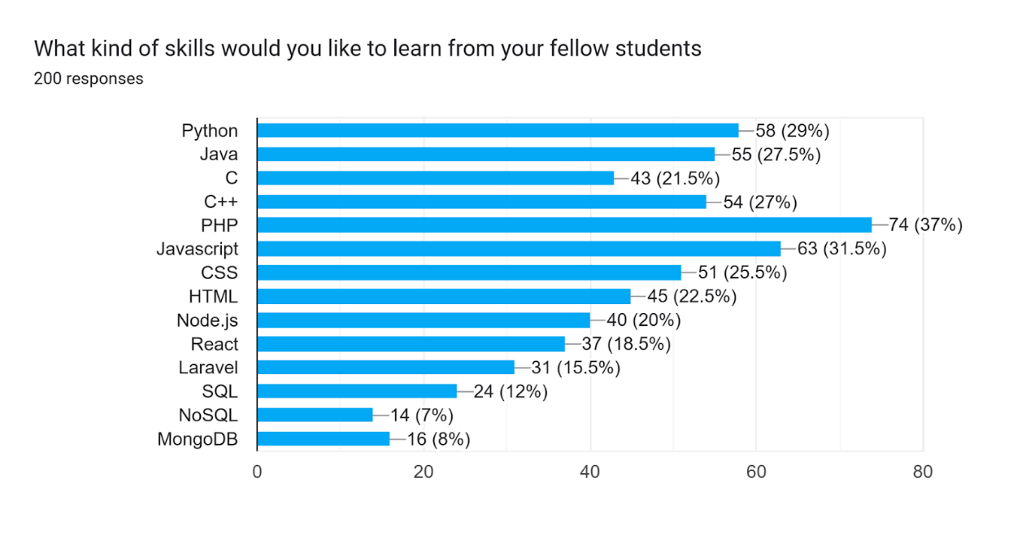**4.1.13 Kind of Skills that Students Want to Learn from Fellow Students**

***Figure 4.1.13***Skills Students Want to Learn from Fellow Students

In figure 4.1.13, reveals that the most in-demand skill among PLM-CISTM students is PHP, with 37% (74 respondents) expressing interest in learning it, followed by Javascript (31.5%) and Python (29%). Other popular skills include Java, C++, CSS, and HTML, while backend and database technologies like Laravel, SQL, and NoSQL received relatively lower interest. This suggests a stronger preference for frontend and general-purpose programming skills over specialized backend or database technologies among students.

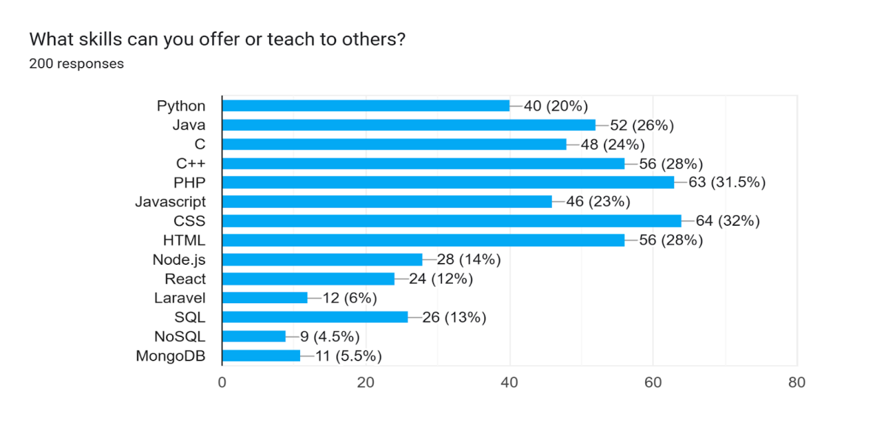**4.1.14 Skills that Can Offer or Teach to Others**

***Figure 4.1.14*** Skills that Can Offer or Teach to Others

In figure 4.1.14, presents the technical skills that PLM-CISTM students reported being able to offer or teach to their peers, based on 200 survey responses. The most common skill students felt confident in teaching was CSS (32%, 64 respondents) indicating they could offer assistance with it. This was followed by PHP, with 63 students (31.5%), HTML (28%, 56 respondents), JavaScript (23%, 46 respondents), and Java (26%, 52 respondents). Other notable skills include Python (20%), C (24%), and C++ (28%). Backend and database-related technologies such as Node.js (14%), React (12%), Laravel (6%), SQL (13%), NoSQL (4.5%), and MongoDB (5.5%) were less commonly reported, indicating that fewer students are prepared to teach these technologies. The results suggest that while students express high interest in learning programming and frontend skills, a relatively smaller subset feels confident enough to teach these areas, highlighting a potential gap between learning and mastery. Furthermore, frontend technologies continue to dominate both in terms of learning demand and teaching capacity.

**4.2 Instruments Used**

The instrument used in this study was a self-assessment survey/questionnaire designed to capture the participants' personal experiences and perceptions. The survey was created using Google Forms to ensure ease of access and data collection. Google Forms allowed for efficient distribution to participants, as well as seamless data management and analysis.

The content of the survey was carefully crafted to align with the research objectives and key themes of the study. It covered multiple dimensions of the research topic, such as the benefits, limitations, and effectiveness of the care options being studied. The questions were also designed to encourage participants to reflect on their personal narratives and provide rich insights into the subject matter

**4.3 Population and Sample**

***Table 4.3.1 Population and Sample***

|  |  |  |  |
| --- | --- | --- | --- |
| **Target Respondents** | **Population Size** | **Percentage** | **Sampling Method** |
| IT Students or Faculty | 329 | 100% | Purposive Sampling |

The target population for the predictive scheduling system for Information Technology students should consist of eligible IT faculty members or students who can provide the needed information for the study. To ensure sufficient sample size, the developers should target at least three hundred and twenty-nine IT faculty members or students. In addition, purposive sampling, a non-

probability technique, will be used to select faculty members or students based on specific criteria that are relevant to the research objectives. This focus and relevant sample are expected to provide valuable insights into meaningful conclusions.

In order to examine the data gathered by the developers, the following statistical tools were used in this study. The developers will use the following statistical treatments for this study:

1. **Percentage** – used to get the percentage of the distribution of respondents in each of the categories considered. This was used to show the profile of the data gathered of the respondents.

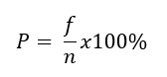**Formula**:

Where:

P = Percentage (in %)

f = Frequency of each group of respondents in the sample size

n = Total sample of respondents

2. **Mean -** used to find the average value of a specific variable in the data. It allows developers to understand the typical value of the parameter being studied.

**Formula:**

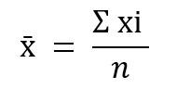

Where:

x̄ = Sample Mean

f = Frequency of each group of respondents in the sample size

n = Total sample of respondents

3. **Mode** - the value that has a higher frequency in a given set of values. It is the value that appears the greatest number of times.

**4.4 System Evaluation**

In assessing SkillSynergy: A Web-Based Skills Exchange Platform for CISTM Students of Pamantasan ng Lungsod ng Maynila using taxonomy-based matching and assessment, the developers will adhere to ISO/IEC 25010 to ensure that the system meets quality standards in key areas such as functionality, performance efficiency, usability, and user perception of functionality. ISO/IEC 25010 serves as a comprehensive framework for evaluating software quality, outlining the essential quality attributes that should be assessed when appraising a product's characteristics (ISO 25000, 2022). The focus on functionality, performance efficiency, usability, and reliability during the evaluation process aims to confirm that the system's features, specifically the matching and assessment functionalities, work as intended. Other ISO/IEC 25010 attributes will be considered after the system has been implemented and used for its intended purpose.

***Table 4.4.1 ISO 25010-2011 Characteristics used for System Quality Evaluation***

|  |  |  |  |  |  |  |
| --- | --- | --- | --- | --- | --- | --- |
| **Characteristics** | **Description** | 1 | 2 | 3 | 4 | 5 |
| **Functional Suitability** | Ensures that the system provides the required functionalities, such as accurate taxonomy-based matching and assessment. The platform should meet the specified needs of CISTM students for skill matching and assessments. |  |  |  |  |  |
| **Performance Efficiency** | Evaluates how effectively the system performs under expected workloads, focusing on response time, resource consumption, and overall system performance during high user traffic. |  |  |  |  |  |
| **Usability** | Assesses the ease of use, including the system's interface design, navigation, and overall user experience to ensure that CISTM students can effectively interact with the platform. |  |  |  |  |  |
| **Reliability** | Evaluates the system's ability to maintain performance, recover from failures, and provide uninterrupted service, ensuring the platform operates smoothly without issues**.** |  |  |  |  |  |

For the evaluation of SkillSynergy: A Web-Based Skills Exchange Platform for CISTM Students of Pamantasan ng Lungsod ng Maynila, the developers will focus on the following ISO/IEC 25010:2011 quality characteristics to ensure the system meets the required standards:

1. **Functional Suitability –** This characteristic ensures that the system provides the required functionalities, such as efficient taxonomy-based matching and assessment capabilities. The platform should meet the specified needs of CISTM students by enabling accurate skill matching, personalized recommendations, and assessments.
2. **Performance Efficiency –** This evaluates how effectively the system performs under expected workloads. The developers will assess the platform's response time, resource consumption, and overall performance to ensure smooth operation, even during high user traffic.
3. **Usability –** A critical aspect for ensuring the platform is user-friendly. The developers will evaluate the ease with which CISTM students can navigate the system, use its features, and access information. Factors such as interface design, accessibility, and overall user experience will be considered.
4. **Reliability –** This characteristic will assess the system's ability to maintain performance under stress, recover from errors, and provide uninterrupted service. The developers will ensure the platform functions without failures, with appropriate backup and recovery measures in place.

These quality characteristics will be used as the foundation for evaluating the system's readiness and effectiveness before it is fully implemented. Additional characteristics of ISO/IEC 25010 will be addressed after the system’s launch and usage.

***Table 4.4.2 The five-point Likert Scale***

|  |  |
| --- | --- |
| **Criteria** | **Numerical Value** |
| Excellent | 4.21 – 5.00 |
| Very Good | 3.41 – 4.20 |
| Good | 2.61 – 3.40 |
| Fair | 1.81 – 2.60 |
| Poor | 1.00 – 1.80 |

Table 4.4.2 refers to a five-point Likert scale that will be used by developers to assess the numerical value of the data they can collect when developing a SkillSynergy: A Web-Based Skills Exchange Platform for CISTM Students since it is simple to use and comprehend, enabling respondents to effectively express their ideas. An instrument that is frequently used to evaluate attitudes and opinions is the 5-point Likert scale. In addition to neutral options and intermediate choices, there are five answer options, ranging from excellent to poor (VOXCO, 2022). It makes user participation convenient by facilitating prompt feedback on system features. For students participating in the implementation of the SkillSynergy: A Web-Based Skills Exchange Platform the Likert scale provides a user-friendly experience while guaranteeing effective data gathering and analysis.

**4.4.3   Evaluation**

***Table 4.4.3.1 Overall Mean for Characteristics in ISO 25010 Evaluation***

|  |  |  |
| --- | --- | --- |
| **Criteria** | **Criteria** | **Interpretation** |
| Functional Suitability | 3.21 | Good |
| Performance Efficiency | 3.44 | Very Good |
| Usability | 4.43 | Excellent |
| Reliability | 3.41 | Very Good |
| **Overall Mean** | **3.62** | **Very Good** |

As shown above in table 4.4.3.1, SkillSynergy: A Web-Based Skills Exchange Platform presents the overall mean scores for various quality characteristics based on the ISO 25010 software quality evaluation model. The criteria evaluated include Functional Suitability, Performance Efficiency, Usability, and Reliability. Each criterion received a corresponding mean score and qualitative interpretation. Functional Suitability scored 3.21, interpreted as "Good"; Performance Efficiency received a score of 3.44, interpreted as "Very Good"; Usability scored the highest with 4.43, rated as "Excellent"; and Reliability had a score of 3.41, also rated "Very Good." The overall mean across all criteria is 3.62, which falls under the interpretation of "Very Good." This indicates that the SkillSynergy platform generally meets high standards of software quality based on user evaluation.

Using this 5-point Likert scale, the respondents were able to answer the following questions:

***Table 4.4.3.2 The five-point Likert Scale***

|  |  |
| --- | --- |
| **Response Categories** | **Numerical Value** |
| Strongly Agree | 5 |
| Agree | 4 |
| Neither Agree or Disagree | 3 |
| Disagree | 2 |
| Strongly Disagree | 1 |

**4.2.1 Post Evaluation**

The system was evaluated by the developers using the ISO/IEC 25010 standard to assess its usability, functionality, performance efficiency, and reliability. This section presents the data collected from an additional 200 respondents who participated in the post-evaluation by completing the assessment questionnaire, bringing the total number of respondents to 400.

**PART I. Functional Suitability**

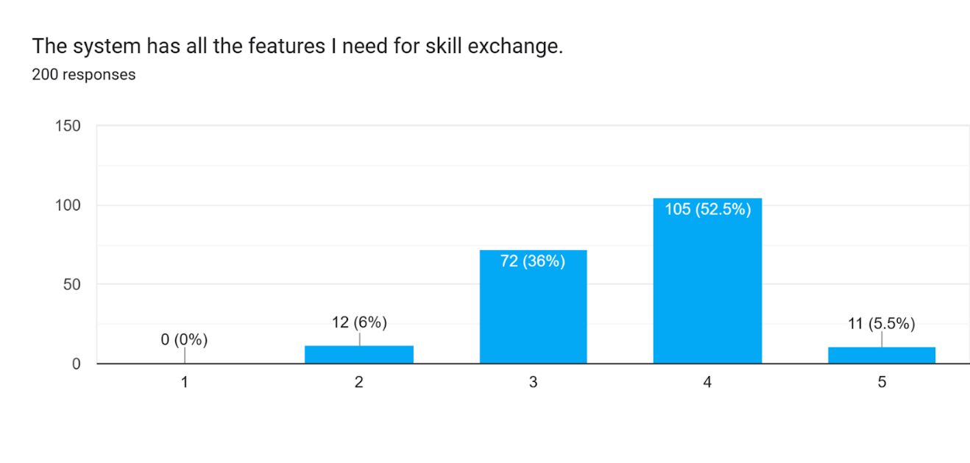

***Figure 4.2.1 The System Has All Features***

Figure 4.2.1 shows the participants’ level of agreement with the statement, *“The system has all the features I need for skill exchange,”* based on responses from 200 individuals. Most respondents, 52.5% (105 participants), rated the system as 4, indicating that they mostly agree that the system includes the necessary features. Meanwhile, 36% (72 participants) gave a rating of 3, suggesting a neutral stance or that some features may still be lacking. A smaller group, 5.5% (11 participants), gave the highest rating of 5, showing strong satisfaction with the system’s features. On the other hand, 6% (12 participants) rated it as 2, and 0% selected 1, indicating that very few users were dissatisfied. Overall, the data reflects a generally positive perception of the system’s features, with most users finding it adequately equipped for skill exchange purposes, though some see potential for enhancement.

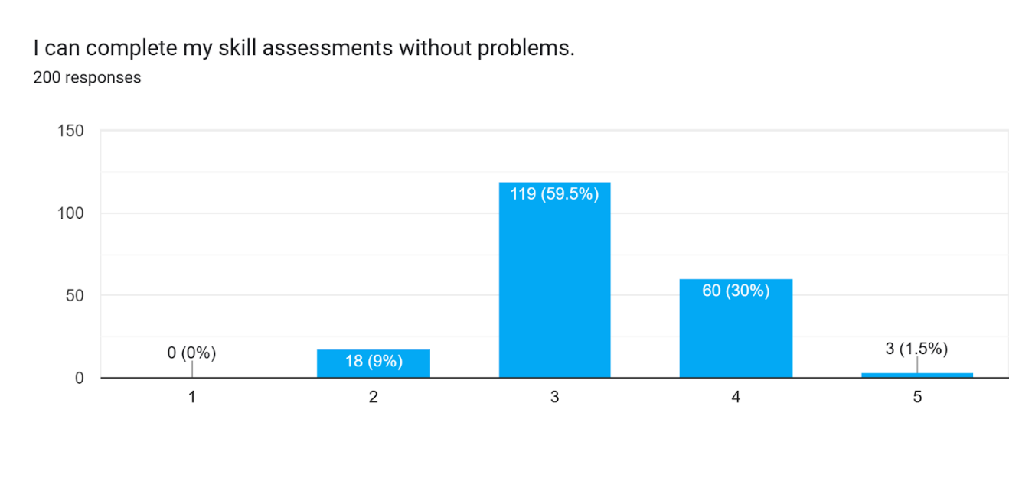

***Figure 4.2.2 Students can Complete their Skills Assessments***

Figure 4.2.2 presents the participants’ responses to the statement, *“I can complete my skill assessments without problems,”* based on a total of 200 respondents. The highest portion of responses, 59.5% (119 participants), selected 3, indicating a neutral experience — they were able to complete assessments but may have encountered minor challenges. 30% (60 participants) rated a 4, suggesting generally positive and smooth experience in completing skill assessments. Meanwhile, 9% (18 participants) gave a score of 2, reflecting slight difficulties, and only 1.5% (3 participants) rated it at 5, showing complete satisfaction. Notably, 0% of the respondents selected 1, indicating no strong negative experience. These results imply that while most users did not encounter major issues, there is still room for improving the system's assessment flow and clarity.

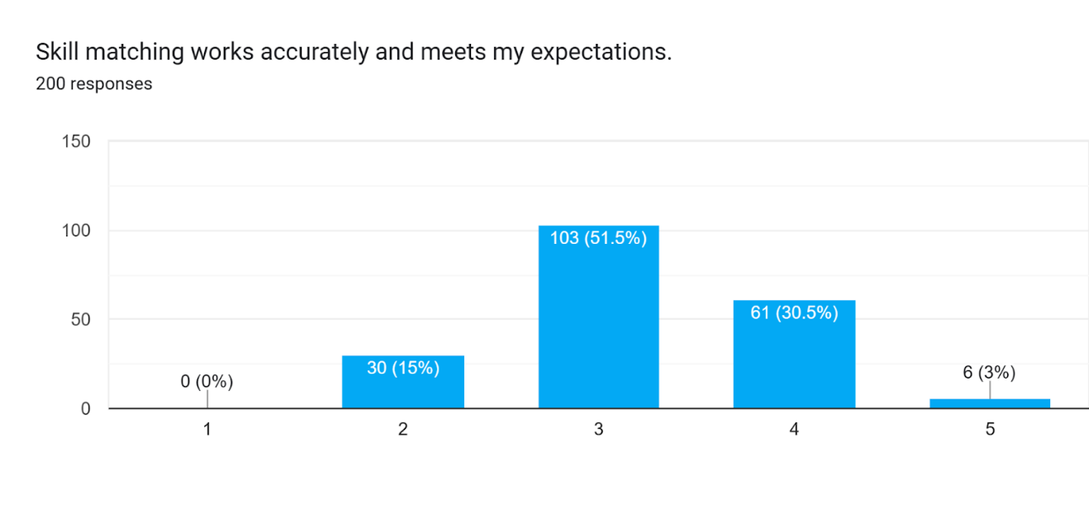

***Figure 4.2.3 Skill Matching Works Accurately***

Figure 4.2.3 indicates that most respondents rated the statement, "Skill matching works accurately and meets my expectations," with a score of 3 (51.5%). A significant portion gave a score of 4 (30.5%), showing moderate satisfaction. Only a small percentage rated it 5 (3%), indicating high satisfaction, while 15% rated it 2. No one gave a score of 1. This suggests that most respondents find skill matching somewhat accurate but with room for improvement.

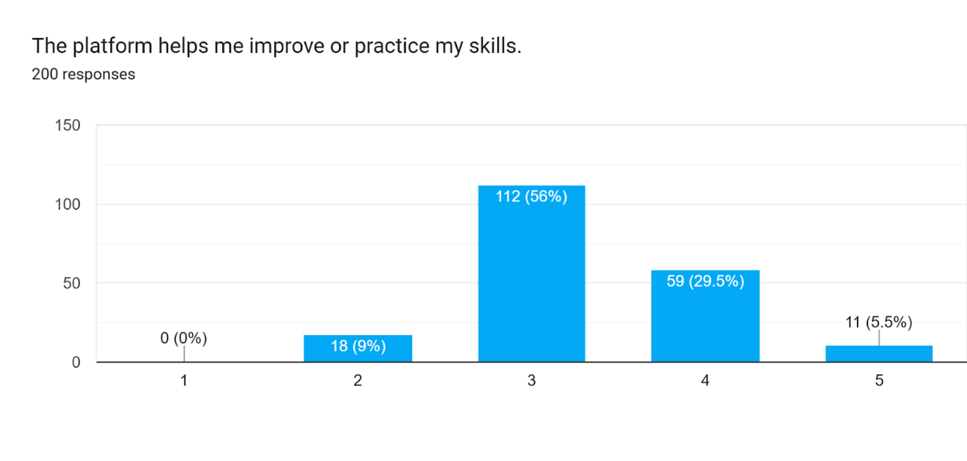

***Figure 4.2.4 The Platforms Helps Students to Improve***

Figure 4.2.4 shows that most respondents (56%) feel neutral about the platform's ability to help improve or practice skills, rating it a 3. Positive feedback (rating 4) was provided by 29.5% of users, while 9% rated it as 2, indicating some dissatisfaction. Only 5.5% strongly agreed (rating 5) that the platform significantly helped with skill improvement. No users disagreed entirely (rating 1), suggesting overall moderate to positive perceptions.

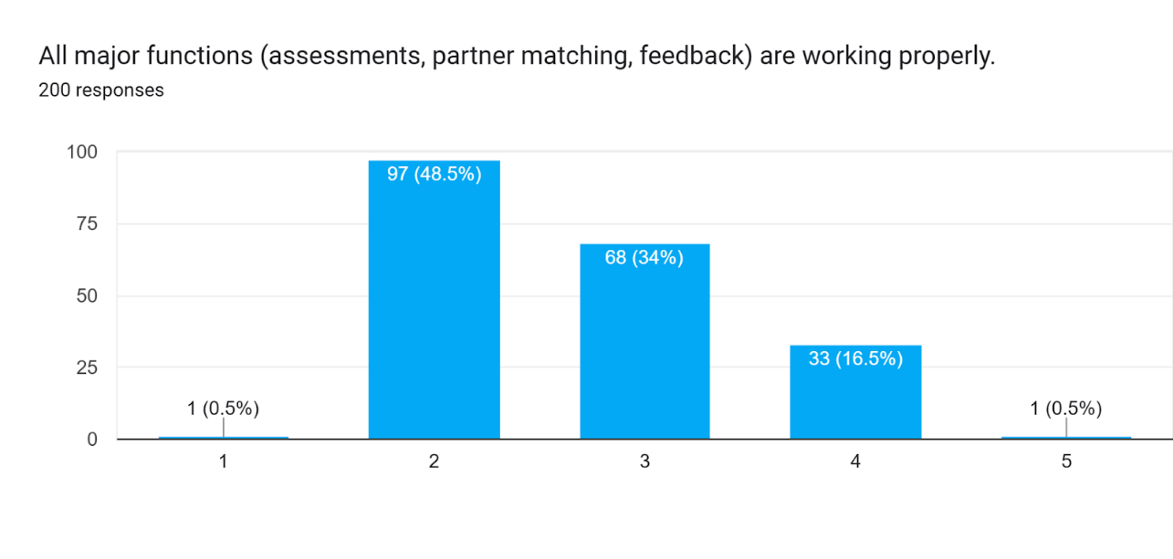

***Figure 4.2.5 All Major Functions are Working Properly***

 Figure 4.2.5 shows the responses to the statement, "All major functions (assessments, partner matching, feedback) are working properly." Many respondents (48.5%) selected a rating of 2, indicating dissatisfaction that the functions are not working well. A significant portion (34%) gave a neutral rating of 3, suggesting that the platform's functions are perceived as adequate but not exceptional. A smaller group (16.5%) rated it positively with 4, and only 0.5% rated it as 5, reflecting strong satisfaction. A very small number (0.5%) rated it at 1, indicating a high level of dissatisfaction. The results highlight that while most users find the functions unsatisfactory or neutral, a smaller group views them positively.

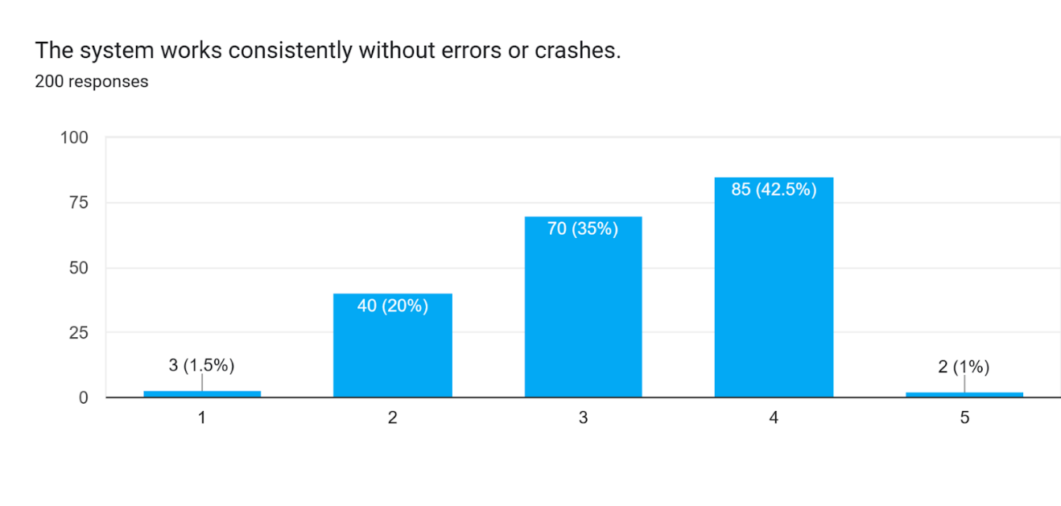**Part II Reliability**

***Figure 4.2.6 The System Works Consistently***

Figure 4.2.6 shows the responses to the statement, "The system works consistently without errors or crashes." The majority of respondents (42.5%) gave a rating of 4, indicating that the system performs well with minimal issues. A significant portion (35%) rated it neutrally with a 3, suggesting that the system is generally functional but may not be flawless. A smaller group (20%) rated it as 2, reflecting dissatisfaction with the system's consistency. Only 1.5% rated it as 1, showing that a few users experienced significant problems, while just 1% gave a rating of 5, indicating strong satisfaction. The results suggest that most users find the system relatively stable, though there is a notable portion with reservations about its reliability.

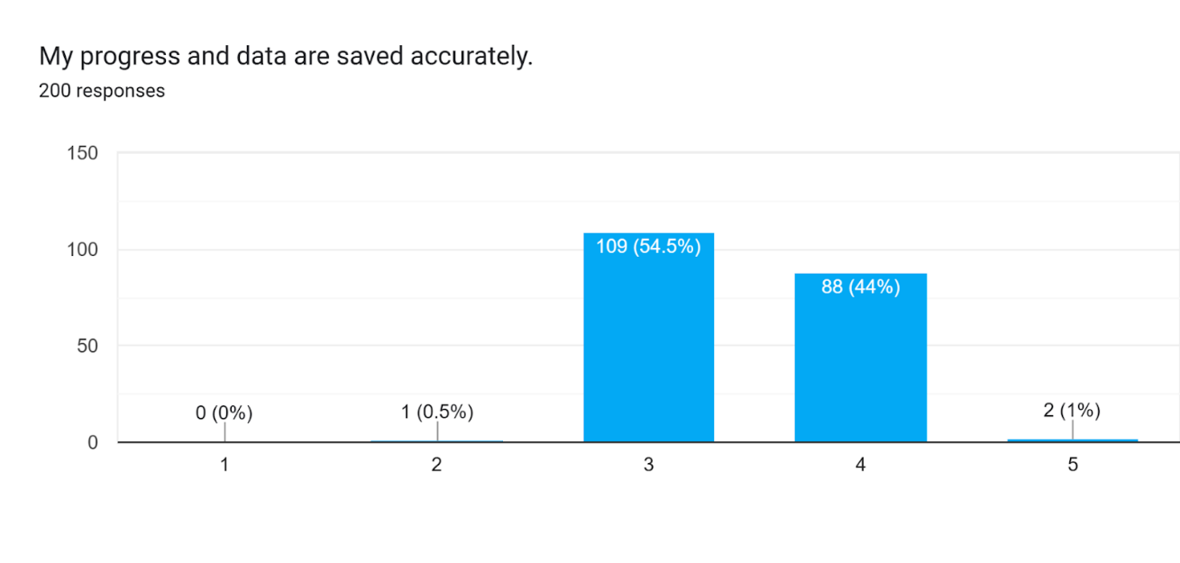

***Figure 4.2.7 Progress and Data are Saved Accurately***

Figure 4.2.7 displays the responses to the statement, "My progress and data are saved accurately." Most respondents (54.5%) rated it 3, indicating a neutral stance, suggesting that they feel their progress and data are adequately saved but may not be entirely confident in the system's accuracy. A substantial portion (44%) rated it 4, indicating a positive experience with saving data accurately. Only a small percentage (1%) gave a rating of 5, reflecting strong satisfaction, while 0.5% rated it 1, showing minor dissatisfaction. No respondents selected a rating of 0, indicating that no one completely disagreed with the statement. The results highlight that most users have a neutral to positive perception of how their progress and data are saved, with very few expressing strong concerns.

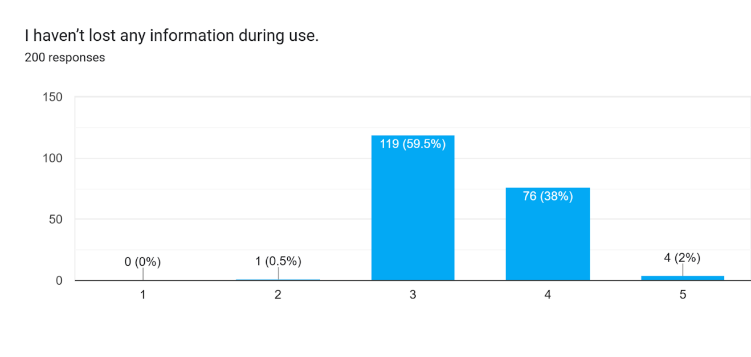

***Figure 4.2.8 Haven’t Lost Any Information During Use***

Figure 4.2.8 shows the responses to the statement, "I haven't lost any information during use." The majority of respondents (59.5%) rated it 3, indicating a neutral stance, meaning they haven't experienced significant data loss but may not feel entirely confident about the system's consistency. A substantial portion (38%) rated it 4, indicating that they haven't lost information and are satisfied with the system's performance in this regard. A small percentage (2%) rated it 5, suggesting strong confidence in the platform's ability to retain information, while 0.5% rated it 1, showing some dissatisfaction. No respondents selected a rating of 0, indicating that no one has had major issues with data loss. Overall, most users report no issues with losing information, but there is a slight concern among some users.

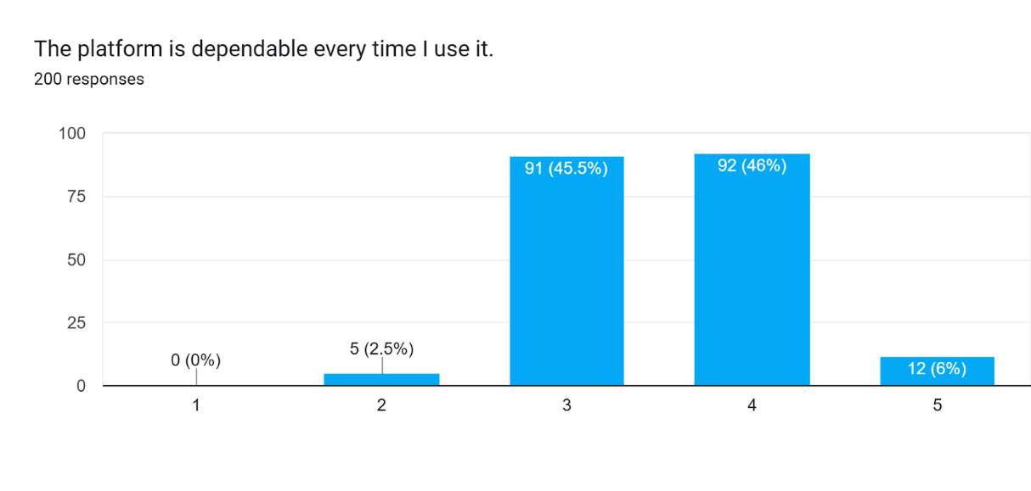

***Figure 4.2.9 The Platform is Dependable***

Figure 4.2.9 shows the responses to the statement, "The platform is dependable every time I use it." A significant portion of respondents (46%) rated it 4, indicating that they find the platform reliable most of the time. A similar percentage (45.5%) gave a neutral rating of 3, suggesting that while the platform is generally dependable, users may have some reservations. Only 6% rated it a 5, showing strong trust in its dependability, and 2.5% rated it 2, indicating some concerns. There were no responses for 0, suggesting that none of the users found the platform completely undependable. The results highlight that most users find the platform dependable, with a small group expressing strong confidence.

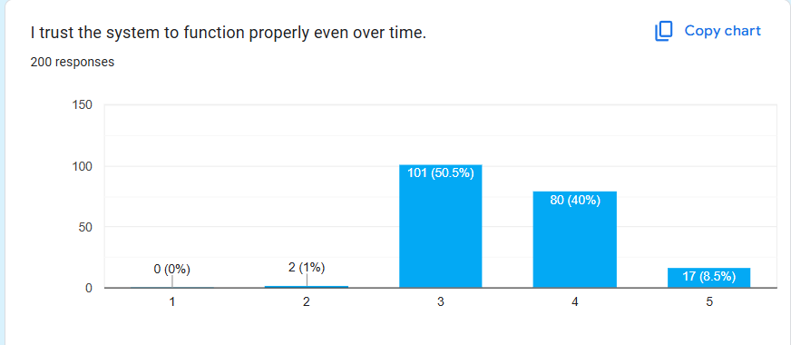

***4.2.9 Trusting the System to Function Properly***

Figure 4.2.9 shows the responses to the statement, "I trust the system to function properly even over time." The majority of respondents (50.5%) selected a neutral rating of 3, suggesting uncertainty regarding the platform’s long-term reliability. A significant portion (40%) expressed trust in the system’s ability to function properly with a rating of 4. Only 8.5% rated it a 5, indicating strong confidence in its long-term performance. A small group (1%) rated it as 2, showing some doubt, while no users rated it 1, reflecting no strong disagreement about the system’s long-term dependability.

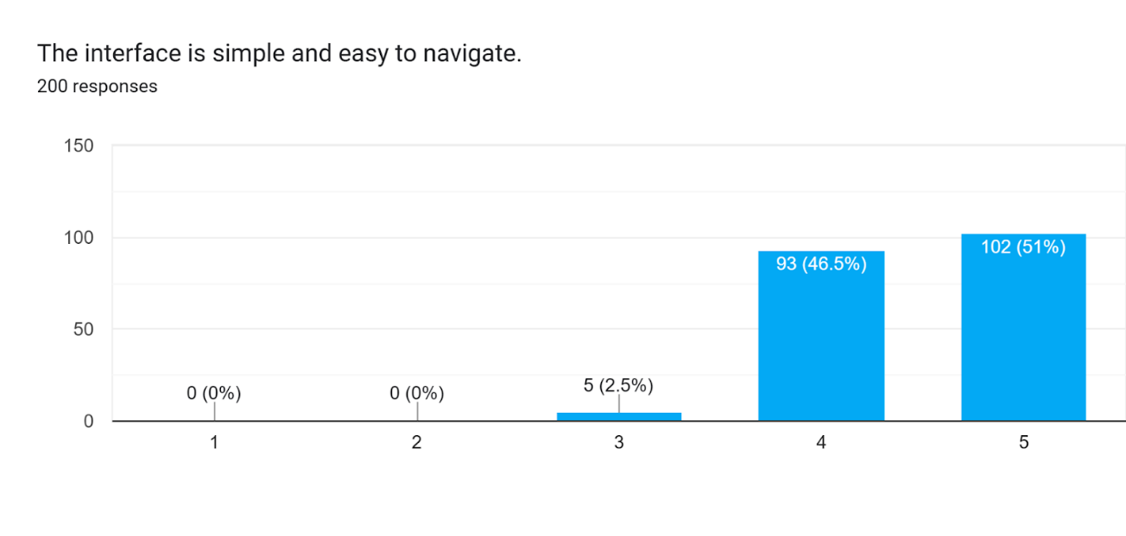**Part III Usability**

***Figure 4.2.10 Interface is Simple and Easy to Navigate***

Figure 4.2.10 shows the responses to the statement, "The interface is simple and easy to navigate." Most respondents (51%) rated it 5, indicating that they find the interface highly user-friendly. A close 46.5% gave it a 4, suggesting that the interface is mostly easy to navigate, with only minor areas of improvement. A small number (2.5%) rated it 3, implying that a few users found it somewhat difficult to use. No respondents rated it 1 or 0, meaning the interface is largely seen as intuitive by the majority.

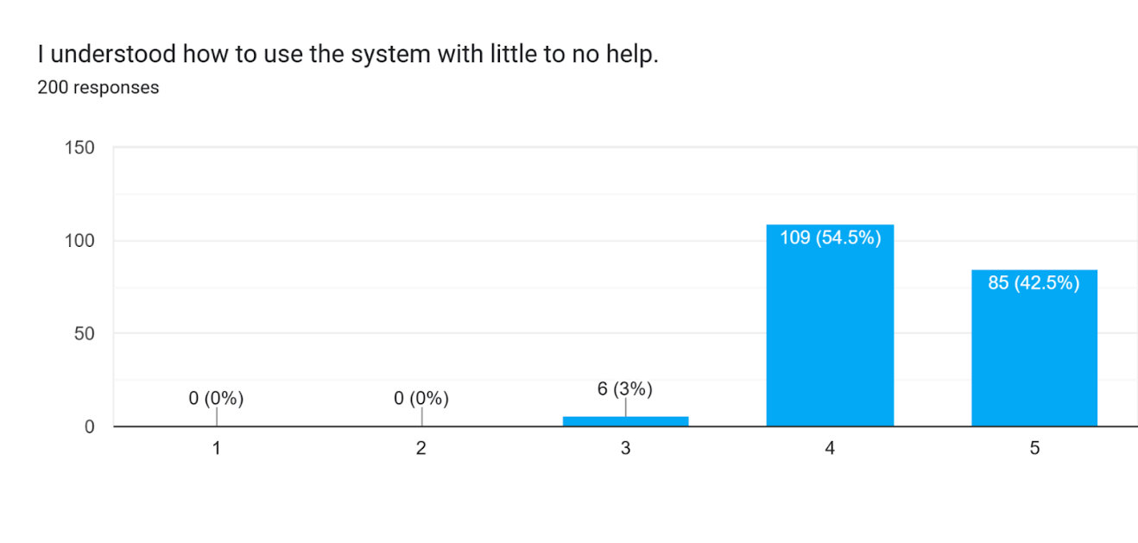

***Figure 4.2.11 Understood How to Use the System***

Figure 4.2.11 presents the responses to the statement, "I understood how to use the system with little to no help." The majority of respondents (54.5%) rated it 4, suggesting they could use the system with minimal assistance. A strong 42.5% gave it a rating of 5, indicating a high level of ease in using the system independently. A small portion (3%) rated it 3, showing slight difficulty or confusion. No users rated it 1 or 0, suggesting that the system is relatively easy to understand for most users.

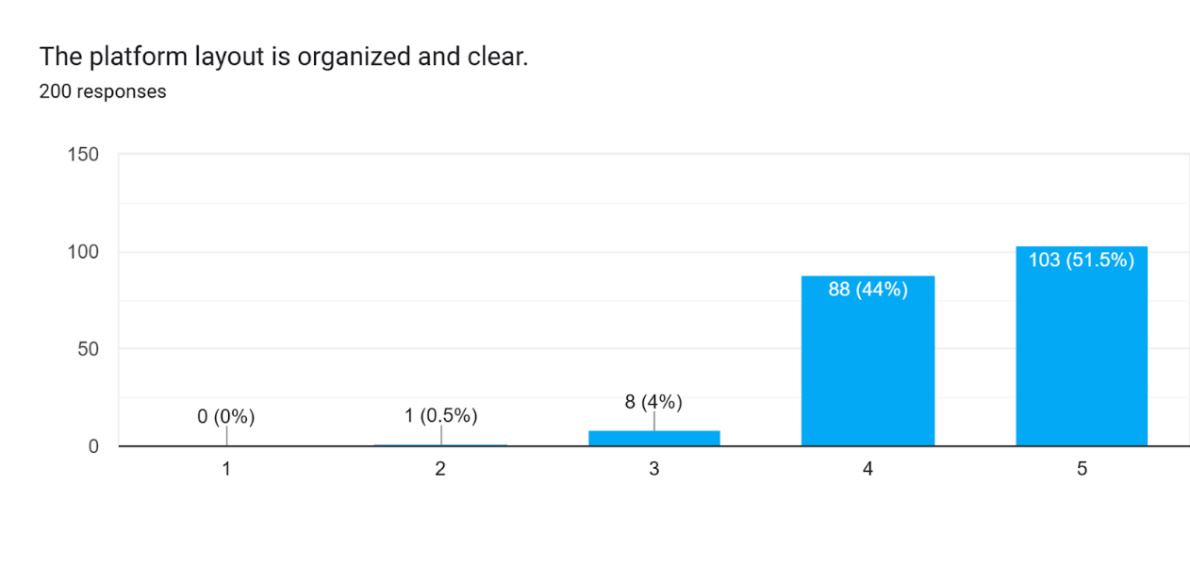

***Figure 4.2.12 The Platform Layout is Organized and Clear***

Figure 4.2.12 shows the responses to the statement, "The platform layout is organized and clear." A significant number of respondents (51.5%) rated it 5, indicating they found the layout well-organized and clear. A large portion (44%) gave it a 4, suggesting that the layout is generally well received, with only minor suggestions for improvement. However, 4% rated it 3, showing some dissatisfaction with its clarity. Only 0.5% rated it 1, indicating minimal complaints, while no users selected 0.

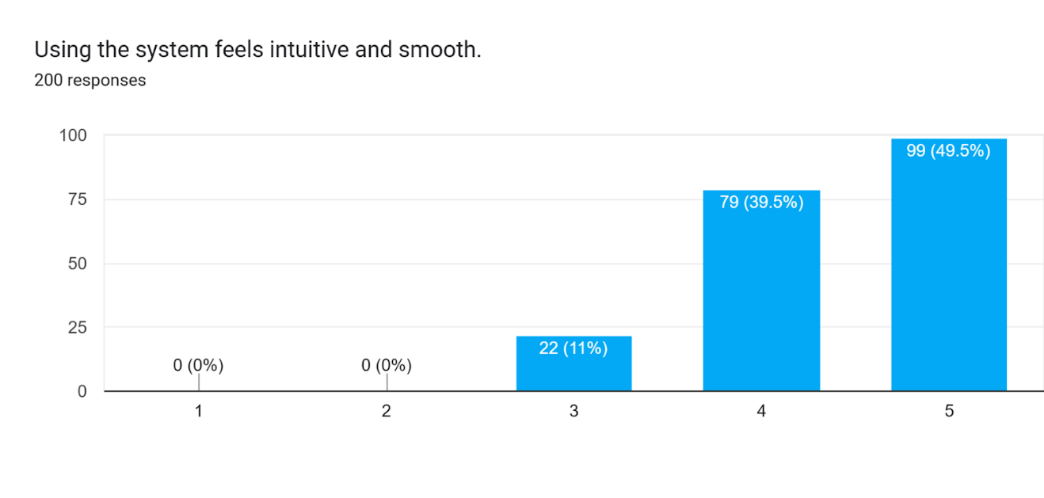

***Figure 4.2.13 The System Feels Intuitive and Smooth***

Figure 4.2.13 displays responses to the statement, "Using the system feels intuitive and smooth." The majority (49.5%) rated it at 5, reflecting that most users find the system highly intuitive and easy to use. Another 39.5% rated it 4, suggesting the system is mostly smooth to use with few minor hurdles. A smaller group (11%) gave it a rating of 3, implying that some users faced challenges using the system. No one rated it 1 or 0, signaling that the platform’s intuitiveness is generally accepted.

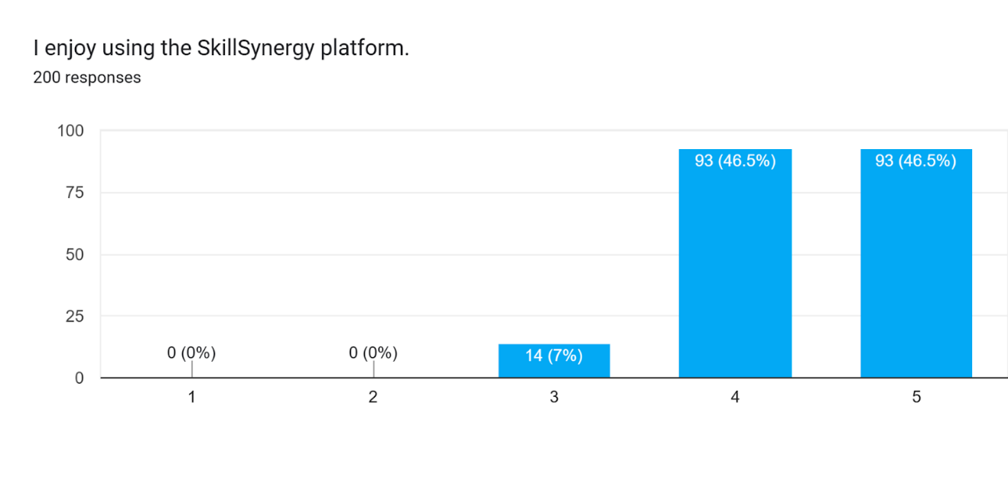

***Figure 4.2.14 Students Enjoy Using the SkillSynergy Platform***

Figure 4.2.14 shows the responses to the statement, "I enjoy using the SkillSynergy platform." The responses are overwhelmingly positive, with 46.5% of respondents rating it 5 and another 46.5% rating it 4, indicating strong enjoyment and satisfaction with the platform. Only 7% rated it 3, suggesting a few users had a more neutral experience. No respondents rated it 1 or 0, showing that the platform is generally seen as enjoyable by most users.

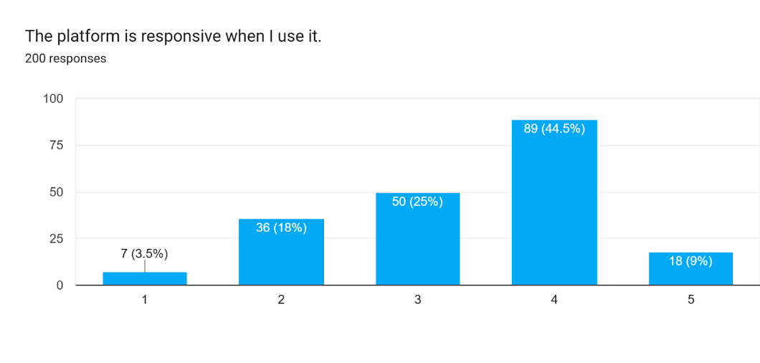**Part IV Performance**

***Figure 4.2.15 The Platform is Responsive***

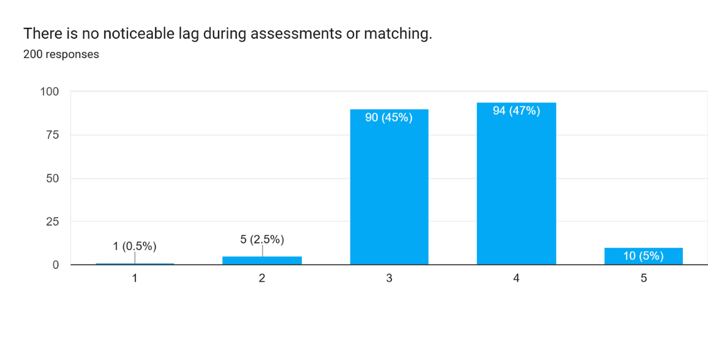 Figure 4.2.15 shows the responses to the statement, "The platform is responsive when I use it." The majority of respondents (44.5%) rated the platform a 4, indicating that they find it responsive most of the time. A considerable portion (25%) gave it a neutral rating of 3, suggesting that while the platform is generally responsive, there may be occasional delays. A smaller group (18%) rated it 2, showing some dissatisfaction with the responsiveness. Only 3.5% of users rated it 1, indicating they experienced significant issues with the platform’s responsiveness. A very small portion (9%) rated it at 5, showing strong satisfaction with the responsiveness.

***Figure 4.2.16 There is No Noticeable Lag***

Figure 4.2.16 presents responses to the statement, "There is no noticeable lag during assessments or matching." The majority of users (45%) rated the platform a 3, suggesting that they experience some lag but not frequently. A close portion (47%) rated it as 4, indicating that most users did not notice significant lag. Only 5% gave it a rating of 5, reflecting strong satisfaction with the platform’s speed during

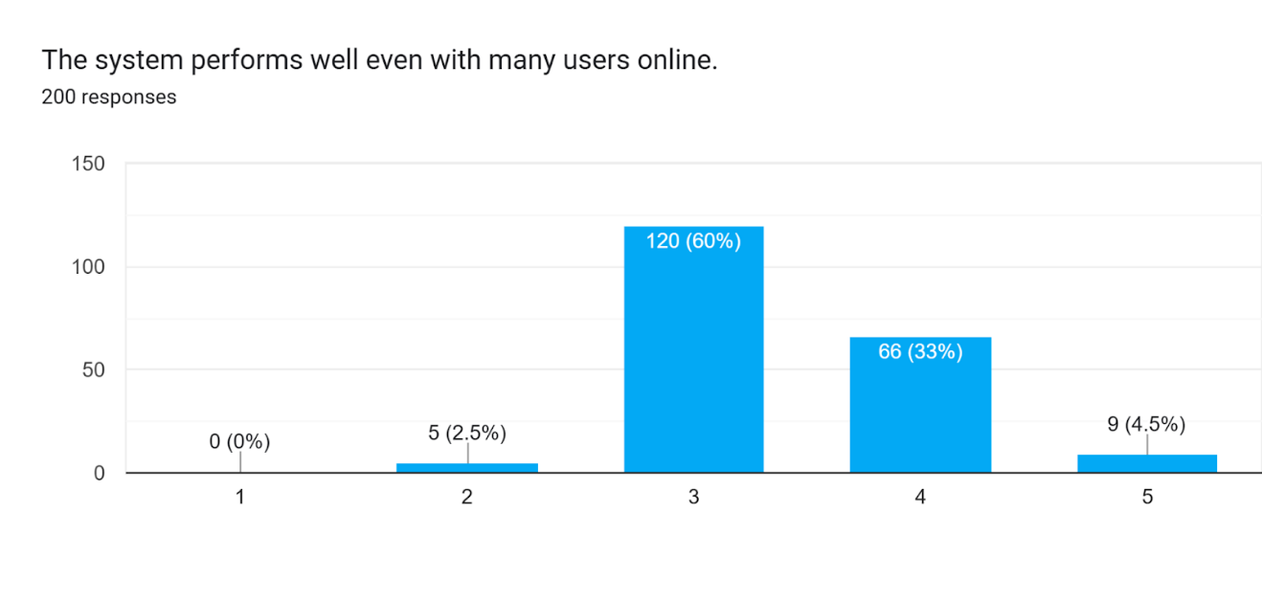 assessments. A very small group (2.5%) rated it as 2, and only 0.5% rated it as 1, showing minimal dissatisfaction or lag issues.

***Figure 4.2.17 The System Performs Well Even with Many Users Online***

Figure 4.2.17 shows the responses to the statement, "The system performs well even with many users online." The majority (60%) of respondents rated it 3, showing a neutral stance, suggesting that while the system performs decently under load, there might be occasional slowdowns. A third of users (33%) gave it a rating of 4, indicating good performance under heavy usage. A small portion (4.5%) rated it 5, reflecting confidence in the system’s ability to handle high traffic. No users rated it 1, and only 2.5% rated it 2, pointing to relatively few complaints.

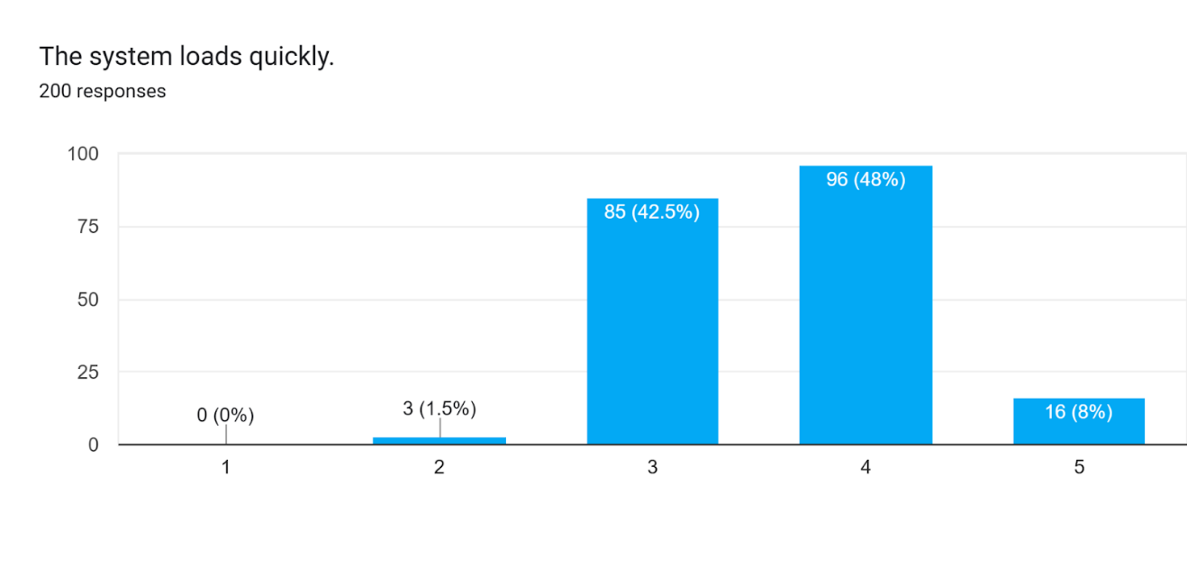

***Figure 4.2.18 The System Loads Quickly***

Figure 4.2.18 shows the responses to the statement, "The system loads quickly." A substantial portion (48%) of users rated it 4, indicating that the system typically loads quickly. Another 42.5% rated it 3, suggesting that the system may load at an average speed but may have occasional delays. Only 8% rated it at 5, showing that a small group found the system to load exceptionally fast. A very small portion (1.5%) rated it 2, indicating mild dissatisfaction, while no users rated it 1 or 0.

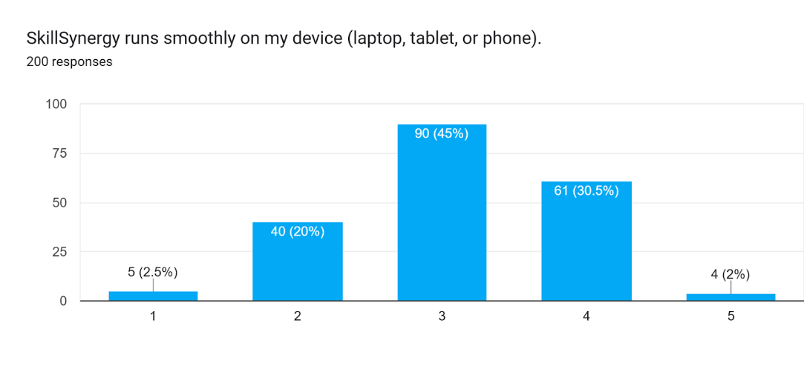

***Figure 4.2.19 SkillSynergy Runs Smoothly on the Devices***

Figure 4.2.19 presents the responses to the statement, "SkillSynergy runs smoothly on my device (laptop, tablet, or phone)." The majority (45%) rated it 3, indicating that while the system works well on their devices, some users may experience occasional issues. A significant portion (30.5%) gave it a 4, suggesting that the platform runs smoothly on their devices with minimal issues. A smaller group (20%) rated it 2, showing some dissatisfaction with how the platform performs on their devices. Only 2% rated it as 5, indicating that a small number of users had no issues running the system on their devices.

**LIST OF REFERENCES**

365Talents. (2025, February 26). Your comprehensive guide to “Skills Taxonomy” https://365talents.com/en/resources/your-comprehensive-guide-to-skills-taxonomy/

Acosta, M. (2016). Paradigm Shift in Open Education and E-learning Resources as Teaching and Learning in Philippines. Jurnal Ilmiah Peuradeun, 4(2), 161–172. https://media.neliti.com/media/publications/98362-EN-paradigm-shift-in-open-education-and-e-l.pdf

Al-Ghamdi, A., Al Harbi, D., Alarfaj, N., Al Hajri, A., Almarashdeh, I., Alsmadi, M., Alshabanah, M., & Alrajhi, D. (2019, June 11). Developing and Implementing a Web-Based Platform for Skills and Knowledge Exchange. International Journal of Scientific Research in Science and Technology. 562-573. 10.32628/IJSRST196345. Papers.ssrn.com. https://papers.ssrn.com/sol3/papers.cfm?abstract_id=3418538

Al-Ghamdi, A., Al Harbi, D., Alarfaj, N., Al Hajri, A., Almarashdeh, I., Alsmadi, M., Alshabanah, M., & Alrajhi, D. (2019, June 11). Developing and Implementing a Web-Based Platform for Skills and Knowledge Exchange. Papers.ssrn.com. https://papers.ssrn.com/sol3/papers.cfm?abstract_id=3418538

Amic, J. (2023, March 27). The Power of Peer-to-Peer Learning: Creating a Culture of Knowledge Sharing. MasterStart. https://masterstart.com/blog/news/the-power-of-peer-to-peer-learning-creating-a-culture-of-knowledge-sharing/

Angermann, H., & Ramzan, N. (2017). Taxonomy matching using background knowledge. In Springer eBooks. https://doi.org/10.1007/978-3-319-72209-2

Arco-Tirado, J. L., Fernández-Martín, F. D., & Hervás-Torres, M. (2019b). Evidence-based peer-tutoring program to improve students’ performance at the university. Studies in Higher Education, 45(11), 2190–2202. https://doi.org/10.1080/03075079.2019.1597038

Arinto, P. B. (2016). Issues and Challenges in Open and Distance e-Learning: Perspectives from the Philippines. The International Review of Research in Open and Distributed Learning, 17(2). https://doi.org/10.19173/irrodl.v17i2.1913

B., Sreeya. (2019). Benefits of Web-Based Learning. Test Engineering and Management. 81. 4912-4916. Benefits of Web-Based Learning

Babas., (2020) Programming Competencies of Filipino Information Technology Students: Inputs to Improving Instructional Processes. https://www.researchgate.net/publication/343219008_Programming_Competencies_of_Filipino_Information_Technology_Students_Inputs_to_Improving_Instructional_Processes

Bank, A. D. (2021, March 23). ADB Study Calls for Skills Training Reform in the Philippines. Asian Development Bank. https://www.adb.org/news/adb-study-calls-skills-training-reform-philippines

Bencito, Dabu, and Santiago., (2020). Development and Evaluation_of Study-Buddy Pairing Application for Android. https://www.researchgate.net/publication/341930600_Development_and_Evaluation_of_Study-Buddy_Pairing_Application_for_Android

Bohnert, A. (2023, October 26). What is a skills taxonomy? A brief guide. HackerRank Blog. https://www.hackerrank.com/blog/what-is-a-skills-taxonomy/

Bringula, Aviles, Batalla, Borebor, Uy and Diego (2017) Factors Affecting Failing the Programming Skill Examination of Computing Students. https://www.mecs-press.org/ijmecs/ijmecs-v9-n5/IJMECS-V9-N5-1.pdf

Cabrera, MC. R., (2024). Publications ASSESSMENT USING SOLO TAXONOMY IN STRENGHENING THE 21ST CENTURY SKILLS. Retrieved March 31, 2025, from https://depedbataan.com/wp-content/uploads/2024/11/ASSESSMENT-USING-SOLO-TAXONOMY-IN-STRENGHENING-THE-21ST-CENTURY-SKILLS.pdf

Candid. (2025). Wadhwani Foundation launches AI skill-building platform in Philippines. Philanthropy News Digest (PND). <https://philanthropynewsdigest.org/news/wadhwani-foundation-launches-ai-skill-building-platform-in-philippines?utm_source>=

Capuz, M.; Atienza, M.;., (2020) Effectiveness of peer-assisted-learning model in teaching physical examination in Otorhinolaryngology to clerks and postgraduate interns. Philippine Journal of Health Research and Development ; (4): 30-38, 2020. https://pesquisa.bvsalud.org/portal/resource/pt/wpr-886601?lang=en

Clover, I. (2023, January 19). Advantages and Disadvantages of eLearning. eLearning Industry. https://elearningindustry.com/advantages-and-disadvantages-of-elearning

Cornerstone Editors. (2024, December 10). Unlocking the future: AI-enhanced skills matching and ontology. Cornerstoneondemand.com; Cornerstone OnDemand. https://www.cornerstoneondemand.com/resources/article/unlocking-the-future-ai-enhanced-skills-matching-and-ontology/

Dream MBBS. (2024, March 28). Pamantasan ng Lungsod ng Maynilla. DREAM MBBS STUDY ABROAD LLP. https://dreammbbs.in/pamantasan-ng-lungsod-ng-maynilla/#:~:text=Pamantasan%20ng%20Lungsod%20ng%20Maynila,a%20positive%20impact%20on%20society.

eSchool News. (2024, January 4). Learning in the digital age. https://www.eschoolnews.com/digital-learning/2024/01/03/learning-in-the-digital-age/

FedEx Philippines. (2022). Kalibrr: The Filipino-Founded AI Hiring Platform | Fedex.com. https://www.fedex.com/en-ph/business-insights/sme/ai-is-powering-how-small-businesses-find-talent-in-the-philippines.html?

Francisco, A. B. (2022). Virtual Mobility: The Lived Experience of Exchange Students in a Higher Education Institution in Asia. Advances in Social Science, Education and Humanities Research/Advances in Social Science, Education and Humanities Research. https://doi.org/10.2991/assehr.k.220103.032

Herron, A. (2024, October 29). Circle City Readers needs funding to sustain its successful tutoring program. Axios; Axios Indianapolis. https://www.axios.com/local/indianapolis/2024/10/29/circle-city-readers-tutoring-program-second-year-funding?utm_source

IEEE Conference Publication Skills Me. (2022, June 22). - Knowledge Exchange Platform. | IEEE Xplore. https://ieeexplore.ieee.org/document/9820517

JANZZ.technology. (2020, February 5). Knowledge Base Archives - Page 7 of 13 - JANZZ.technology. JANZZ.technology. https://janzz.technology/category/knowledge-base/page/7/?utm_source

Jooss, S., Collings, D. G., McMackin, J., & Dickmann, M. (2023). A skills‐matching perspective on talent management: Developing strategic agility. Human Resource Management, 63(1), 141–157.https://doi.org/10.1002/hrm.22192

Junior Philippine Institute of Accountants - SKSU Local Chapter (2024) Study Buddy System. https://www.facebook.com/share/p/1FSeaufZGy/

Lantaca, R. B., Ehong, CG. P., Tupos, M. P., Jadap, ML. C., Capilitan, F. T. Jr., and Namoco, S. O. (2022). Collaborative Learning in an Online Setting of Philippine State University Students in the Philippines: A Phenomenological Study. Sci.Int.(Lahore),34(5),517-521,2022. https://www.sci-int.com/pdf/638042106935854131.-LantacaSARAH-EDU-Pevissed-15-11-22%20PAID_Edited_Nov16%20%2811%29.pdf?utm

Li, Z., Ren, C., Li, X., & Pardos, Z. A. (2021). Learning skill equivalencies across platform taxonomies. CatalyzeX. https://www.catalyzex.com/paper/learning-skill-equivalencies-across-platform

Llego, M. A. (2020, June 15). DEPED Online Learning: The growing role of the smartphone in education. TeacherPH. https://www.teacherph.com/deped-online-learning-smartphone-education/#google_vignette

Majid Zamiri, & Camarinha-Matos, L. M. (2021). A Mixed Method for Assessing the Reliability of Shared Knowledge in Mass Collaborative Learning Community. IFIP Advances in Information and Communication Technology, 24–36. https://doi.org/10.1007/978-3-030-78288-7_3

Manila Bulletin. (2020, March 13). E-learning: What it is, how it works. https://mb.com.ph/2020/03/13/e-learning-what-it-is-how-it-works/

Marshall University. (2019). What is Community-Based Learning? – Center for Teaching & Learning. Marshall.edu. https://www.marshall.edu/ctl/community-engagement/what-is-service-learning

Mendez, Jeanky & Bulanadi, Jehan. (2020). Job matcher: A web application job placement using collaborative filtering recommender system. International Journal of Research Studies in Education. 9. 10.5861/ijrse.2020.5810.

Merchant, M. E. (2024). The disconnect of soft skill development and job skill proficiency in higher education. https://eric.ed.gov/?q=skills&id=ED649253

Microsoft News Center Philippines. (2021, September 13). Empowering Filipino Youth with Informed Educational and Career Paths through Edukasyon.ph’s Innovative Platform. <https://news.microsoft.com/en-ph/2021/09/13/empowering-filipino-youth-with-informed-educational-and-career-paths-through-edukasyon-phs-innovative-platform/>

*MIT Solve*. (2025). Mit.edu. <https://solve.mit.edu/solutions/18234>

Newsbytes.PH. (2017). Study: Over 50% of Pinoy IT students lack programming skills. https://newsbytes.ph/2017/02/01/study-over-50-of-pinoy-it-students-lack-programming-skills-3/

Nuncio, Rhoderick V., et al. “An E-Learning Outreach Program for Public Schools: Findings and Lessons Learned Based on a Pilot Program in Makati City and Cabuyao City, Laguna, Philippines.” Evaluation and Program Planning, vol. 82, no. 101846, Oct. 2020, p. 101846, https://doi.org/10.1016/j.evalprogplan.2020.101846.

OpenGov Asia. (2019, August 8). EXCLUSIVE: Promoting Digital Literacy in the Philippine. https://opengovasia.com/2019/08/08/promoting-digital-literacy-in-the-philippine-education-system/

OpenGov Asia. (2025, February 19). The Philippines: Digital Platforms for Inclusive Education. https://opengovasia.com/2025/02/19/the-philippines-digital-platforms-for-inclusive-education/

Othman, F., Kasim, S., Mohd Sharip, Sharfizie, Md Kamdari, Nor’Azurah, & Ab. (2023). PeerLoom: peer-to-peer skill exchange platform for university students / Farrah Othman … [et al.] - UiTM Institutional Repository. Uitm.edu.my. https://ir.uitm.edu.my/id/eprint/94161/1/94161.pdf

Patacsil, F., & Tablatin, C. L. S. (2017, September 17). Exploring the importance of soft and hard skills as perceived by IT internship students and industry: A gap analysis. Patacsil | Journal of Technology and Science Education. https://www.jotse.org/index.php/jotse/article/view/271/279

Peer Tutorial – UPV Teaching and Learning Resource Center. (2024). Upv.edu.ph. https://tlrc.upv.edu.ph/peer-tutorial/?utm_source=

Petrican, Teodor & Stan, Ciprian & Antal, Marcel & Salomie, Ioan & Cioara, Tudor & Anghel, Ionut. (2017). Ontology-based skill matching algorithms. 205-211. 10.1109/ICCP.2017.8117005.

PIDS study emphasizes interagency collaboration to address skills mismatch. (2024). Pids.gov.ph. https://www.pids.gov.ph/details/news/press-releases/pids-study-emphasizes-interagency-collaboration-to-address-skills-mismatch

Pursell, H. (2024, July 26). What is Skills-Based Matching? Definition, Purpose, Benefits | Guider AI | Guider AI. Guider AI. https://guider-ai.com/blog/what-is-skills-based-matching

Qureshi, M. A., Khaskheli, A., Qureshi, J. A., Raza, S. A., & and Yousufi, S. Q. (2021). Factors affecting students’ learning performance through collaborative learning and engagement. Interactive Learnring Environments, 31(4), 2371–2391. https://doi.org/10.1080/10494820.2021.1884886

R. K. Kavitha, V. JalajaJayalakshmi, R. Rassika (2018) Collaborative learning in computer programming courses using E-learning environments. https://www.researchgate.net/publication/323277780_Collaborative_learning_in_computer_programming_courses_using_E-learning_environments

Skill swapping: Helping your business innovate in uncertain times. (2024). Independentpublishersguild.com. https://www.independentpublishersguild.com/IPG/IPG/Latest/Blogs/IPG/Posts/Skill-swapping--Helping-your-business-innovate-in-uncertain-times.aspx

Skills Taxonomy by Abodoo. (2024). Abodoo.com. https://www.abodoo.com/products/skills-taxonomy

Sri, M. Bhagya M. (2025).Peer-to-Peer Skills and Knowledge Exchange Platform.https://www.researchgate.net/publication/389074921_Peer-to-Peer_Skills_and_Knowledge_Exchange_Platform/references

Structure learning for Bayesian networks. (2024). Github.io. https://ermongroup.github.io/cs228-notes/learning/structure/

Team, A. (2024, December 12). What is a Skills Assessment and Why is it Important? The Avilar Blog. https://blog.avilar.com/2020/05/20/what-is-a-skills-assessment-and-why-is-it-important/

The BOSS Magazine. (2024, August 14). Empowering Lifelong Learning: The role of online learning platforms in skill development. BOSS Magazine. https://thebossmagazine.com/online-learning-platforms-skill-development/

The Effects of Online Collaborative Learning (OCL) on Student Achievement and Engagement. (n.d.). The International Academic Forum (IAFOR). https://iafor.org/journal/iafor-journal-of-education/volume-10-issue-3/article-2/

The impact of peer learning within a group of international post-graduate students – a pilot study. (2018). eric.ed.gov. https://files.eric.ed.gov/fulltext/EJ1208456.pdf

The Impact of peer tutoring on academic achievement in financial Accounting and reporting of First-Year accountancy Students in Pamantasan NG Lungsod NG Maynila. (n.d.). researchgate.net. <https://www.researchgate.net/publication/377500397>

The International Academic Forum. (2023, March 2). The effects of Online Collaborative Learning (OCL) on student achievement and engagement - The International Academic Forum (IAFOR). The International Academic Forum (IAFOR). https://iafor.org/journal/iafor-journal-of-education/volume-10-issue-3/article-2/

Topping, K. J. (2021). Digital peer assessment in school teacher education and development: a systematic review. Research Papers in Education, 38(3), 472–498. https://doi.org/10.1080/02671522.2021.1961301

Training and development at Work: An introduction Archives - FutureLearn. (n.d.). FutureLearn. https://www.futurelearn.com/info/step-course/training-and-development-at-work-an-introduction

Ullah, I., Tabassum, R., & Kaleem, M. (2018). Effects of Peer Tutoring on the Academic Achievement of Students in the Subject of Biology at Secondary Level. Education Sciences, 8(3), 112. https://doi.org/10.3390/educsci8030112

V, V., Mohania, M., & Goyal, V. (2021, July 3). TagRec: Automated Tagging of Questions with Hierarchical Learning Taxonomy. arXiv.org. https://arxiv.org/abs/2107.10649

What Is Synergy? (n.d.). What is Synergy? (with types, requirements and examples) | indeed.com. Indeed Career Guide. https://www.indeed.com/career-advice/career-development/what-is-synergy

Yeboah, A. (2023). Knowledge sharing in organization: A systematic review. Cogent Business & Management, 10(1). https://doi.org/10.1080/23311975.2023.2195027

Youngren, J. (2021). Impacts of collaborative learning on student engagement Impacts of collaborative learning on student engagement. https://red.mnstate.edu/cgi/viewcontent.cgi?article=1511&context=thesis